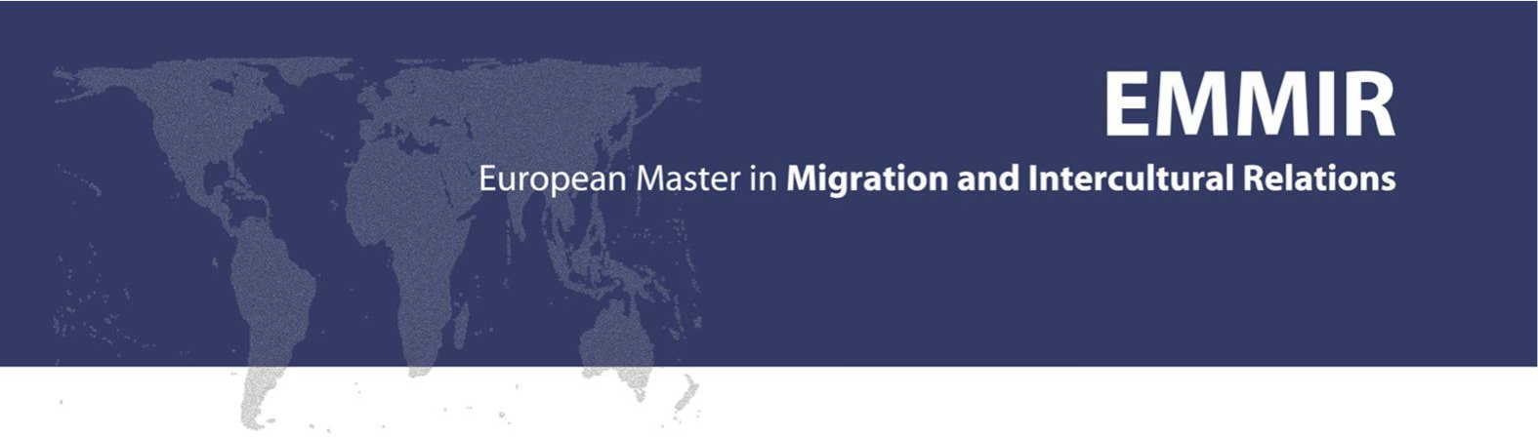

The Education of Nomadic Children in Gedaref, Sudan:
Whether, and to What Extent, the Current Education System Responds to Nomadic Children’s Needs, Desires and Expectations

By Natalia Chojnacka

Thesis Submitted in Partial Fulfilment of the Requirements for the Degree in European Master in Migration and Intercultural Relations

First Supervisor: Dr. Alawiyya Ibrahim Farag, Ahfad University for Women, Sudan
Second Supervisor: Dr. Abdel Rahman El Rehiema ElDood, UNICEF, Sudan

June 2015

Declaration

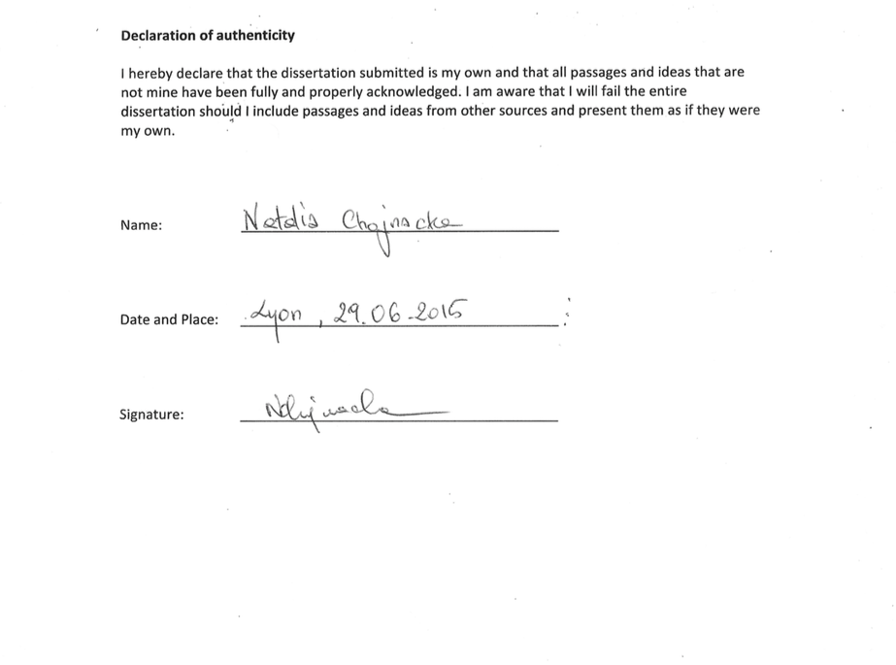

Abstract

This study was undertaken to assess the extent to which current educational services are sufficient and successful in responding to the needs, desires and expectations of nomadic children in the state of Gedaref, Sudan, incorporating a gender-based analysis.

Qualitative analysis is predominant in the study, as it aims at describing the social reality of pastoralist groups. Therefore, the main focus is placed on individuals’ words, and on my observations. Examination of participants’ perceptions (interpretivism) combined with the conviction that social phenomena are outcomes of interaction between individuals (constructionism) underpin the research. A cross-sectional design was chosen for this study due to its utility in capturing various cases, variables and mixed data. In this research triangulation is present under multiple forms, namely: data triangulation (use of a variety of sources in a study), theory triangulation (use of multiple theories to interpret results), and methods triangulation (multi-methods to study the research problem).

To the present day, education cannot be considered either free or compulsory in Sudan. There is little evidence of humanitarian agencies’ financial support on the ground. Furthermore, there is very weak coordination between the various agencies involved, and ministry bodies. Not only are education targets established abstractly, with a distinct lack of indicators adapted to the nomadic reality, but there is also a serious paucity of statistical data.
The current educational system, being weakly adapted to nomadic or semi-nomadic lifestyles and needs, is inappropriate for those nomadic individuals who wish to benefit from the service, and this is especially true in the case of nomadic girls.
The intervention framework, which aims at bringing all children to schools by 2015, is underpinned by the perception that western education is universal. This approach is bereft of proper contextualisation. Generalization in terms of nomadic communities’ needs, expectations and desires should be avoided, as should the assumption that schooling is necessary and automatically leads to empowerment.

Key words: Education for All (EFA), nomadism, marginalization, girls, and development

Acknowledgments
This MA thesis would not have been possible without the moral, academic and logistical support of many people.
Firstly, I would like to express my sincere gratitude to my supervisors, Dr. Alawiyya Farag and Dr. Abdel Rahman ElDood, for their constructive guidance, support and belief in the research.

I would also like to acknowledge the great institutional support provided by the Education Section of UNICEF Sudan, and by my work colleagues. Special thanks go to the chief of the Education Section, Hassan Ali Mohammed, and also to Anna Acker, for appreciating the value of this research. My appreciation is also extended to Rathiga Veludipillali, Omeima Mustafa and Omeima Dahab for their moral and administrative support.

In addition, I gratefully acknowledge the encouragement and assistance of AUW staff, and in particular, Tayseer, Muhammad, and Dr. Ahmed Gamal AdDin for their willingness to help and support me with accessing the field. In addition thanks go to Dr. Amna AlBadri for her help with accessing relevant sources.

Of course, my appreciation extends also to the officials from the state MoE in Gedaref who helped me to reach remote nomadic communities during my fieldwork: thank you to all of those concerned. I would particularly like to express my gratitude to Adam Yahia Mohammed. Without him, this research would not have been achievable.

I would like to express my very special gratitude to Kate Peirse-O’Byrne for her help as proof-reader. In addition, thanks go to Mohammad Osman and Anne- Marie Garrioch for their help as translators or proof-readers.
Thanks are also due to my friends for their love and support. I would like to express my gratitude to all of my ‘Sudanese’ friends, who made me feel at home in Sudan, and with whom I shared wonderful moments. Particular thanks are due to my extremely supportive flatmate, Azra.

I would also like to express my particular gratitude to Amy Winterbotham and Emile Sauzedde for hosting me in their peaceful place while I wrote this research, creating a warm atmosphere for me to work in, and for providing multi-level support.

Last but not least, I am grateful to all the respondents who shared their opinions with me. Without them, this work would not have been possible.

Dedication

To all the people of Sudan

Acronyms

ALP Alternative Learning Programme
CPA Comprehensive Peace Agreement
CRC The convention on the Rights of the Children
DRIP Declaration on the Rights of Indigenous Peoples
EFA Education for ALL
EMIS Education Management Information System
FYPER Five-Year Programme for Economy Revitalisation
GER Gross Enrolment Ratio
GDP Gross Domestic Product

GOS Government of Sudan

GPI Gender Parity Index
HAC Humanitarian Aid Commission
HDI Human Development Index
HNO Humanitarian Needs Overview
IDP Internally Displaced Population
IFAD International Fund for Agricultural Development
MDG Millennium Development Goal (s)
OOSC Out-of-school- Children
NNGO National Non-Governmental Organisation
INGO International Non- Governmental Organisation
NGO Non- Government Organisation
NCLAE National Council For Literacy and Adult Education
MoE Ministry of Education
PCA Programme Cooperation Agreement
PTA Parent- Teacher Association
SMOE State Ministry of Education
RBA Rights’ -Based- Approach
SPLM Sudan People’s Liberation Movement
UN United Nations
UNDP United Nations Development Programme

UNESCO The United Nations Organization for Education, Science and Culture

UNICEF United Nations Children’s Fund
WB World Bank
WFP World Food Programme

Table of Contents
Declaration II
Abstract III
Acknowledgments IV
Dedication V
Acronyms VI
ChapTER 1: Introduction 1
1.1 Background of the study 2
1.2 Statement of the problem 3
1. 3. Aims of the study 6
1.4. Research questions 6
1.5. Terminological concerns 7
1.6 Research Area description 8
1.7 Outline of thesis 18
Chapter 2:Literature Review: What has been said? 20
2.1. Introduction 20
2.2 Nomadic education worldwide 22
2.2.1 Introduction 22
2.2.2 Development and nomads 22
2.2.3 Education For All (EFA) 24
2.2.4 Girls Education 26
2.2.5 Interpretation of EFA: What the EFA Means for Nomadic Peoples 26
2.2.6 Challenges to nomadic education 27
2.2.7. Strategies And Solutions 30
2.3 SUDAN 34
2.3.1 Nomads in Sudan 34
2.3.2. Development and marginalization of nomads 34
2.3.3. Development and women 35
2.3.4 Services in Sudan 36
2.3.5. Education in Sudan 37
2.3.6 Girls’ education in Sudan 39
2.3.7 Nomadic Education in Sudan 40
2.3.8 EFA & Nomads in Sudan: What accounts for low enrolment? 42
2.4 Gedaref 48
2.4.1. Development in Gedaref 49
2.4.2 Education: the observed situation for nomadic children 49
2.5 Localities 52
ChapTER 3: Theoretical and conceptual framework 54
3. 1 Introduction 55
3.2. Theoretical framework 55
3.2.1 Sociology of Education 55
3.2.2 Multi-level framework 56
3.2.3 The Macro level: Discourses in Development 56
3.2.4 The Meso level: A Rights Based Approach To Education for ALL 58
3.2.4 The micro level: Agency and diversity 60
3.3 Conceptual framework 62
Chapter 4: Research design and Methodology 63
4. Approaches and Methodology 64
4.1 Philosophical Approaches 64
4.2 The research design 65
4.3 Data collection 65
4.4 Sample and sampling procedures 67
4.5 Data collection instruments 70
4.6 Validity of the research instruments 73
4.7 Research ethics 74
4.8 Data analysis 74
4.9 Fieldwork reflections and study limitations 75
CHAPTER 5: Findings and analysis 78
5.1 Introduction 79
5.2. Macro level 79
5.3 MESO level 90
5.4 Micro level 101
Chapter 6: Discussion, conclusions, and recommendations 110
6.1 Discussion 111
6.2 Conclusions 117
6.3 Recommendations 119
Bibliography 121
ANNEXES: 129
Annex 1: Tables 129
Table (1): Nomadic children 6-13 years old who are not enrolled in Basic School 129
Table (2) Basic education statistics for year 2012-2013; Sudan 130
Table (3) Strategy Nomadic Education 2013-2016 131
Table (4): Strengthen and weakness of existing nomadic education institutions 132
Table (5): Distribution of nomadic people by state 133
Table (6): Nomadic education gross enrolment trends 2005 – 2009 134

Chapter 1

Introduction

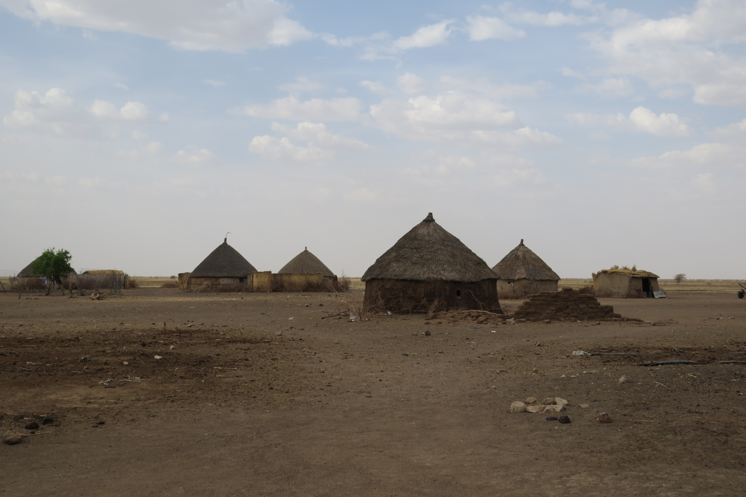

Pic. 1

(…) Over the last decades (the nomadic people) had to contend with rapid changes to their ways of life, often as a consequence of global patterns of development that are highly unsympathetic to spatially mobile groups. To make their ways in the contemporary world, nomadic groups are finding that their indigenous mode of education is no longer adequate. (Dyer, 2006, p. 1).

1.1 Background of the study

This study concerns education for nomadic people in Sudan. According to the United Nations Declaration on Human Rights, education is a fundamental human right (UNDHR, 1948). However, while working as an intern in the Education Section UNICEF Sudan, numerous meetings with the Ministry of Education and local and international Non-Governmental Organisations (NGOs) indicated that the provision of education to nomadic communities is a serious problem, particularly as concerns nomadic girls.
The Convention on the Rights of the Child (CRC) is based on the proposition that children should have equal opportunity to develop and reach their full potential. It pledges to honour the fundamental rights of every child regardless of gender, race, religious beliefs, income, physical attributes, geographical location or other status (Out-Of-School Children Initiative- OOSCI, 2014).
Article 3 of the World Declaration on Education for All 1990 (EFA) identifies nomads as a group facing discrimination in access to education (UNESCO, 1990). At the 2000 World Education Forum held in Dakar (Senegal), the international community reaffirmed its commitment to achieving EFA goals by 2015 (UNESCO, 2007). However, the 2010 Global Monitoring Report indicated that nomadic people continue to be exposed to educational disadvantage, and stressed the importance of taking ‘urgent action’ to address this (UNESCO, 2010 in ibid.) This pledge was reiterated in the Global Out-of-School Initiative (OOSCI), which aims at bringing all out-of-school children into school by 2015. As the EFA objectives have not yet been accomplished, a post-2015 development agenda is currently being designed in consultation with all relevant actors (UNESCO, 2015).
The purpose of education is to enable individuals to be in charge of their future (UNESCO, 2007). It has been globally recognized that, if requested, states should provide education to all indigenous people, including nomads, in order to help them secure their livelihoods (UN, 2008). Attempts to increase educational access for nomads are not a new phenomenon in the Sudanese context and globally, but these attempts have not always had satisfactory results. Many governments, scholarship programmes and other stakeholders agree that educating nomadic peoples in the context of rapid global socio-economic change is a challenge of massive proportions (Carr-Hill and Peart, 2005; Dyer 2006; Krätli, 2001; MoE 2013b; Oxfam, 2005). Moreover, while nomadic young people in general face many challenges in access to education, the obstacles faced by nomadic girls are even greater (International Fund for Agricultural Development (IFAD), 2012; Farag 2013).

Overall, two major assumptions concerning the failure to ensure pastoralist education dominate the debate. The first one is that pastoralists / nomads are willing to formally educate their children, but that a lack of curriculum relevance, schools’ geographical remoteness, and an ill-suited school calendar act as huge disincentives to pursuing formal education. The second assumption is that pastoralists actually have very little interest in most formal education programmes, due to their intrinsic incompatibility with nomadic culture. In other words, parents are reluctant to educate their children in line with modern standards as such education is confronting and unnecessary for their way of life (Krätli and Dyer, 2009). In 2010, during the Global Gathering of Women Pastoralist in Mera (India) pastoralist women declared that in their view their children are in need of ‘tools and opportunities’ enabling adaptation to the current modern reality, which argues in favour of the former assumption. However, they also highlighted that such opportunities should not be antagonistic to their culture and lifestyle (IFAD, 2012).

Sudan’s Interim National Constitution declares education to be a right for every citizen and requires the state to guarantee access to free basic education, without discrimination on the basis of religion, race, ethnicity, gender or disability. However, the Sudanese national action plan concerning “Education for All” indicates that this is not presently the case; the plan identifies ‘nomads’ and ‘girls’ as being disadvantaged in terms of access to quality education services (OOSCI, 2014). In light of these observations, education providers in the Republic of Sudan need not only to address problems affecting pastoralists / nomads in general, but need also to develop mechanisms, strategies and policies to tackle issues specific to pastoralist girls (Oxfam, 2005). This dissertation aims to examine the reasons behind the low participation of nomadic children in the educational system, incorporating a gender-oriented analysis.

1.2 Statement of the problem

Participation by nomads in education, both worldwide and specifically in the Sudanese context, is recognised as being a huge challenge for education providers (Krätli and Dyer, 2009; Krätli, 2001; MoE, 2013). The determination to provide education to all communities, including those with a pastoral lifestyle, has led to the development of an array of policies and programmes (both formal and non-formal) such as free primary education, boarding schools, mobile schools and e-learning programmes. Nevertheless, when measured according to global standards, these initiatives have had limited success.

The current system of educational provision in Sudan is guided by global declarations such as the Convention on the Rights of the Child (CRC), Education for All (EFA) and the Millennium Development Goals (MDGs). National laws, policies and plans are developed in accordance with these documents’ pledges. As already indicated, Sudan’s Interim National Constitution declares education to be a universal right and requires the state to guarantee access to free basic education, without discrimination on the basis of religion, race, ethnicity, gender or disability. Moreover, the interim Poverty Reduction Strategy recognizes that education plays a key role in reducing the causes of poverty and tribal conflict and is thus crucial for economic reform (OOSCI, 2014). In addition, the rationale for provision of education to nomadic children is based on the assumption that education serves to fulfil one’s potential and sustain one’s livelihood (UNESCO, 2007).

However, Sudan is far from ensuring universal access to education. According to Middle East and North Africa (MENA) region estimates, Sudan has both the largest number and the highest percentage of out-of-school children in the region. Almost a third of children – more than three million in all (age 5 -13 years) – are not receiving basic education (OOSCI, 2014).

Furthermore, according to Sudan’s out-of-school children study conducted in 2013 as part of the Global Out-of-School Initiative (OOSCI) , “exclusion from school prevails in rural settings among disadvantaged groups including nomads, war-affected populations and internally displaced persons. Children from poor families and girls remain at risk of leaving school due to economic factors and social norms” (OOSC. 2014, p. 2). Therefore, it is reasonable to conclude that difficulties concerning educational provision in Sudan are not limited exclusively to nomadic children.
As statistics show, the general Gross Enrolment Ratio (GER) in formal primary schools, which is one of the ways of measuring children participation in education, is not satisfactory. However, it is even lower amongst nomads. A data set from 2012 (State reports) indicates that 175,969 out of 616,555 school-aged (6-13) nomadic children were enrolled in basic education in Sudan. Therefore, the GER among nomadic children was only 28,5%, while the total general GER at the national level was 70.7%. In the state of Gedaref, these figures were 29.3% and 68.1%, respectively (see tables 1 and 2).
The raw number of out-of-school children – among one of the most frequently cited education statistics – illustrates just how many primary school-age children are excluded from education (OOSCI, 2014). According to the latest data, 459,424 (275, 439 boys and 246, 579 girls) out of 616,555 (331, 411 boys and 270,720 girls) nomadic school-aged children (6-13 years) in Sudan are out of school. In the state of Gedaref 13,960 boys and 11, 367 girls are out of school, making a total of 25,327 (State Reports 2012 in MoE, 2013b).
While nomadic and pastoralist boys and girls have equal rights to free basic education, a significantly lower proportion of girls benefit from this opportunity. The figures indicate that at the national level 68, 985 out of 270,720 nomadic girls (25.4% GER) as opposed to 106,984 out of 331,411 nomadic boys (32 % GER) are enrolled in schools. This means that girls constitute only 38% of the total number of pastoralist children enrolled in primary education, while they constitute 45% of the total number of school-aged nomadic children (see tables 1 and 2).
In Gedaref, 5,820 out of 18,172 boys are in schools, while 4,705 out of 17,730 girls are in schools. The GER for Gedaref shows, once again, that girls are more disadvantaged than boys; the GER for boys is 32%, while it is only 26.5 % for girls. Thus, girls constitute 40% of the total number of nomadic children enrolled in schools (ibid.)
The data makes clear that the proportion of nomadic girls enrolled in primary education is significantly lower than that of nomadic boys. Moreover, although school retention is an issue with respect to both sexes, girls are more prone to drop out than boys are (MoE, 2013b), for reasons that will be discussed in Chapter 2.
In sum, the very high number of OOSC in Sudan, the low participation rate of nomadic children in Sudan-based education programmes, and the even lower participation rate of nomadic girls in Sudan are remarkable both at national and state levels (Gedaref). These observations led me to raise the following broad questions:
- Is any Education Sector stakeholder capable of ensuring free education for all pastoralist children in Sudan?
- Who benefits from the inclusion of nomads in the educational system?
- Should pastoralist children be targeted by formal or non-formal educational programmes?
- Does the removal of certain obstacles automatically lead to higher enrolment?
- Why are rates of participation in education programmes lower for girls than for boys?
- Is the nomadic culture sufficiently understood by education providers?
These broad questions contributed to the development of the specific aims and research questions outlined below.

1. 3. Aims of the study

This study aims at assessing the extent to which current educational services are sufficient and successful in responding to the needs, desires and expectations of nomadic children in the state of Gedaref, Sudan, incorporating a gender-based analysis. This broad aim comprises the following three main objectives:
- To understand and assess the roles played by the community and local and international actors in the provision of education to nomadic children;
- To map and assess adjustability of educational services to the nomadic way of life, integrating a gender perspective; and
- To understand the reasons behind nomadic children’s low rates of participation in the education system, and in particular, why rates of participation are even lower among girls.
The study further aims at raising awareness among mainstream society about nomads, their ways of life, and the problems they encounter due to droughts and overgrazing. It is my hope that my research findings will help to guide stakeholders involved in the provision of education to nomads.

1.4. Research questions
In order to achieve the broad aim and objectives outlined above, I developed the following research questions:

Questions:
- What are the roles played by the Ministry of Education (at different levels), local and international NGOs and the United Nations (UN) agencies in the provision of education to pastoralist groups? What is their understanding of nomads?
- Are the views of nomadic communities taken into account and/or reaching stakeholders involved in education provision? What is the pastoralist community’s perception of said stakeholders?
- What policies and programmes are in place to increase pastoralist children’s participation in educational programmes? What evidence of these initiatives can be found in the field?
- How suitable and in demand are the currently provided educational programmes to nomadic communities, in terms of modes of delivery and curricula?
- What are the problems encountered by stakeholders in providing education to nomadic communities?
- What challenges do nomadic children encounter when joining the education system? What are the critical factors contributing to girls’ lower participation rates?
- To what extent do current educational services contribute to nomadic community development, taking into account gender disaggregation?

1.5. Terminological concerns
For the purposes of consistency and coherency, I will first outline and define the terminology used in relation to the study group (pastoralism/nomadism), and the social services provided to this group (terms relating to education).

Pastoralism/Nomadism
In general terms, pastoralism encompasses an array of different mobility patterns, ranging from long- distance migration to short and seasonal movements combined with other activities (UNDP, 2006). Based on the variation in mobility, Ahmed Gaffar Ahmed (1976) identified 3 groups (ElDood, 2010), namely:
a) Pastoral nomads: the group moves with their whole family and livestock from one area to another in search of water and pasture;
b) Semi-nomads: the family splits into two groups, with the first group moving with stock in search of food and water, and the second staying in one place and engaging mainly in agricultural activity;
c) Transhumance: the family moves from a permanent base (settlement) but their major activity is agriculture. Other activities, such as the breeding of livestock, are secondary in importance.
Broadly speaking, the above-mentioned categories of nomads show similar socio-cultural characteristics (El-Arifi, 1975). In addition, the term ‘Pastoralism’ is often employed as an equivalent of ‘Nomadism’ (UNEP, 2013). While this research focuses on both pastoral and semi-nomadic groups, the terms ‘pastoral’ and ‘nomadic’ are used interchangeably – encompassing both groups – unless it is otherwise explicitly stated.

Education
For the purposes of this research, education is defined as ‘a process or an act of acquiring knowledge’ while schooling denotes ‘the process of teaching or being taught in a school’. While education comprises schooling, it does not necessarily take place in a school setting. Terminological differentiation of both terms is crucial for this study, since institutional schooling has often been perceived as antagonistic to the nomadic lifestyle (Krätli and Dyer, 2009).
It is also relevant to elaborate on different methods leading to knowledge acquisition. This dissertation will refer to the following three broad categories:
- Formal education “corresponds to a systematic, organized education model, structured and administered according to a given set of laws and norms, presenting a rather rigid curriculum as regards objectives, content and methodology”. It is characterized by a contiguous education process, which necessarily involves the teacher, the students and the institution (Zaki, 1988, p. 2). Formal educational institutions are organized according to administrative, physical and curricular considerations and require a minimum of classroom attendance from students (ibid.).
- Non- formal education comprises flexible and alternative modes of providing primary or basic education. Generally, these do not require student attendance, which implies less student-teacher contact than in formal educational modes. Most activities take place outside the institution (ibid.).
Non-formal approaches have emerged as a result of limited funding, in order to meet new targets set internationally in a partnership with civil society (Rogers, 2004). This category is inclusive of distance education, “an educational process in which a significant proportion of the teaching is conducted by someone removed in space and/or time from the learner” (Perraton, 1982, p. 4 in Perraton, 2007, p. 12).
- Informal education is a learning process that usually does not take place within the conventional educational system, and is available to children as members of a complex social network. It is considered crucial to a child’s development (Krätli and Dyer, 2009) and is primarily based on ‘conversational’ learning (Thomas, 2002 in ibid.).
In order to differentiate between state-provided (formal or non-formal) education and informal education, the term ‘conventional’ will be applied to denote the institutionalized service. All three methods are pertaining to pastoralist children.

1.6 Research Area description

The research was conducted in an area comprising 3 communities: Tayba, in West AlGalabat county; Wad Nourein, in Alfaw county; and Wad alKhasheet farig, in AlRaha county. All three communities are located in the state of Gedaref in the south- eastern region of Sudan.
This section first sketches the geographical location where my fieldwork took place, and then provides more detailed information about each of the three communities.

Gedaref and Butana Region
Gedaref shares an international border with Ethiopia to the east and 4 state borders with: Kassala and Khartoum states to the north, AlGezira state to the west, and Sennar state to the south. Gedaref covers an area of approximately 75,263 km². According to the 2008 census its population amounts to approximately 1,369,300 out of which 18,257 individuals have been identified as having a nomadic background (9,563 males and 8,694 females) (CBS, 2008). The 2012 statistics indicate that in Gedaref, 35, 902 (MoE, 2013b) out of 397,587 school-aged children have a nomadic background.
Gedaref has been identified as an area where some nomadic tribes remain totally mobile: not only young men accompany the herds, but the whole family (Farag et al., 2008). This mobility pattern is linked to the fact that Gedaref is part of a broader geographical area: the Butana Region. An exhaustive description of this geographical area provides important information about the background of the visited communities.
The Butana region (see map 1) covers most of the present states of Kassala and Gedaref, and is well- known as ‘the region inhabited by nomads’. It lies in southeastern Sudan between Latitude 13ْ 40' and 17ْ 50' North and Longitude 32ْ 40' and 36ْ 00' East, extending over 120,000 km (Darosa and Agab, 2008). The Butana region is bordered by the Main River Nile to the north-west, the Blue Nile to the south-west, the Atbara River to the north-east and by the railway connecting Kassala and Sennar to the south. The region is characterized by flood-prone uniform plains, which are predominantly composed of clay, clay soil and sandy soil. Most of Butana is located on the low rainfall savannah, with a smaller portion extending into the semi-desert agro-ecological zones of Sudan (Darrag, 1989 in Abbas et al., 1992). The northern limit of the region receives less than 100mm of rain annually, with rainfall increasing in intensity towards the south, reaching a maximum of approximately 400mm per year (El-Arifi, 1975). Many seasonal rivers cross it, namely the Atbara, Seitite, Ba-Salam, Gash and Rahad Rivers. Small, temporary valleys run through these plains during the rainy season (Darosa and Agab, 2008).
Although pastoralists’ highly mobile nature makes it hard to sketch their geographical distribution with either detail or precision a general overview is available (see map 3). Their distribution across the country, as well as their migratory patterns (if still persisting), are dictated by the need to supply their animals with water and pasture (ElArifi, 1975; Darosa and Agab, 2008).

Map 1 source: Agad and Abbas(FAO, 1997)
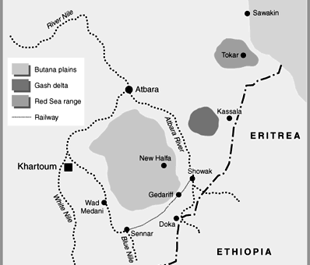
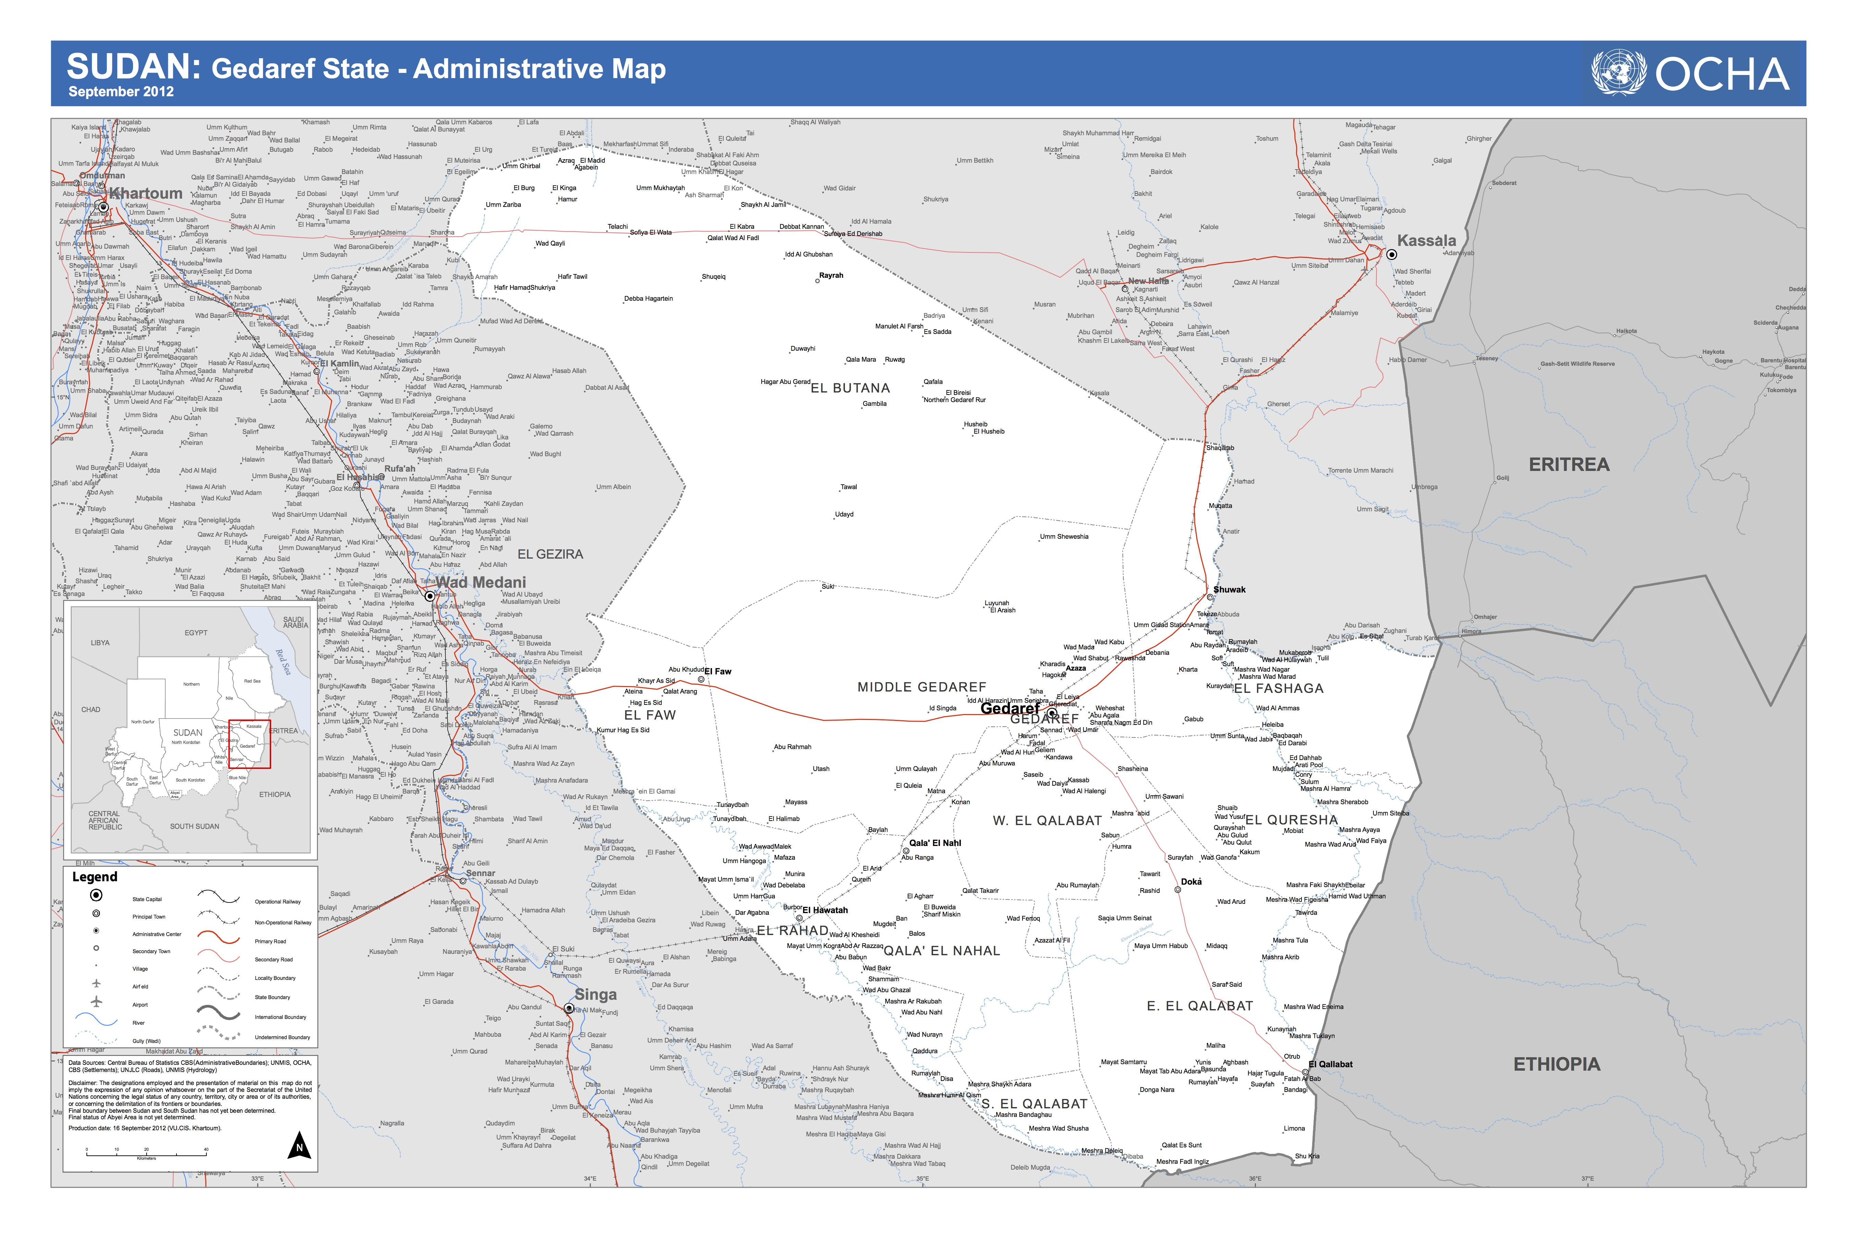
Available sources indicate that the Butana region is inhabited by tribes such as the Shukriyya, the Batahin, the Lahawin, the Kawahla, the Rashida and the Rufaa al-Shariq as well as Kenana. The predominant livestock animals among these groups are camels, cattle and sheep.
Historically, recurring droughts have seriously affected traditional pastoralism. In the 1970s, pastoralism was further threatened by increasing food insecurity and deterioration of livelihoods (Mohamed and Ahmed, 1991). As noticed by El-Arifi (1975), there was a strong tendency to abandon pure nomadism and combine it with agricultural activity, especially among nomads along the Atbara and the Blue Nile rivers (El Arifi, 1975). In order to adjust to this change, pastoralists adopted new strategies such as small animal breeding or agriculture. The emerged types of subsistence economy, ranging from pure pastoralism to agro-pastoralism, were contingent on the amount of annual precipitation, the fertility of the soil, and inherited indigenous knowledge (Mohamed and Ahmed, 1991). Furthermore, drought hit the area in 1984, forcing many communities to abandon the traditional herding system and leading to the settlement of some elite pastoralist groups (Mohamed and Ahmed, 1991). That disturbance was reflected in the rapid decrease of nomadism: from 73.3 % in 1984 to 22.0% in 2003 (Darosa and Agab, 2008).
In addition, an agricultural development programme called the New Halfa Agricultural Scheme precipitated a gradual reduction in mobility among nomads. The scheme attracted many pastoralist groups, with members of Shukriyya tribe showing particular interest, and led to their settlement in the surroundings of the city (Abbas et al.1992).
As a consequence of this shift, some camel herders stopped breeding for subsistence purposes, engaged in entrepreneurship and started selling their beasts at the market. This brought significant change in the prevailing mobility pattern. In many cases, it was no longer entire families who were migrating, but only young males responsible for herding the animals. The rest of the tribe would remain in a settlement (Mohamed and Ahmed, 1991).

Map 3 source: El Arifi (1975)

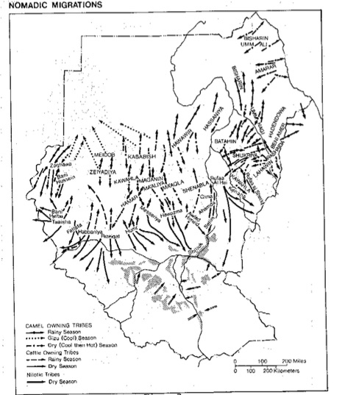
As Abbas et al. remarked (1992) more than 20 years ago, only one out of at least 4 types of herding identified by their research team resembled classical nomadic-transhumance. A new pattern had emerged, growing in intensity over the past 30 years. This new pattern is currently labelled semi- or agro- nomadism (Mohamed and Ahmed, 1991). It is important to stress that this label is broad: the transition resulted in a large diversity of herding schemes, herd management methods and agricultural activities; there is no clear-cut classification of pastoralist patterns (Abbas et. al. 1992).

One result of these recent and novel nomadic patterns was “consolidating camel herds in the hands of a few rich households” (ibid, p. 66). Accordingly, pastoral systems concentrated on specific animal breeding had to be combined with other form of subsistence economy (agriculture) or other strategies such as trade and employment (ibid.).
Currently, many men of nomadic backgrounds, from both poor and rich families, migrate in order to seek employment. The less economically privileged, especially those who do not possess livestock, seek to settle either permanently or temporarily in the towns. Sometimes, the whole household may decide to move, but cases of individual migration are not rare. Those who can afford to go abroad immigrate to the Gulf region in search of employment (UNDP, 2006).
In addition, the expansion of both traditional and mechanized rain-fed agriculture in the southern parts of the region have gradually reduced grazing areas and migration route distances. As a result, many conflicts arise over resources. The shifting of agro-climatic zones southward due to climate change further aggravates the situation. The reduced pasture capacity, combined with increasing numbers of livestock, lead to much confusion in terms of the relationship between tribes and land. The majority of pastoralist groups are operating within a strained ecosystem. Therefore, pasture overgrazing, land degradation and conflicts with local farmers have increased in frequency. The traditional mode of subsistence is being affected by the intervention of mainstream population and conditioned by nature, and in consequence is being jeopardized and losing its practicality (ibid).
Although the viability of the pastoralist system in Sudan is questioned with increasing vehemence, especially after the secession of South Sudan, “pastoralism has always been and remains the predominant system of livestock production in Sudan, making significant contributions to both rural livelihoods and the wider economy” (UNEP, 2013, p. 12).
In the following part of this section, I provide a brief description of the 3 visited communities impacted by the above-mentioned social, environmental and economic changes.
Wad Nourin
On the first day of my field trip, I visited the Wad Nourin community (see map 4) located in Alfaw County, near to the border with Middle Gedaref. According to the 2008 census data, the total population of the county is 175,424 individuals (85,712 male and 89,712 female). All these individuals were considered as having an urban or rural mode of living i.e. there were no ‘nomadic’ individuals inhabiting Alfaw. However, such results are sometimes due to an aversion to census-taking observed among many pastoralist tribes worldwide (Konczacki, 1967).
Although livestock animals were visible in the surroundings, the members of Wad Nourin community would not openly admit to their agropastorialist lifestyle. They claimed to have abandoned pastoralism in the 1980s, after recurrent droughts plagued the state. From that moment, they have purportedly secured their livelihood by land cultivation alone. Tribe members informed me that the land belonged to the community, and that women took part in its cultivation. This information being at odds with their surroundings, I sought further clarification. Ministry officials confirmed what I had observed: the community has a semi-nomadic pattern of subsistence. Officials further explained that its members are reluctant to disclose this information and that the community belongs to the Shukriyya tribe. There was no electricity (apart from the solar panels provided as an e-learning component) and no access to water within the community.
The community comprised around 50 children. According to the community leader, 10 out of 30 school-aged children (3 girls and 7 boys) were going to the nearest school, located 5/6km away. Participation in the e-learning programme meant first direct exposure to conventional education for the 18 participating children (14 boys and 4 girls). It was the first time the community had received education within their community.
Map 4: Location of Wad Nourin community
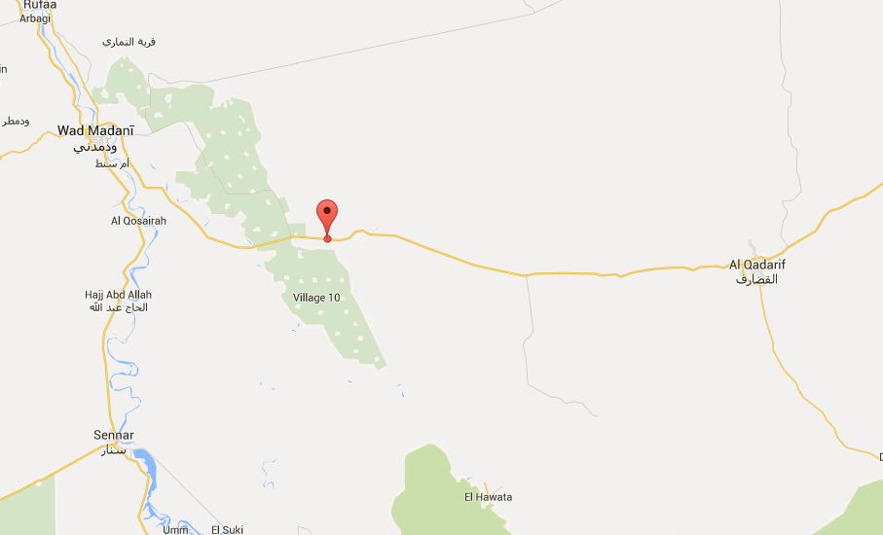

Tayba community
Tayba community, which I visited on the second day of my stay in Gedaref, is located on West Galabat County territory (see map 5). The total population of the county amounts to 91,421 individuals (44,444 male and 46,977 female). Out of this figure, 3,287 citizens (1,870 male and 1,417) have been identified as being of nomadic background (CBS, 2008).
Like the first visited location, the community settled more than 20 years ago. Their subsistence mostly depends on livestock, but they also engage in farming activities. During the rainy season, over the period of 3 months, men (older men and 13-15 year old boys) move to the north in order to graze their animals. According to the community members, the drought negatively affects both community and animal well-being. At the time of research, the nearest water point was 6km away; limited electricity was available owing to the e-learning programme. The community identified as belonging to the Lahaween tribe.
It was impossible to obtain information about the total number of children in the community. The community leader claimed that the exposure of 101 children (51 boys and 50 girls) to the e-learning programme was the Ministry’s first attempt to provide education within the community. According to his statement before implementation of the e-learning project they had been sending boys to one remote school, but this ended because children were too far away from their parents. Girls were not allowed to go for security reasons. However, one of the ministers rectified this statement and explained that previously, there was one attempt to provide education within the community, but it had failed.
Map 5: Location of Tayba community 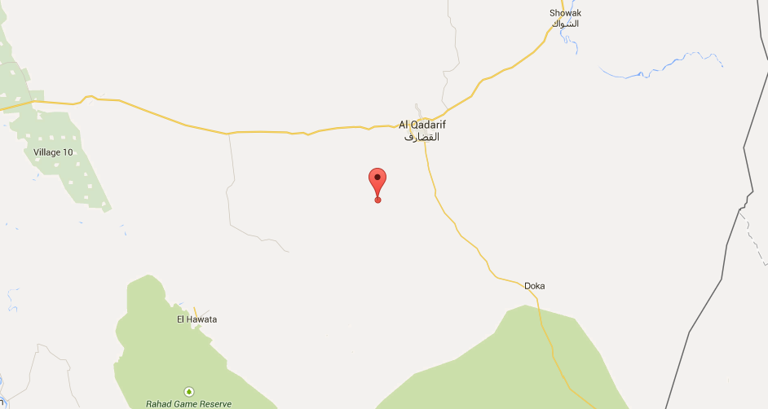
Wad al Khaseet (AlRahad county)
The third visited community inhabited fariq Wad al Khaseet next to the ElHawata locality (see map 6). The fariq is in AlRahad county, whose population amounts to 194,637 individuals (94, 977 male and 99,640 female) out of which 5,271 (2,672 male and 2,599 female) had a nomadic background (CBS, 2008). 2 teachers from Wad al Basheer, a fariq located close by, were also present during the visit.
The visited community was pastoral- nomadic (in strict terms) and belonged to the Kenana tribe. As Arifi has observed (1975), during the dry season, the Kenana tribe used to abandon the central Butana region, which would then remain almost entirely uninhabited (El-Arifi, 1975), and migrate towards the river regions. There they would remain until the rainy season, at which point flies, insects and boggy soil began to disturb the community and their herds (ibid.). These days, the whole community is still mobile, but they now claim that they would like to find an area to settle in.
The older children in this community hadn’t received any education, and their parents were illiterate. The e-learning programme was the first time the community had been exposed to conventional education. The mobile school I visited contained one class, and was opened on 22 January 2015. Although not able to provide the exact number of school-aged children, the community members assured me that the number of children was large enough to ensure an intake of 50 pupils per year.

Map 6: Location of AlHawata locality
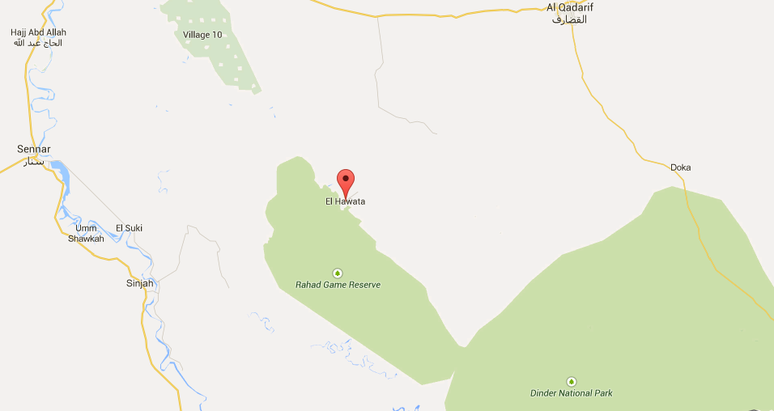
Overall, despite nomadism among camel herders in the Butana region being in sharp decline due to all of the above-mentioned constraints, a considerable number of these nomads (97.1%) remain interested in practising this profession. For the majority, this is due to the social prestige accorded to camel owners, as well as a desire to maintain the tradition of camel herding, which started over 2500 years ago (Majid and Sakr, 1998 in Darosa and Agab, 2008). Moreover, herding sometimes satisfies household needs for food, milk, meat and other camel products (ibid.). A recent study among pastoralist groups in Sudan points to the fact that there are many people who no longer practice herding yet maintain their identity as a member of a pastoralist group (Young et al., 2012).

1.7 Outline of thesis
As stated previously, state-provided education is supposed to help pastoralist children to preserve their culture and identity, as well as to reach their full potential in their particular environmental, social and economic context. In order to assess the successfulness and efficiency of education services in Gedaref, this dissertation is organized into the following six chapters:
Chapter 1 Introduction: comprises the background of the study, statement of the research problem, the study’s aims, detailed research questions, an outline of the thesis and a description of the research area.
Chapter 2 Literature Review: focuses on what scholars, researchers, and government documents have written about development, pastoralists and the provision of educational services to nomads. The issues discussed here are development and understanding of nomads, challenges affecting nomads in terms of access to quality education, and methods used to overcome the problem of low participation rates.
Chapter 3 Conceptual and Theoretical Framework: provides the theoretical and conceptual framework for the study. General conceptualizations of education and processes of socialization are discussed. These are followed by theoretical perspectives concerning different levels of research aggregation (macro, meso and micro levels).
Chapter 4 Research design and Methodology: addresses the epistemology, ontology, and methodology of the research. The philosophical position, the research design and the methods of data collection are discussed in detail. The sample and sampling procedures are discussed, as well as difficulties encountered in reaching the sample. The validity of the research and ethical issues involved are addressed. Lastly, I discuss the challenges I encountered and the lessons I learnt during my fieldwork.
Chapter 5 Findings and Analysis: presents the findings, following the multi-level theoretical framework established for the purpose of data scrutiny. Firstly, the macro perspective is provided (policies, discourses and practices at the state and the global level); secondly, the meso level is discussed according to the Rights’-Based- Approach (RBA), and comprises an evaluation of current programmes designed to target nomadic children; and finally, to complete the micro-level analysis, information gleaned from the community is provided. The synthesizing section marshals all the data in line with the study purposes.
Chapter 6 Discussion, Conclusions, and Recommendations: contains a discussion focused around the research problem, objectives and the research questions. It is guided and framed by the reviewed literature, previously established theoretical framework, and the fieldwork findings. Finally, it presents the general conclusions reached after conducting the research and the recommendations to all different parties interested in the provision of nomadic education.
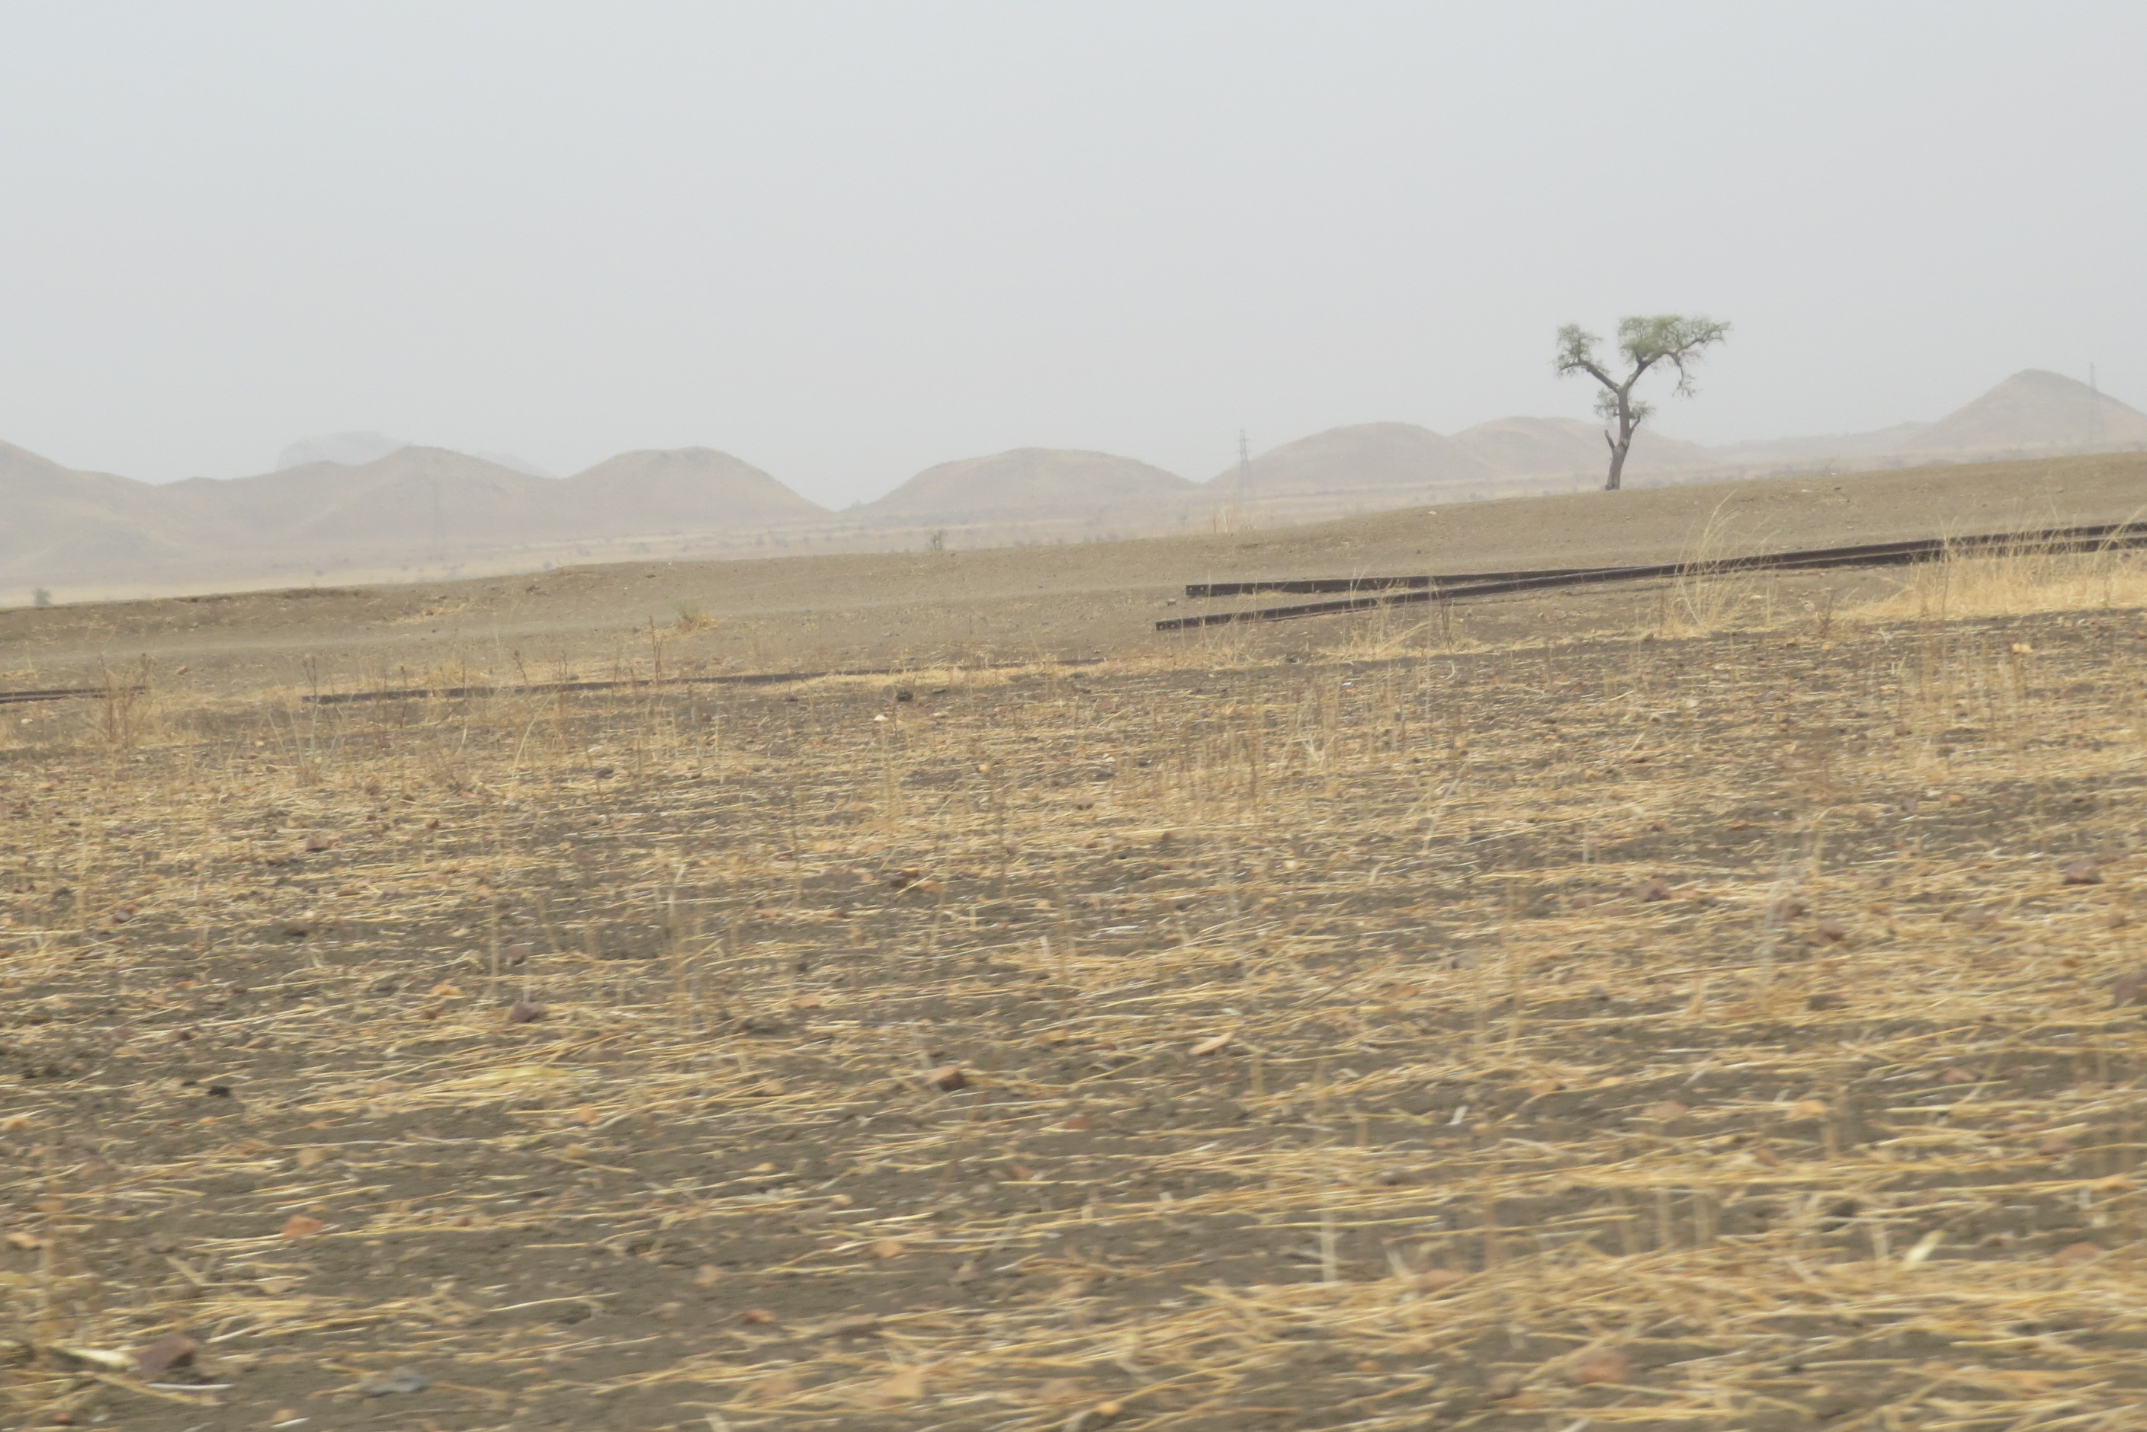
Pic. 2 Dry lands of Gedaref State

Chapter 2

Literature Review: What has been said?

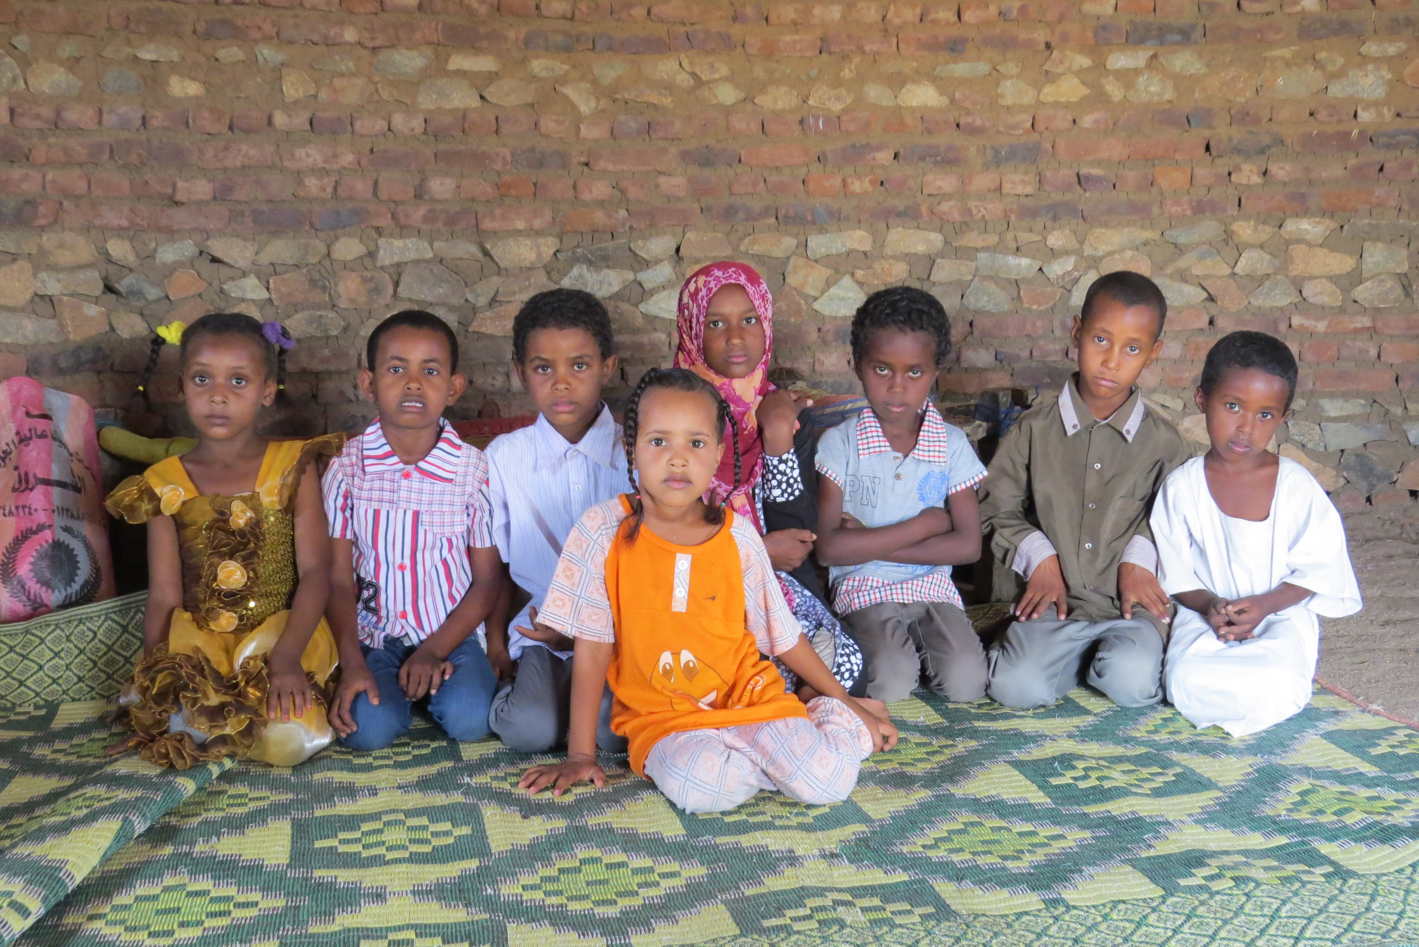

Pic. 3 Learning space in Wad Nourin community

2.1. Introduction
“Education is important for everyone, it is one of the most important means of empowering girls and boys with the knowledge, skills and self-confidence necessary to participate fully in the development process”. (MoE, 2013a, p. 2)

Since the UNHDR 1948 it has been globally acknowledged that access to quality basic education should be guaranteed to every human being, regardless of his or her social position, gender, age, sex and culture. However, only recently have pledges initiated by the EFA led to a new notion of basic education. It has been recognized that conventional provision of basic education is a priori exclusive of some groups within society (Krätli and Dyer, 2009). According to the latest EFA report, nomads and girls do not have the same opportunities to benefit from educational services as other children (UNESCO, 2010). In 2012, an estimated 31 million primary school-aged girls were out of school, and an even larger number of lower secondary school-aged girls were so (UNICEF, 2015).
The especially unfavourable position of nomadic girls is axiomatic, and is evidenced by many different cases worldwide (IFAD, 2012).

The exact number of nomadic OOSC worldwide is unknown. However, their interest in education services has often been very limited. The reasons behind pastoralist peoples’ low participation in educational programmes has been the subject of contentious debate, with an array of different theories emerging. It is important to recognise that simplistic explanations are not possible; many different factors will influence beneficiaries’ response to, and the successfulness of, an educational project (Krätli and Dyer, 2009; Car Hill and Peart, 2005).

Currently, in the light of increasingly harsh climatic conditions, land degradation and obstacles to securing livelihoods in traditional ways, nomadic people are calling for access to knowledge and skills that will enable their children to adapt to the changing world. During the Global Gathering of Women Pastoralists in Mera, in India (2010), participants expressed their appreciation of education and claimed that they are often marginalized within the development agenda. Special attention is being paid to the challenges encountered by girls and young women as they tend to be further disadvantaged by their gender (IFAD, 2012).
Although, in Sudan, there is some understanding of the factors underpinning girls’ – and particularly nomadic or semi-nomadic girls’ – low participation in education programmes, this understanding is not sufficient (Farag, 2013).

This literature review seeks to provide an exhaustive account of the issues linked to the provision of nomadic education, with particular analysis of gender-based issues. The chapter starts at the global level and then looks closely at the particular situation in Gedaref state, where the research was undertaken.

2.2 Nomadic education worldwide

2.2.1 Introduction
There is no single definition of ‘who’ nomads are. Usually, they are defined as socio-economic or ethnic groups who constantly travel and migrate in large or small groups in search of means to secure their livelihood. One of the most commonly cited characteristics of these groups is their strong cultural link to their animals. Animals determine individuals (men’s to be precise) wealth, social status and power (Farag, 2013). These groups tend to be contrasted with settled or sedentary populations who are tied to a fixed location, and who live in villages, towns and cities (…) (Car Hill and Peart, 2005). This distinction is becoming more and more blurred in the light of increasing sedentarization and reduced herding practices amongst those who identify themselves as pastoralists.
In 2005 it was estimated that nomads constitute about 6% of the African population and could be found in no less than 20 African countries. They are generally perceived as disadvantaged and hard-to-reach groups. Their mobility and cultural traits have constituted a particular challenge for development in general, and education in particular (Car Hill and Peart, 2005).
Historically capable of surviving despite harsh environmental conditions, pastoralist women – irrespective of whether they come from a highly patriarchal or more gender-balanced social context – are all currently facing challenges linked to securing their livelihoods, and have requested education services for their children so they may acquire essential life skills and access new opportunities (IFAD, 2012).
In the Mera Declaration, women acknowledge that pastoralist groups have often been marginalized but that attention is increasingly being paid to the issues facing their people. However, consultation with pastoralist groups about their development agenda is mostly non-existent, and where it occurs, is restricted to men only (ibid.).
In the following section, different perceptions of development; and discourses that have had a direct impact on approaches to nomads, development and their education; will be sketched.

2.2.2 Development and nomads
For more than about half a century (1920-1980), pastoral development theories and practices were guided by the assumption that “nomadic pastoralism was an evolutionary cul de sac, environmentally destructive, economically irrational and culturally backward” (Krätli, 2001, p. 15).
The prevailing 20th-century concept of development and progress is responsible for this ‘barbaric’ portrayal of nomads. It was, and often still is, assumed that the ‘primitive superstructure’ in the economic system amongst nomads was adjusted to their ‘primitive’ level of social evolution. Such generalizations about nomadic culture and civilization should be avoided, considering that an array of separate large nomadic patterns with different structures can be traced and identified (Kradin, 2002).
Recently undertaken research has proved these assumptions to have been inaccurate. Indeed, nomadic societies generally have long traditions of sophisticated institutional structures and an exceptionally high level of social capital. Members of pastoralist groups are often very confident with a strong sense of dignity and have good entrepreneurial, negotiating and management skills (Krätli, 2001). Moreover, it is now recognised that pastoralists and agropastoralists are capable of creating means to sustain themselves in ways that also sustain bio-diversity, and in harsh conditions where conventional farming fails (IFAD, 2012).
Historically, pastoralists have also been vilified for their purported reluctance to change; a long-standing, unsubstantiated belief, which has been widely analysed and disproved over the last three decades (Hogg 1982, Rigby 1985 in Krätli, 2001). The fallacy of the assumption lies in the conceptualization of ‘change’. The change that was expected to take place within pastoralist groups was towards modernization, and implied cultural assimilation. Modernisation was conceived as being the universal way of achieving better results and progress. The need for cultural assimilation was due to nomads’ self-government and isolation resulting in central government having difficulties with imposing control on these groups. This then significantly hampers the state building process and challenges the authority and legitimacy of the central government. Nomadic autonomy has been often conceived of as a threat to national order (Hogg 1997 in Krätli, 2001).
However, since the beginning of this century there has been growing recognition of the fact that ‘development’ should be understood as a process that empowers people to achieve freedom, social inclusion, and personal and collective well-being (Sen, 1999). In 2005, a global shift in understanding how development should be understood occurred. The UN General Assembly formally proclaimed 2005-2014 to be a UN decade of education for sustainable development. This concept stems from recognition of the interrelatedness of the most critical social, economic and environmental challenges facing the world. It has been realized that ‘sustainable development’ is not exclusively relevant to the environment, but in fact to all spheres of social progress. Gunter Pauli expresses this as follows:
“We want to respond to the basic needs of all in co-evolution with nature.” (UNESCO, 2007)

Right after this came the United Nations Declaration on the Rights of Indigenous Peoples (DRIP), adopted by the General Assembly in 2006. DRIP sets forth international parties’ specific pledges and commitments towards, inter alia, pastoralist people. Article 8(2)(a) stipulates that:
“States shall provide effective mechanisms for prevention of, and redress for any action which has the aim or effect of depriving them of their integrity as distinct peoples, or of their cultural values or ethnic identities”.
In this context, it is relevant to recall that being able to decide ‘where to live’ is considered a key element of human freedom (UNDP, 2009). Most people move in search of better opportunities. In the modern world, people migrate hoping to combine their own talents with resources in their destination country. Nomads traditionally do so in search of pasture for their animals. In both cases there is one objective: to benefit themselves and their immediate family (Tomei, 2011). Such a migratory pattern is voluntary. Contrary to that phenomenon is forced migration. This occurs when people have to flee conflicts or natural disasters and abandon their houses because not doing so puts their life at risk. The current situation of pastoralist groups rather resembles the latter (IFAD, 2012).

In light of increasingly harsh climatic conditions, the above Mera Declaration of the Global Gathering of Women Pastoralists set forth a rationale for policy makers’ actions to support the development of pastoralism. Point 11 of this declaration contains a message pertaining to the sustainability of pastoralism and the crucial role played by the eco-system in this sphere. The declaration calls upon policy-makers to:
“DEVELOP specific policies that promote the sustainability and welfare of pastoral ways of life and the ecosystems (they) rely on for survival. The policy-making process must include meaningful participation, and consultation, with pastoralist women.” (Mera declaration, point 11 in ibid.).
There is a need to ensure provision of a practical, quality education to all pastoralist community members interested in this service. The critical role education plays in the development process is stressed in the Education for All (EFA) Initiative.

2.2.3 Education For All (EFA)
Basic learning needs . . . comprise both essential learning tools . . . and the basic learning content . . . required by human beings to be able to survive, to develop their full capacities, to live and work in dignity, to participate fully in development, to improve the quality of their lives, to make informed decisions, and to continue learning.
(World Declaration on Education for All, Article 1, Paragraph 1)

The Education for All initiative was launched by UNESCO, UNDP, UNICEF and the World Bank in 1990 during the World Conference on Education for All. All participants pledged to universalize primary education and reduce illiteracy by the end of the decade. This movement was propelled by an unequivocal consensus about the critical role of education. Since the Copenhagen Summit (1995) there has been escalating concern among international stakeholders about the socially excluded, coupled with recognition of the benefits linked to educating females. So, the EFA initiative is grounded in the assumption that learning is the key to sustainable human development and to sustaining all livelihoods. Enhancing learning is deemed to be pivotal in improving quality of life (UNESCO, 2000).
However, in 2000, many countries’ results were far from reaching the expected target. Subsequently, the international stakeholders met once again in Dakar (Senegal) and affirmed their commitment to achieving Education for All by the year 2015. They identified the following six goals:

Education for All Goals
Goal 1
Expanding and improving comprehensive early childhood care and education, especially for the most vulnerable and disadvantaged children.
Goal 2
Ensuring that by 2015 all children, particularly girls, children in difficult circumstances and those belonging to ethnic minorities, have access to, and complete, free and compulsory primary education of good quality.
Goal 3
Ensuring that the learning needs of all young people and adults are met through equitable access to appropriate learning and life-skills programmes.
Goal 4
Achieving a 50 per cent improvement in levels of adult literacy by 2015, especially for women, and equitable access to basic and continuing education for all adults.
Goal 5
Eliminating gender disparities in primary and secondary education by 2005, and achieving gender equality in education by 2015, with a focus on ensuring girls’ full and equal access to and achievement in basic education of good quality.
Goal 6
Improving all aspects of the quality of education and ensuring excellence of all so that recognized and measurable learning outcomes are achieved by all, especially in literacy, numeracy and essential life skills.

Source (http://www.unesco.org/new/en/education/themes/leading-the-international-agenda/education-for-all/efa-goals/
Achieving EFA goals requires finding ways to provide education outside of the conventional system to minority groups, such as nomads (UNESCO, 2000). The framework also recognizes the disparity between men and women in access to education. The EFA thus requires appropriate integration of nomadic children, especially girls, in the education system.
As stipulated in Article 3 of EFA, its main objective is to increase literacy levels worldwide through the adoption of holistic and comprehensive approaches. Programmes are supposed to be innovative in terms of ideas and perspectives on education provision and learning throughout life. The participation of civil society in the formulation, implementation and monitoring of education services is key. EFA does not recommend a particular number of years of study, and nor does it presume that formal education means better education: equal value and emphasis are placed on formal and non-formal approaches. Learning is understood to be a lifelong and commensurate process, encompassing basic knowledge needs of all types (ibid.).
Although the Dakar Framework indicates that some countries, i.e. Arab countries, are expected to face many challenges in trying to deliver on this commitment, the international community has pledged to contribute to national efforts to develop appropriate strategies and mobilize necessary resources. It affirms that ‘no countries seriously committed to education for all will be thwarted in their achievement of this goal by a lack of resources’ (UNESCO, 2000, p. 3). International support shall be provided as long as the government follows the EFA principles for action, which include: comprehensiveness, equity, a learner-friendly environment, commitment to achieving EFA goals, and keeping pace with technological advancements (ibid.).

2.2.4 Girls Education
Since the beginning of the century, recognition of the importance and value of girls’ education has become widespread. Besides recognizing it as intrinsic fundamental human right, it has been realized that providing girls with an education is a ‘critical lever to reaching other development objectives’. Girls’ education is essential for community well-being, helps break the cycle of poverty and has a positive impact on other generations. Educating girls is considered key to achieving quality learning relevant to the 21st century (UNICEF, 2015).
Despite this recognition, as mentioned, an estimated 31 million girls of primary school age were out of school in 2012, and the number was even larger for girls of lower secondary school age.
The critical role played by ‘power relations’ in obstructing girls’ education has only recently been globally recognized. ‘Power relations’ have a direct impact on girls’ participation and evidence thereof can be found at the family, school, community and national government levels (ibid.).

2.2.5 Interpretation of EFA: What the EFA Means for Nomadic Peoples
While the actions of many national programmes and development agencies were and continue to be designed with the aim of satisfying the socio- economic needs of nomadic communities, they are rarely guided by a definite policy or intervention approach. Most of the attempts to provide basic services to these communities have fallen short of meeting the specific challenges posed by their lifestyle (Car Hill and Peart, 2005)
Governments as well as development agencies tend to blame the recipients for the failure of education provision in pastoral areas. Low school enrolment and high drop out rates are attributed to pastoralists’ lack of interest in education, and parental ignorance (Krätli, 2001, p.28). It is believed that illiterate parents are insensitive to, and difficult to persuade of, ‘the value of education’. Different stakeholders involved in the provision of education portray cultural values and widespread illiteracy as primary factors influencing low attendance rates, even after having witnessed the glaring inadequacies in the education system (Krätli, 2001).

Less mainstream understandings of the (non) integration of nomads into the educational system highlights the role played by the government’s perception of nomadism. The political administration is considered to be neglectful of nomads, due to nomads’ weak sense of national allegiance. Accordingly, it is not surprising that in actual terms, services provided to pastoralists are often inaccessible (Krätli, 2001). For nomads, there are inherent difficulties in formal education, including distance, cost, and security. When these obstacles are diminished, nomads have often responded with enthusiasm (Krätli, 2001).
Moreover, ElDood (2010) has observed that while formal education supposedly ‘eradicate[s] poverty by opening access to alternative livelihood options’, this is not necessarily pastoralists’ experience: employment does not necessarily follow from formal education (p. 15). It has further been observed that gender roles and power relations are so ingrained in nomadic communities that without a holistic approach to education, government or international agency initiatives for bringing nomadic girls to school are ineffective. A balance needs to be achieved between two goals: on one hand, adapting content and structure to the reality of nomadic existence; and on the other hand, addressing factors that legitimise pastoralists’ gender-based social norms (Car Hill and Peart, 2005). Research identifies pastoralist girls as the biggest victims of societal marginalization and poorly designed development projects (IFAD, 2012).

2.2.6 Challenges to nomadic education
A) ACCESSING EDUCATION
This section provides an overview of the challenges concerning education service provision for nomadic children worldwide, and includes a gender-based analysis of these challenges. Firstly, challenges encountered by both girls and boys will be illustrated, and secondly, those challenges particular to nomadic girls will be addressed.

I) CHALLENGES COMMON FOR BOTH SEXES

Mobility

Mobility poses a serious problem where education is provided through traditional institution-based educational systems (Krätli and Dyer, 2009). The use of rigid, formal school calendars and daily timetables is incompatible with the inherently mobile nomadic lifestyle: constant migration inevitably disrupts nomadic children’s schooling (Tahir et. al 2005).

Distance

On-site static schools are often geographically distant from pastoralist settlements, which significantly hampers children’s access to education. Girls are especially impacted in these situations because of parents’ reluctance to lose sight of their daughters, let alone allow them to travel to distant locations (Krätli, 2001).

Children’s work
Many scholars agree that the traditional pattern of economic subsistence amongst nomadic societies involves domestic chores by children of all ages. The larger the herd size, the greater the labour demanded of children, as they are perceived as independent workers from a very early age (UNEP, 2013). Indeed, leaving a child without work is considered a sign of parental negligence. In addition, the school experience is often deemed an obstacle to learning how to secure one’s livelihood: a skill that is essential for pastoralists in both practical and cultural terms (Krätli and Dyer 2009, Car Hill and Peart 2005, Tahir 2005).
It is also important to highlight that a pastoralist’s workload will differ, depending on factors such as age, gender and location (Birch et al., 2010). For example, with sedentarization, women and girls’ domestic workload increases, as men are obligated to travel far from home to graze animals (IFAD, 2012).
Fees and cost of education
Gains and benefits resulting from non- informal education are not immediate (Krätli, 2001). Therefore, an obligation to pay fees for education is often discouraging. Due to low levels of liquidity among pastoralist groups, even relatively small cost-sharing schemes often pose problems (Krätli and Dyer, 2009). In addition, even if education is free of charge, the cost of uniforms, supplies, meals and transport surpass some families’ financial capacity (OOSCI, 2014).

Environmental events and conflicts
The pastoralist lifestyle is conditioned by the climate. Unpredictable environmental events such as floods and prolonged droughts obviously have a negative impact on the continuity of the schooling cycle (Krätli and Dyer, 2009). Similar effects can be observed when conflict over land encroachment arises, which influences the group’s mobility (Birch et al., 2010)

Illiteracy
Illiteracy is often presented as a major cause for parents’ underestimation of the value of education. In addition, as far as formal education is concerned, parents’ lack of familiarity with the basic education programme entails their inability to support their children at home (Krätli and Dyer, 2009).
II) CHALLENGES PARTICULAR TO GIRLS

Early marriage and the traditional role of women
The deeply-rooted, common practice of early marriage and women’s traditionally ascribed role within pastoralist communities constitute a huge obstacle to girls’ education (Krätli and Dyer, 2009, IFAD, 2012). Early marriage has a negative impact on nomadic girls’ enrolment and school retention. As a nomadic girl will move to a different household after marriage, paying for her education is not considered a good investment (Roth, 1991 in Krätli, 2001; IFAD, 2012).

Household Strategy and taking second place to boys
Within families for whom pastoralism, perhaps combined with agriculture, remains a viable economic strategy, education is perceived as a ‘plus’. Household members choose to educate one or more children in order to establish links with the city or wider society. Although formal education is provided with the perspective that it is an alternative to the pastoral economy, it appears to be used by pastoralists as a functional addition to their way of life (Krätli, 2001). Boys tend to be selected over girls for such education, due to the lack of employment prospects for pastoral women, even when educated (IFAD, 2012). Similarly, girls take second place to boys and men in precious food allocations (IFAD, 2012), which means they are more subject to hunger. This, in turn, hampers their ability to focus on their studies (WFP, 2015a).
B) CURRICULUM RELEVANCE
In most cases, education systems for nomads rely on standard curricula. These have been developed by the sedentary / mainstream population and are often perceived by nomads as being irrelevant to their experience. For some theorists (Krätli, 2001; Dyer, 2006; Tahir et al. 2005; MONEC, 2003), the lack of specific curriculum is a major explanation for pastoralists’ supposed low interest in education. Krätli (2001) has suggested two ways to cope with this problem: (1) the introduction of relevant topics or (2) the modification of standard subjects to match nomads’ background (Krätli, 2001).
The desired curriculum content varies from group to group and thus needs to be developed in close consultation with the community concerned (Car Hill and Peart, 2005). For instance, parents consulted in Kenya stated that they would like the curriculum to include subjects such as animal husbandry or range management (Birch et al., 2010).

C) PROVISION OF EDUCATION TO NOMADS: CHALLENGES

Budget and funding
One of the main issues with formal education provision is the cost of school construction and maintenance in remote areas (Krätli and Dyer, 2009).

Staff/ teachers
Schools in pastoral areas have a very high rate of staff turnover and the highest rate of requests for moving to other locations. Teachers coming from non-nomadic backgrounds are not impressed by the combination of low salary, isolation, lack of materials and harsh life conditions (MOEST in Krätli, 2001).

Learning materials
Provision of adequate teaching and learning materials to remote locations is costly and time consuming (Krätli and Dyer, 2009).

Legacy
Krätli and Dyer (2009) emphasize ‘difficulties in overcoming a legacy of antagonism to nomads’ livelihoods’. They recognize that predominantly formal education policies have been aimed at achieving cultural assimilation. Therefore, in the eyes of pastoralist parents, school is often perceived as a place where children become irresponsible and absorb alien and negative values and lifestyles (Krätli and Dyer, 2009). In some cases, school is perceived as an option for ‘stubborn’ children or even a method of punishment (Birch et al. 2010)

2.2.7. Strategies And Solutions
Krätli (2001) has observed that attempts to provide education to nomadic peoples stem from two different rationales that may or may not work together. The first rationale focuses on helping an individual to become an accomplished and well-rounded human being, while the second rationale is that of integrating nomads into mainstream society (Krätli, 2001). During the aforementioned pastoralist women’s gathering in Mera, it was noticed that while pastoralist women realize the value of education as a tool helping to save pastoralism, many children see it rather as a ‘bridge’ to escaping their traditional, and currently very harsh, way of life (IFAD, 2012).
In relation to the goal of ‘integration of nomads into mainstream society’, Krätli and Dyer (2009) have concluded that the Millennium Development Goals have narrowed the broad notion of education conceived by EFA to one that exclusively encompasses ‘primary schooling’. Such a reduction has had a negative impact on approaches to the provision of education to nomadic groups (Krätli and Dyer, 2009).
Achieving Education for All, a goal based on the idea that creating equal chances leads to the improvement of one’s wellbeing, does not involve states or international agents distributing a universal educational pattern. Education is a tool for empowering individual and collectives. Accessing ideas, practices and knowledge should serve the ultimate goal of fulfilling one’s potential (Panos, 2007).

- Necessary conditions:

This part of the dissertation contains an overview of types of education, and different methods employed by governments or international agencies to provide nomadic education. As regards the type of education employed, worldwide, the non-formal approach has proved to be more successful and cheaper to implement than the formal approach (Krätli and Dyer, 2009). Nevertheless, a few formal education programmes have been implemented with some degree of success. Provision of the service within an environment that was non-antagonistic to nomadic culture turned out to be essential for attracting nomads (Krätli, 2001). According to Krätli (2001), in order to receive a positive response from beneficiaries, formal programmes had to be free of charge, and needed to be provided within the existing education structure. Concomitantly, children had to be significantly freed from their traditional tasks and household chores. Programmes had also to correspond to the existing pastoral ideology. Tahir et al (2005) observe that making the benefiting community the major stakeholder of all education development programs is key to ensuring its success. Ismail (2002) has noticed that many researchers stress the need to establish a special education system for nomads, with specific indicators, and which is adjusted to their way of life (Ismail p. 8 in ElDood, 2010). In addition, ElDood observes (2010) that appropriate funding is key to achieving EFA among nomads (this being contingent on countries’ demographic, economic, political and educational circumstances, and the extent of private financing available) (ElDood, 2010).

b) Modes (methods) of delivery:

Although the type of education implemented (formal/non-formal) is often interlinked with or conditioned by modes of delivery, such a correlation is not imperative (Car Hill and Peart; 2005).
Different modes of delivery have been proposed to or adapted by nomads. Generally these can be clustered into two groups:
(1) Conventional delivery by means of fixed permanent schools; and
(2) Alternative modes or forms of delivery, which include (settled) boarding schools, (mobile) mobile schools, boat schools (Tahir et al. 2005) and distance learning.
Taking into account the scope of methods adopted at the global level, an overview of on-site schools, boarding schools, mobile schools and distance learning will now be provided.

- On-site schools
On site schools were used, for instance in Nigeria. Research suggests that these structures correspond to the needs of those nomads who have settled already, or who envisage doing so. In Nigerian case these were conventional permanent structures in the form of a cement block of classrooms. Tahir et al. (2005) points out that their provision is based on the premise that education’s ultimate aim is to settle and fully integrate nomads into mainstream society.
One attempt to make these ‘fixed’ schools more attractive was the introduction of a school-feeding programme. The UN World Food Programme was organised in order to encourage school retention (Car Hill and Peart, 2005).

2) Boarding Schools
A boarding school system is a priori an ideal solution allowing children from distant nomadic settlements to benefit from stable education. Such was the case in Mongolia. A boarding school project was launched in 1940 in order to raise literacy levels and the general educational level in a country where about 50% of the population was comprised of nomadic pastoralists. The system relied on hundreds of schools with dormitory facilities. Education was entirely free and investment was at approximately 15% of GDP. This investment made it possible to hire well-trained and highly motivated staff. Most of the teachers came from a nomadic background. Although the curriculum was not relevant to the pastoral way of life (MOSTEC, 1999 in Car Hill and Peart, 2005), within twenty years of the programme being implemented, Mongolia passed from 2% to more than 90% basic literacy (Krätli, 2001).

3) Mobile Schools
Mobile schools have generally used specially constructed tents, temporary shade under trees, or thatches staffed by teachers who move with the nomads during migrations. This mode of delivery has been used in both formal and non-formal types of education. The tent schools of Iran are a successful example of mobile schools. There, the mobile schools followed the standard national curriculum, but the methodology was very different, being based on flexibility (Car Hill and Peart, 2005). The mobile school mode was also applied in other countries, such as Nigeria. With some curriculum and education strategy adaptation, the government introduced the model during the 2002-2003 period. Since then, over 700 mobile collapsible classrooms for pastoral nomads have been provided to nomadic primary schools in Nigeria’s Sahel and Savannah zones (Tahir et al. 2005). A further example of the mobile school system can be found in Kenya; these schools operate outside of the mainstream education system (Birch et al., 2010).
Although this may seem an ideal solution, mobile schools have encountered problems with the design of the collapsible classrooms (made of canvas and light aluminium props) in addition to a lack of financing for the supply and maintenance of an adequate numbers of tents, as well as non-nomadic teachers’ reluctance to travel and thus effectively lead a nomadic lifestyle (Tahir, 1997 in Car Hill and Peart, 2005).

d) Open and Distance Learning (ODL)
ODL is an umbrella definition introduced in the 1990s to describe both distance education and open learning work. Both methods are designed in order to provide education to those who are ‘hard- to-reach’ and are justified on pragmatic grounds, i.e. traditional full-time contact education is at odds with the living conditions of the prospective students (Krätli and Dyer, 2009). Although this approach to education can theoretically be integrated into all dimensions of formal and non-formal education, international stakeholders, including Sudan, have thus far seen it rather as a tool to provide non-formal education.
Distance education is defined as ‘an educational process in which a significant proportion of the teaching is conducted by someone removed in space and/or time from the learner’ (Perraton, 2007). Open learning is understood to be ‘an organised educational activity, based on the use of teaching materials, in which constraints on study are minimized either in terms of access or of time and place, pace, methods of study, or any combination of these’ (Perraton, 1997 in Perraton, 2007, p.12).
Several countries have attempted distance education through radio. Research suggests the most successful example of this for nomadic populations was the 1996 UNESCO adult education project in Mongolia, which targeted nomadic women in the Gobi desert (Robinson 1997 in Krätli, 2001).
Generally, a key driver for ODL policies has been the promise of reducing per-student costs, with the use of technology as the solution. However, in most cases, the actual costs of distance education programmes have been equal to or higher per capita than those of conventional education (Perraton, 2007). Many specialists point to the fact that over-optimism about an ODL approach should be avoided as programmes do not have to be necessarily well-designed or successfully implemented.
Worldwide, programmes designed to increase nomadic children’s participation in educational systems have tended to attract more boys than girls (Car Hill and Peart, 2005; IFAD, 2012).

2.3 SUDAN

2.3.1 Nomads in Sudan
According to the 2008 Sudan census, nomads represent 8.9% of the total population of the country. Warning must be given concerning these statistics as they represent estimations rather than facts. This census is also crucial to illustrating the perception of nomads by mainstream society. The UNEP Standing Wealth study (2013) points out the fact that the description of nomads in the given census depicts mobility as an outstanding feature of pastoralists and establishes clear opposition between sedentary and nomadic lifestyles (Elamin Ahmed and Abdel Rahman 2008, p. 454 in UNEP, 2013, p. 23.) This ‘othering process’ in our understanding of nomads has had a direct impact on the approach adapted by the government towards nomadic communities and their marginalization. In fact, the policy of the GOS has generally been oriented towards their sedentarization (ElDood, 2010).
In order to understand the dynamics between the State and pastoralist communities, the following part of this section will include a brief overview of the development process in Sudan and its repercussions on nomadic communities.

2.3.2. Development and marginalization of nomads
El Arifi (1975) has observed that as the migratory aspect of life and transitory character of pastoralist settlements have been seriously obstructing the customary provision of social services, the government’s development strategy has been oriented towards their sedentrization. According to ElDood (2010) this trend, characterized by the conceptualization of settlement as a panacea to all problems, has been predominant in the discourse of both governments and development agencies.
As reported by Babiker (2011) pastoralists and agro-pastoralists were marginalized and suffered from resource alienation due to the mainstream historical obsession with large-scale mechanized crop production that was incompatible with forms of subsistence for nomadic communities. This marginalization was highly discernible in the disputes over the Ethiopian/Sudanese boundary, in which commercial farmers were asked to participate but herders were omitted.
In addition, the failure to consolidate land entitlements has resulted in tensions between farmers and nomads. However, as noted, historically, these tensions would not have led to conflicts. In fact, disputes over pastoral corridors and land rights between the two groups only recently emerged, due to severe droughts and dwindling resources, and sporadic land encroachment by animals and herders for grazing purposes (UNDP, 2006a).

Sudan has one of the largest and most species-diverse livestock populations in Africa and the Arab region. Livestock supplies the nomads with their basic needs: milk, meat, wool, hides and skins. They are also the main source of cash income used to buy other goods such as grain, sugar and clothes (FAO, 1997).
Recently, well-deserved recognition of the value of livestock production occurred. According to recently published data, nomads raise 95% of Sudan’s animal resources and contribute significantly to the country’s GDP (17% of the total amount) (MoE, 2013b). The recognition of the value of pastoralism tends to occur in conditions where it cannot be ignored, i.e. economic and humanitarian crises.

2.3.3. Development and women
The gender relations in Sudan are complex and diversified. Currently, the Sudanese Constitution stipulates that women are equally entitled to all civil, political, economic, social and cultural rights (AEO, 2014). However, gender dynamics imposed by the British colonial power have had a significant influence on Sudanese society. As only men were included in their system of rule (public and productive sectors), patriarchy was strongly reinforced, thus precipitating women’s decline in political power. In 1992 (UNDP), at the national level, gender inequality was noticed in formal education, political decision-making and occupational spheres. For instance, the literacy rate of men above 15 years of age was 43%, while that of women was 12%. The proportion of women in the national labour force was 29.1% (in Grawert, 2007).
Engagement in politics was largely a male domain, although elderly women’s advice is also accepted.
While employment opportunities for women have existed mostly in towns, unpaid agricultural work by women prevailed in the countryside. In Northern and Central Sudan, women’s labour contribution has generally been marginalized in farming and nomadic communities (Holter, 1993 in Grawert, 2007). The women lost control over the food supply, which had previously guaranteed them an important position in the household. Generative, socializing and reproductive obligations traditionally imposed on women remain almost unchanged and have been limiting women’s chances of obtaining professional qualifications and/or earning a substantial share of the family income. As a consequence, women have become financially dependent on men (Bernal, 1988 in Grawert, 2007).
From 1969, the Sudanese Socialist Union (SSU) engaged in its mission to built up a cadre of modern educated women, however, this attempt did not succeed in reaching the majority of rural women and failed to reverse the subordination of women. The social status of women in Sudan is generally dependent on the husband’s position. As such, in order to gain full social recognition, women have to marry (Grawert, 2007).
In order to tackle obstacles encountered by women in the highly patriarchal context of Sudan, a positive discrimination policy has been applied to leverage female capital.

2.3.4 Services in Sudan
For more than a decade, Sudan has been affected by a protracted crisis that has hampered provision of basic services by the GOS. This crisis emerged as a consequence of an array of intertwined factors. Firstly, borders issues with South Sudan resulted in substantial economic instability and conflicts in Abyei, Blue Nile and South Kordofan. The country has hosted more than 100,000 South Sudanese refugees fleeing the conflict in their country. In Darfur, millions are still displaced, with most of those individuals living in camps to this day (UNHCR, 2015). What is more, North Darfur, Kassala and the Red Sea region endure erratic rainfall, and scarce land and water resources. Access to safe drinking water is very limited in many parts of the country. Added to all of these factors is an extremely low level of basic infrastructure (ALNAP, 2009).
Moreover, it has been observed that the availability of services is conditioned by service providers’ allegiances to the government. For instance, there is one hospital per 115,000 people in the formerly government-controlled areas of the state, compared to one per 800,000 in former Sudanese People’s Liberation Movement areas (SPLM) areas (ibid.).

2.3.5. Education in Sudan
Sudan is a signatory of EFA and MDG goals, and is thus committed to ensuring that by 2015 all children, boys and girls alike, are ‘able to complete a full cycle of primary education and gender parity is achieved at all levels at schooling’ (MoE, 2013a, p. 2). The commitment of the Sudanese government to provide free basic education to everyone is influenced by the guiding principles of the Education for All initiative (MoE, 2013b).
Aside from the obvious benefits stemming from knowledge acquisition, the education of Sudanese children is nowadays considered one of the most important investments the government can make in terms of economic, cultural and social gains (ibid.). The fact that the government of Sudan understands that education is crucial for poverty reduction and the improvement of living standards is reflected in its commitment to EFA, CRC and MDG goals (ElDood, 2010).

a) General educational approaches and policies in Sudan

As already stated, educational approaches in Sudan are underpinned by the government’s commitment to international declarations such as EFA or MDG 2&3. The endeavour to provide educational services to all children has resulted in the stipulation that education should be non-discriminatory, free and compulsory.
However, currently, approximately 2.6 million primary school aged children (6-13) – that is to say one third – of children in Sudan are out-of-school. This is mainly attributed to the Sudanese government’s very low expenditure on education. According to data in the Education Baseline Survey 2008, government participation in non-salary elated expenditure was hitherto only 1%. Community contributions amounted to 89%, and other sources provided the remaining part of the share (OOSCI, 2014). In 2010 (ElDood) Sudan spend less than 2% of its GDP on education. This was the lowest investment in education within the sub-Saharan area. According to Mirghani & Alhassan’s estimations (2007), 19% of the government’ public expenditure and 6% of GDP are required in order to be able to achieve the primary education MDGs (ElDood, 2010).
Table (8): Public expenditure on education – Per cent
Indicator | 2002 | 2003 | 2004 | 2005 | 2007
% of education expenditure from public expenditure | 4.6 | 4.2 | 3.7 | 2.9 | 2.8
% of ed. Sector from GDP | 0.6 | 0.7 | 0.8 | 0.8 | 2
Source: Ministry of Finance - Education Base line survey, 2008

b) Structure and administration
The following section provides an overview of the current structure and administrative system in Sudan. The general education system comprises basic and secondary education. Children can join preschool education at age 4. This is offered by both kindergartens and traditional Islamic schools, called khalwas. It is available over a two-year span and is neither free nor compulsory. Basic school education starts at the age of 6, and continues for eight years (grades 1 to 8). This has been compulsory since 1998. It is divided into three stages: grades 1-3, grades 4-6, and grades 7 to 8. At the end of grade 8 pupils sit the final exams, and if successful, receive the basic education certificate (UNESCO, 2012).
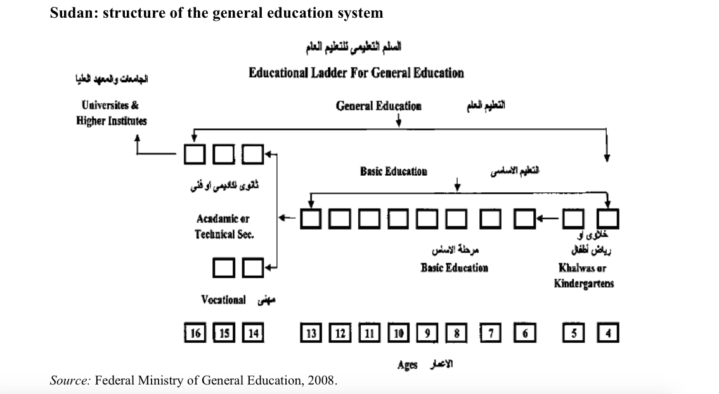
Illustration 1

2.3.6 Girls’ education in Sudan
The MoE in Sudan perceives educating girls and women to be crucial to economic development. It also brings many social benefits (MoE, 2013a). For instance, exposure of women to a few years of basic education reduces infant and under-fives’ mortality (SHHS, 2006 in ElDood, 2012). Since 2007, a national strategy for girls’ education has been in place to bridge the gap between girls and boys participation in the educational system. As a result, over the last decade, the female-male gender parity index increased to 94% at the secondary level and to 105% at the tertiary level in 2011.

However, in primary education, girls constitute 52% of all out-of-school children. The differences in their enrolment trends depend on whether they are displaced; had a rural, urban or nomadic background; household wealth; and age. The major challenges preventing girls from enrolling are poverty, cultural barriers, learning quality, school-based issues and insecurity. For instance, Kane (2004) has found that girls are more sensitive to school quality and more influenced by the teacher’s character (USAID, 2008 in Farag, 2013). It has been also noted that parents with low income tend to educate boys rather than girls. Many low-income households rely on their children’s labour, with girls being responsible for daily chores, and boys being responsible for providing supplementary income (MoE, 2013a).
According to the latest statistics, at the national level, the general GER for girls in basic education (6-13) is 67.4, while it is 71.8 for boys. The gap between the two groups (4.4) is noticeable, but is not particularly flagrant.

However, a huge gap is apparent between nomadic girls’ national GER and general boys’ national GER (aged 6-13). According to the latest statistics, 68,985 out of 270,720 nomadic girls are enrolled in schools, resulting in in 25.4% GER while 2,796,264 out of 3,816,170 general boys are benefiting from the same service, resulting in 73.3% GER (see table 1 and 2). Therefore, there is a gap of 47.9% between the general enrolment of boys and that of nomadic girls.
As will be further explained (at 2.3.9), there are several reasons why nomadic girls enrol less and drop out more often than boys.

2.3.7 Nomadic Education in Sudan
Attempts to provide education to nomadic communities in Sudan had already been undertaken more than half a century ago, but no serious attempts were made until the 1990s, when the Government of Sudan (GOS) adopted the Jomtein Declaration (ibid.). Increasing enrolment among nomadic groups has been observed since the year 2000 (see Annex 1, table 6).
Despite this history, according to a 2012 survey of members from Government institutions, international actors and non-state actors, a lack of educational services and poor investment in human capital constitute the major challenges facing pastoralists in Sudan (Young et. al, 2012). As at the global level, in Sudan, many factors have led to such a situation. These include nomads’ lack of impact at the policy level and policy makers’ negative attitudes towards the education of nomadic children (ElDood, 2010).
A different rationale for the provision of education to nomads can be traced back throughout Sudanese history. The prevailing approach has been that of cultural assimilation:
“[T]o equip nomad children to earn outside the community they were born into” (Save the children Fund / SCF, 2000, p. 38 in ElDood, p. 15); or
“[To] enable them to assimilate the national outlook and their cultural heritage, to fulfil their civic duties, to gain their rights and privileges, and to increase their productivity” (Suleman and Khier, 1997; Krätli, 2001 in El Dood, 2010 p. 12).
The structure and policies concerning basic nomadic education are exactly the same as the general education ones. Accordingly, nomadic education is organized according to a decentralized three-tier system of general education based on the following units: (1) mahalyas (localities), (2) state ministries of education, and (3) the federal Ministry of Education. In general, responsibility for formal pre-secondary and secondary education lies with the first and second tier, respectively. The federal ministry is responsible for planning, policy, training, educational research, curriculum development, monitoring the quality of instruction and learning, and coordination of state Ministries of Education (ibid.).
In 2000, a special body within the federal Ministry of Education and its respective branches at the state level was established to promote the education of nomadic children. In line with the previously mentioned rationales, the goal of The Department of Education for Nomads has been to provide pastoralists with educational opportunities and enable them to contribute effectively to the development of the nation (Farag, 2008). Its target has been to integrate 99% of pastoralist children into the educational system by 2015, paying special attention to girls (Young et al., 2012).

In parallel to the official education institutions, other types of government schools and institutions provide education, namely, religious institutions, vocational training centres, and ALP centres (OOSCI, 2014).

Education Sector (Civil Society Organisations, International NGOs and UN agencies)

Nomadic education in Sudan is a collaborative effort involving the participation of the MoE, the nomadic community, and – significantly – UNICEF (ElDood, 2010) and other education sector partners.
However, UNICEF support is not provided across the whole territory. Areas of interventions depend on the number of OOSC and the availability of funds, as per donor-imposed conditions (ibid.).
Since 2004, aid agencies they have played a very important role in development and humanitarian assistance in Sudan (ALNAP, 2009). Browne (2005) observed that, for instance, mobile school projects implemented in Darfur by Oxfam achieved a greater degree of success than did the government (Browne, 2005).
However, in March 2009, the government of Sudan expelled 13 international NGOs and revoked the licences of three national NGOs. Subsequently, in June 2012, Khartoum decided to ban the four hitherto remaining aid agencies in eastern Sudan. According to the Humanitarian Aid Commission (HAC), this decision was justified by the NGOs’ failure to implement the projects, and, indeed, project weakness (BBC, 2012). This situation has severely affected the scope of humanitarian aid, as well as its coordination mechanisms. In addition, bureaucratic impediments are rendering the implementation of new projects very slow, including such basic requirements as the recruitment of international staff and the finalisation of technical agreements (ALNAP, 2009). At the same time, international donors are often afraid to entrust their money to unknown local NGOs that have limited capacities.
In this context, it is relevant to mention that the humanitarian community in Sudan has been perceived as partial, due to its focus on IDP populations in camps, and a concomitant tendency to neglect the needs of some pastoralist groups. It has been recognised that aid agencies need to ensure that their responses are based on objective needs assessments (Young et al., 2009b).
According to a recent study carried out by Tufts University (2012), there are 4 NGOs at the national level dedicated explicitly to pastoral matters. However, their primary concerns do not encompass education. Only the AlMassar organisation seems to be actively involved in educational service provision. With regards to UN agencies and international organisations, it has been observed while some of their programmes target nomadic children, these children are usually included in general programmes, which are not adapted to the specific nomadic needs (Young et al., 2012).

2.3.8 EFA & Nomads in Sudan: What accounts for low enrolment?
Farag (2013) states that ‘it may be argued that nomadic children’s educational needs, ambitions are left unsatisfied due to negative parental attitudes towards education due to failure of the parents to meet the educational expenses of their children.’ (p.77). However, this explanation fails to consider the role – or lack thereof – of the nomadic voice, in determining what those educational needs and ambitions are.
In Sudan, the special needs of nomads are rarely taken into account. According to Tufts (2012) findings, although programmes include a specific number of target nomadic children among the beneficiaries, there is no clear indication of how an adaptation of the service to pastoralist groups will be carried out. Most of them expect nomadic children to attend normal on-site static schools (Young et al., 2012).

Challenges
a) COMMON FOR BOTH SEXES
Like observed worldwide, in Sudan nomadic mobility renders the provision of educational services difficult (ElDood, 2010). Although the majority of pastoralist tribes in Sudan have a semi- nomadic (Farag, 2008) rather than a purely nomadic lifestyle, even this poses serious challenges: the seasonal movement of boys in order to herd the animals, for example, precludes the use of fixed school locations. According to the findings of ElDood’s study (2010), less than 17% of nomadic schools have met the official number of required school days. Schools are often located in areas that are far from nomadic communities (4-5 km). Child labour is required by nomadic societies in the majority of circumstances and the division of work tends to be gender-based. Boys learn to herd animals from the age of 4, while girls start to be involved in household chores from the age of 7. The female child’s work is usually perceived as preparation for serving her future husband and his family (MoE, 2013b). Research suggests nomadic girls’ workload to be bigger than that of nomadic boys’ (ElDood, 2010).
According to the official general education policy, school fees should not be charged in nomadic schools. In reality, parents tend to be obliged to pay for hidden school fees and school exam fees. Parents usually have to contribute to school activities such as building classes, paying for teacher incentives or even for water. For these reasons, several schools lack basic learning materials such as textbooks, copy books, pens, and pencils (ElDood, 2010). Further, a lack of running water and toilets has a particularly negative impact on school attendance for older girls, who often miss school during menstruation (Oxfam, 2005).
Moreover, the indirect and direct costs of schooling seem unreasonable to many parents, since the benefits arising from education are not evident for a long time (ElDood, 2010). Envisaging future employment prospects to be meagre, especially taking into account the labour-market situation in Sudan, parents are often reluctant to invest in children’s, and especially girls’, education (Farag, 2013).
In addition, research indicates that there is a powerful correlation between parental illiteracy and children’s participation in educational programmes. Illiterate parents are more reluctant to invest in children’s education. They also cannot help their children with their homework. The illiteracy rate among nomadic parents in Sudan was at 75% in 2010 (ElDood, 2010).
What is more, a study carried out by ElDood (2010) indicated that unpredicted closing occurred in around 7% of the visited schools. Among the most common reasons for this were insecurity or lack of teachers. Additionally, spontaneous migrations due to environmental conditions, or conflicts with the farmers, affected school operations.
b) PARTICULAR TO GIRLS
The dominant social system among nomads in Sudan is patriarchal. Although nomadic women in Sudan have significantly more responsibilities in terms of securing the community’s livelihood, their position has traditionally been inferior to that of men (MONEC, 2003). The majority of nomadic men show a strongly patriarchal attitude towards females, seeing women as child-bearers and valuing them in terms of their domestic role only (Farag, 2008, Farag, 2013). Highly intertwined with this perception of women is the practice of early marriage, a deeply rooted tradition that has a negative impact on nomadic girls’ school enrolment and retention (Farag, 2008). There are discrepancies between different sources’ accounts of the age at which girls get married. According to a 2008 UNICEF evaluation, early marriage is common among 10 to 13-year-old girls (Farag, 2008), while one recent NGO proposal suggests that the practice applies to 13 to 15-year-old girls. Another recent source (Farag, 2013) suggests age 12-15 .In any case, it is clear that the family’s economic situation has a direct impact on whether a girl will marry early or not. Girls from the poorest families are more than three times more likely to get married before reaching the age of 18 than girls from the richest stratum (Plan Sudan, 2013). The (2010) ElDood’s study, which was carried out across Sudan, noted that more than 80% of respondents of the study were married before reaching the age of 20.

In sum, there are extraordinary obstacles in the way of girls receiving an education, and thus it is hardly surprising that low rates of female education are evident in conventional education structures (Farag, 2013). As indicated, certain obstacles to both girls’ and boys’ enrolment are especially detrimental to girls, including the remoteness of schools, poor school conditions, parental attitudes and lack of money. Moreover, given the strong patriarchal structure within nomadic communities, women have no authority to influence family decisions about who goes to school. When widespread early marriage practices are also taken into account, low rates of female enrolment and retention are to be expected.

II) Provision: Identified problems

In the following sections methods designed to ensure education among nomads in addition to the identified problems linked to its provision will be discussed. The Ministry of Education acknowledges many of these obstacles and develops a 4-year strategy in order to increase participation on nomads in the educational programmes (see Annex 1, table 3).

Staff and teachers
Ideally, a nomadic child’s teacher should come from a nomadic background. If this condition cannot be met, he/she should be interested in nomadic education. However, the generally low education levels among pastoralists mean that it is difficult to recruit pastoralist teachers for mobile schools (Oxfam, 2005). As a result, many teachers are poorly qualified in terms of their comprehension of the nomadic lifestyle: a third of teachers are not trained on the pastoralist lifestyle, while those who have received the two-week training on this issue consider it insufficient (MoE, 2013b).

In addition, a strong personality, tolerance, adequate qualifications and appropriate training are all necessary in order for the teacher to provide knowledge and create change (MoE, 2013b). However, many teachers are poorly trained in general terms. Improving recruitment, deployment, utilization, remuneration and supervision of all teachers in Sudan is critical to the efficiency and performance of the education sector (OOSCI, 2014).
Furthermore, the patriarchal structure of society means that in several states, parents are hesitant to send their daughters to school with a male teacher (Farag, et al. 2008); this means that female teachers are more likely to ensure female enrolment and retention.

Perceptions about the service providers
The low government expenditure has obviously been remarked by nomadic communities and influences their perceptions of service providers. In fact, a study conducted by ElDood (2010) indicates that there is certain level of frustration among parents and community leaders in relation to the current nomadic education system. The government has been seen as lacking commitment to creating educational opportunities for nomadic communities. The magnitude of the challenges and problems differs from one factor to another and definitely between states.

Statistics
Quality, up-to-date education statistics are provided via the Education Management Information System (EMIS). This system is still relatively new, having only been introduced in 2009, and its disaggregation is limited to state, gender and age. Accordingly, it provides no information on children’s backgrounds (nomadic or otherwise). Sudan thus lacks specific, quality data concerning nomadic education (Oxfam, 2005) due to the shortcomings of this data collection system (OOSCI, 2014).

III) Curriculum Adequacy
In Sudan, “nomadic children are taught the national curriculum for basic school to ensure future competition for higher educational places and creating good Sudanese citizens for their major contribution in the development of the country” (MoE, 2013, p. 14). These Ministry goals were developed by the sedentary mainstream population, and are often perceived as irrelevant to nomads’ experience. The lack of a specific curriculum has become one of the major explanations for pastoralists’ supposed low interest in education (ElDood, 2010; MONEC, 2003).
Non- formal education: Alternative Learning Programme
The Ministry of Education’s National Council for Literacy and Adult Education is in charge of implementing the Alternative Learning Program (ALP) for out-of-school children who have never attended school, who have left school, or who cannot be mainstreamed into the formal education system without catch-up lessons. The ALP is focused on numeracy and literacy to enable children’s re-integration into the appropriate level of the formal system. In addition, life-skills and vocational training are provided to out-of-school children and youth (OOSCI, 2014). ALP centres follow the official curriculum created for out-of-school children and adults (War Child, n.d). Proportionally more girls then boys are targeted by the ALP (Moe, 2013b).

IV) Methods
The following paragraph presents modes of delivery aiming at ensuring pastoral education in Sudan. Strengthens and weaknesses of existing nomadic education institutions were identified and clustered by the AlMassar Organisation in 2003 (see Annex 1, table 4). In the following section, particular methods designed to ensure suitable, lifestyle-adjusted formal or non-formal education for pastoralists will be presented.
- Mobile Schools

Historically, the most outstanding nomadic school in Sudan was founded by Hassan Nagila in 1932 in Dar Kababish at Hamrat Elshiek in Northern Kordofan. Nagila was a pioneer in the provision of education that was flexible in time schedule, place, method and content, and therefore appropriate for nomads (MONEC, 2003). However, this initiative was unique and small in scope.

The first large-scale use of the mobile school system corresponds to the first serious attempt to educate nomads (ElDood, 2010) The programme started in 1993 and its objective was to set up 76 mobile multi-grade schools offering four years of basic education for approximately 15,000 children in Darfur and Kordofan States. When the nomadic education project started, the enrolment rate of nomadic children was very low (5% for boys and almost 0% for girls). In 2002, the initiative was expanded to cover nomadic communities in a further eight states in East and Central Sudan: Kassala, Red Sea, Gedarif, Blue Nile, White Nile, Sennar, River Nile and Northern States (Eldood, 2010). Although the project has brought some pastoralists children to school, results achieved thus far are considered unsatisfactory.

Theoretically, the mobile school model seems to overcome obstacles linked to the nomadic lifestyle, such as a lack of mobility, and remoteness from formal institutions. However, its success will of course depend on how such a programme is designed and implemented. The current multi-grade model approved by the government does not encompass complete primary school curriculum. The mobile schools are ‘fourth grade schools’, that is, the curriculum covers the first to the fourth grade, with all pupils learning together (Farag, 2008). As a consequence, few nomadic children continue their education for more than four years (Aikam, S and H; el Haq in Oxfam, 2005, p.5). The existing nomadic education system requires the establishment of central schools with boarding facilities to cater for nomadic children beyond Grade 4 (OOSCI, 2014). In 2010, out of 289 schools surveyed, only 10.4% were mobile schools (ElDood, 2010).
There is a very strong structural similarity between the mobile school systems introduced in Sudan and in Nigeria: both assume that mobile school is only ‘a transitory process’ to enable students to pursue higher education in another structure (formal ‘on-site schools’ in Nigeria, and boarding schools in Sudan).
Moreover, Sudan’s mobile schools were eventually renamed ‘on-site schools’ (Farag et al. 2008 in Farag, 2013, p. 83). While Dyer and Krätli (2009) conceptualize the ‘on-site’ mean of delivery as a ‘non-formal’, these structures fall under ‘formal education’ in the Sudanese context. Therefore, on the global level, there is a lack of consistency in how terms such as ‘on-site school’ or ‘mobile school’ are used.
b) Boarding schools
After finishing their 4 grades of education in a mobile school, children are supposed have the opportunity to join a central complementary school with boarding facilities. Although such schools were suggested at the beginning of the nomadic education programme, and indeed still constitute an integral part of the nomadic education strategy (2013b), no boarding schools have been officially opened by the government in the past 20 years. Local communities have established some boarding schools with government support in the River Nile, Northern and Red Sea regions. According to teachers, a lack of boarding facilities turned out to be the most dominant factor causing children to drop out. In 2010, out of 289 schools surveyed, only 0.7% of village schools had boarding facilities (ElDood, 2010).
c) Open Distance Learning
In Sudan, there is currently one programme that falls into the distance learning and non-formal education categories, namely, the E-learning programme. Piloted over the last year and a half, it aims at reducing the number of out-of-school children. It is conceived as an alternative option to formal primary education for children who have never attended school. The project was launched by UNICEF, in collaboration with War Child Holland, Afhad University for Women and the National Council for Literacy and Adult Education.
E-Learning is designed to respond specifically to the challenges of reaching children who are usually excluded from the formal education system. Semi-nomadic children represent more than 70% of participants. The intention is to provide quality education to the child with little or no intervention by a teacher, as with new technology, a teaching component can be embedded in the programme itself.
The project follows JISC’s (2013) definition of eLearning as:
“... 'learning facilitated and supported through the use of information and communications technology'. It can cover a spectrum of activities from the use of technology to support learning as part of a ‘blended’ approach... to learning that is delivered entirely online.”
In this case teachers acquire the role of ‘facilitator’ whose task is to introduce children to the programme, and to supervise children during learning time. Teaching or other qualifications are not considered crucial for the quality of education ensured, as the quality is ensured by a didactic game.

2.4 Gedaref
This section seeks to present a brief overview of the nomadic situation in Gedaref state, where the fieldwork was conducted.

2.4.1. Development in Gedaref
In recent decades, centuries-old patterns of pastoral movement were severely disrupted by drought and insecurity in the region (UNDP, 2006b). In 2009, only about 37% of the population had access to safe drinking water (ALNAP, 2009).
The major non-natural factor contributing to this situation has been the steady expansion in farming over the last four decades. Extending use of large-scale irrigated and mechanized agriculture was part of the development plan for enhanced national food security (sesame and sorghum) and cash crops (cotton) (ibid.). The intention was to transform what was a predominantly pastoral area into a rich agricultural area (Miller, 2007).
Big agro-capitalist merchants controlling the area benefited from the land policy introduced in 1970, which consisted of distributing formerly communal or tribal land amongst rich individuals and companies. A small number of individuals originating from local groups, including the traditional tribal elite (Shukriyya), benefited from this policy. However, it is important to recall that land ownership is restricted to men only, according to customary law (Farag, 2013).
In spite of increasing sedentarization (see chapter 1), extensive herding and semi-nomadism remain two important features of the region. Herders use previously free lands to graze their animals (Miller, 2007).
Such a developmental picture is confusing, and leads to the question of what the future holds for pastoralist children.

2.4.2 Education: the observed situation for nomadic children
Since 2000, each state’s administration is responsible for several tasks relating to the promotion of children’s education. These include, among others, conducting educational surveys, running sensitization and mobilization programmes, establishing schools and their technical and administrative supervision, and providing schools with educational input and budget management (UNESCO, 2012).
However, according to ElDood’s (2010) study findings: (1) the annual work plan for nomadic education is prepared without any consultation with nomadic communities; and (2) while states and localities are in charge of local education budgets, they often lack the funding and technical capacity to comply with service-delivery obligations. Moreover, state and locality mandates often overlap, thus weakening the potential benefits of urban agglomeration (AEO, 2014).

In 2002, the previously mentioned mobile school programme launched by UNICEF in close cooperation with the MoE was initiated in Gedaref state. The following table illustrates the result of this and other initiatives aiming at providing education to nomadic children:
State | Estimated school age children | Enrolment in 2004/05 | Enrolment in 2005/06 | Enrolment in 2006 /07 | Enrolment in 2007/08 | Enrolment in 2008/09
Gedarif | 29,135 | 920 | 7,320 | 4,526 | 7,242 | 8,333
Sources: Federal Nomadic Education Department, 2008

As the overall increase in school enrolment indicates, the implemented strategy has been met with some interest. According to 2012 statistics (see table 1 and 2), 10,525 nomadic children are benefiting from basic education (5,820 boys and 4,705 girls), while the number of OOSC nomadic children is 25,327 (13,960 boys and 11,367 girls). Therefore, the GER for nomadic children in Gedaref is 29.3%. Overall, although the table above indicates a positive trend, this number is significantly lower than the GER for the state in general, which was at 68.1% in 2012.
Viewing the situation from a gender-oriented perspective, 5,820 out of 18,172 boys are in school while 4,705 out of 17,730 girls are in school. The GER for boys is thus 32%, and only 26.5 % for girls, indicating that nomadic girls are in a more disadvantaged situation.
 | Enrolled girls | Girls aged6-13
general | 127,058 | 196,160
nomadic | 4,705 | 17,730
mainstream | 122,353 | 178,430
Statistical data for the years 2012 and 2013 indicates that there are 196,160 girls aged 6-13 in Gedaref, and out of these, 127,058 are enrolled in basic education schools. When nomadic girls are not counted in the equation, the number of enrolled mainstream (rural or urban girls) is 112,353 out of 178,430 primary school aged children (6-13).
 | Enrolled  boys | Boys  aged 6-13
general | 143,892 | 201,427
nomadic | 5,820 | 18,172
mainstream | 138,072 | 183,255

For boys in general, 143, 892 out of 201, 427 boys aged 6-13 are enrolled in basic education. When nomadic boys are removed from the figure, we see that 138, 072 out of 183,255 mainstream boys are enrolled in basic education.

Therefore, in the 2012-2013 period, the GER among mainstream boys and girls (i.e. rural and urban) were 75% and 68.6 % respectively: an overall GER of 71.8 % for both sexes. Accordingly, nomadic girls have the lowest enrolment ratio in Gedaref state (see below).
Category | Enrolled | OOSC
nomadic girls | 26.5 | 73.5
nomadic boys | 32 | 68
mainstream girls | 68.6 | 31.4
mainstream boys | 75 | 25

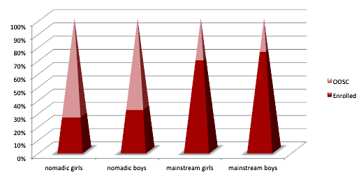

The evaluation (Farag, 2008) of the above mobile school programme introduced in Gedaref indicates, in its findings, the following points:
- According to teachers, boarding schools would be a preferable mode of further education after completion of the 4 grade cycle in a mobile school, especially for boys; while for girls, the best mode is either that of mobile schools or boarding schools. Teachers do not perceive settled daily school as an adequate mode of delivery.
- All children claimed that they like going to school and that they assist their family after school time.
- Religious education and Arabic were children’s favourite subjects.
- Fathers help with daily lessons more than mothers.
- Among family members, the brother takes the role of helping with household work.
- Usually the father will visit the school if there are any problems.
- All parents were paying money for schooling.
- Three fourths of the surveyed parents said education is more important than early marriage.
- There was little prioritisation of educating boys over girls

2.5 Localities

Mahalya (localities) in each state are responsible for the establishment of schools, supply of books, and teacher recruitment, salaries, supervision and inspection (ibid.) Teachers working in nomadic schools are recruited by the state Ministry of Education from those working in existing basic schools (Farag et al., 2008). However, limited revenue means that most localities are unable to pay salaries regularly and thus a huge number of teachers are paid through the federal Ministry of Finance (ElDood, 2010).

The amount of nomadic education provided at the locality level was found to be very low, despite basic education – this including nomadic education – being the local government’s responsibility (ibid).

According to policy, Education Councils and Parent-Teacher Associations (PTAs) ensure community participation at the school level in areas such as school supervision, maintenance, and teachers’ housing (UNESCO, 2012).
Previous Observations:
ElDood (2010) found that nomadic education directors consider there to be three major factors hampering proper service delivery of their units. These are:
- Limited government funding for nomadic education (78.6%);
- The low priority given to nomadic education (14.3%); and
- The fact that plans are not followed when implementing activities (7.7%).
In addition, directors expressed concern about staff shortages at the state level and locality level, as well as about limited skills in policy development and planning. A lack of reliable data was also mentioned as a concern.

As stated previously, some understanding of the reasons behind the low participation of nomads, and particularly girls, in the schooling system exists in Sudan. Challenges encountered by the beneficiaries as well as by the stakeholders have been mapped and analysed. In general terms, one of the main explanations behind their low interest in the services provided is their resistance to the forced settlement policy adopted by the government. Yet, even when settled, they show strong opposition to sending children, particularly girls, to school (Farag, 2013).
Therefore, this research seeks to broaden the current understanding of the reasons underlying low participation of pastoralist children, adopting a gender-based analysis.
Having elaborated on themes relevant to nomads and nomadic children’s education, this paper now provides a discussion of the underlying theoretical framework for this study.

Chapter 3

Theoretical and conceptual framework

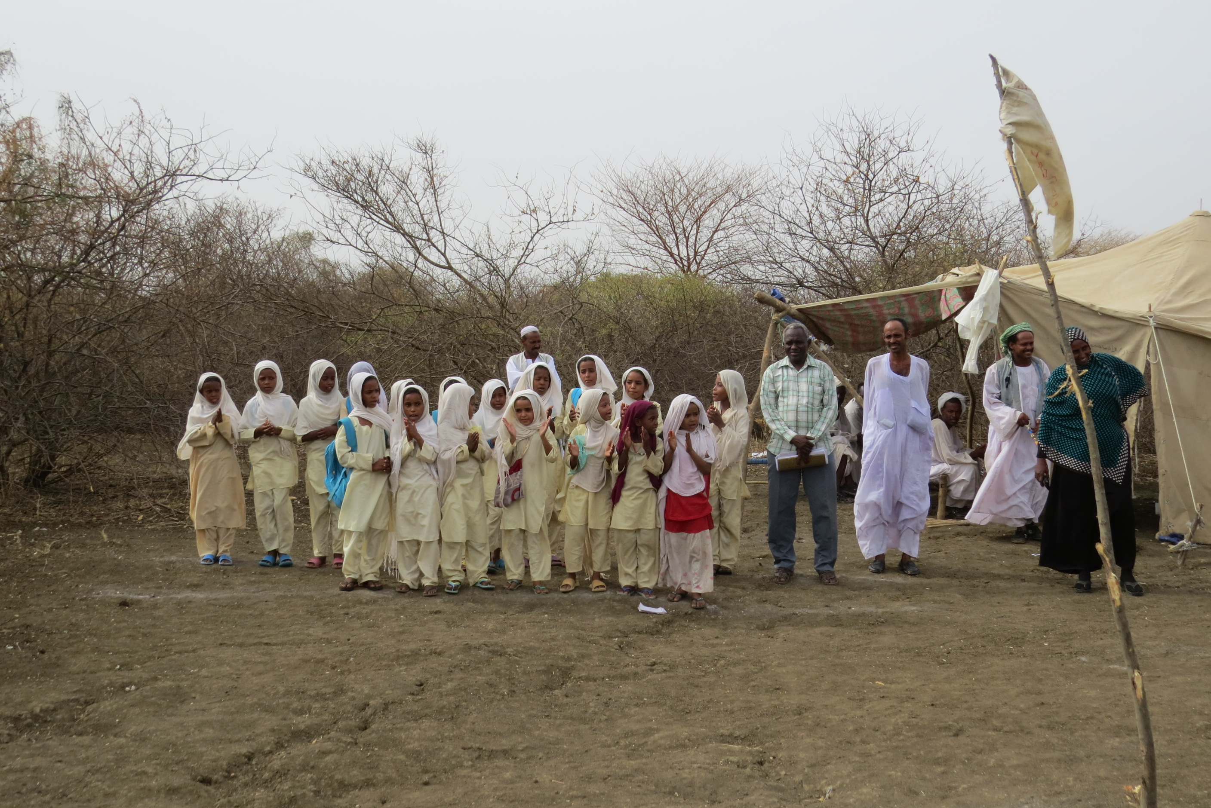

Pic. 4 Mobile school in fariq Wad alKhaseet
‘Educational transformations are always the result and the symptom of the social transformations in terms of which they are to be explained. For a people to feel at any given moment the need to change its educational system, it is necessary that new ideas and needs have emerged from which the old system is no longer adequate.’ Emile Durkheim (n.d.)

3. 1 Introduction

This chapter includes the theoretical and conceptual framework for this dissertation. While the theoretical framework assembles different interrelated concepts guiding this research, the conceptual framework illustrates how these ideas were organized in order to achieve the research’s purpose.

3.2. Theoretical framework

This section presents the theoretical framework upon which the current study is based and upon which interpretation and analysis of the field data will be grounded. As the study focuses on the education of a minority group (pastoralists) in Sudan, preserving a gender perspective, it requires a framework that addresses: internal dynamics within the community, power relations between the minority and majority groups (multiculturalism) as well as the role of international organisations. Firstly, however, a brief description of the field in which this research is embedded will be provided, as it constitutes the starting point for the whole study.

3.2.1 Sociology of Education
The research undertaken for the purposes of this study is embedded in the field of Sociology of Education. This discipline entails the “study of educational structures, processes, and practices from a sociological perspective.” (Saha, 2008, p.300). Emilé Durkheim (1858-1917) was the first one to understand that the educational system should be studied with a scientific eye (ibid.). His endeavour to create a new ‘social science’ discipline was determined by the historical context in which he lived; namely, the post Industrial Revolution period in Europe (ibid).
In his article entitled ‘Education, its Nature and Role’, Emile Durkheim declares that “every society, considered at a given moment in its development, has a system of education which is imposed on individuals” (UNESCO, 1993, p. 3). According to his premise, the ‘human ideal’ differs in each society and thus differences in terms of intellectual, physical and moral expectations are concomitant. Sufficient homogeneity among members of any society is indispensable for its subsistence. Perpetuation of the ‘ideal model’ from one generation to another is achieved through specific education and subsequent inculcation of particular ontological vision, norms and values in the child’s mind. This education, especially in the nation-states context, mostly takes place via formal, institutionalised means (ibid.). In contrast, among indigenous people – including nomadic people – the acquisition of knowledge has, until recently, been transmitted in an ‘informal’ way.
Krätli and Dyer (2009) refer to ‘Informal education’ as that which children acquire participating in well-developed social networks. This education is achieved through face-to-face interaction, and wide range of experiences within their immediate social context (Cole, 1992; Super and Harkness, 1997 in Krätli and Dyer, 2009). ). In order to break down and analyse the current educational situation of nomadic children, including a gender-based analysis of the topic, the following framework has been developed.

3.2.2 Multi-level framework
For a comprehensive analysis of the reasons behind the low participation of nomadic children in the educational system in Sudan in general, and in Gedaref state in particular, this study needs to address various perspectives. Multi- level study requires specific conceptualization and tools for the examination of each of them. For this particular reason, the theoretical framework of this research is designed to address three dimensions:
- The macro level looks at how the institutions within a large population affect the masses. Here, global and national approaches to development and education will be contrasted. Subsequently, the roles played by different stakeholders (community, government, and aid agencies) will be assessed.
- The meso level is the middle ground; it is interested in the organizations that are on a mid-scale (like communities) compared to the macro structure. This section focuses on the adequacy and implementation of the nomadic education programmes currently in place. The scrutiny is realized in line with the ‘Rights- Based Approach’ (criteria set up by UNESCO and UNICEF without which a right to education cannot be fully realized).
- The micro level deals with the daily actions and interactions of people in society; it integrates the definition of culture and socialization preserving a gender perspective; this section focuses on power relations and interactions between different individuals of the nomadic communities.

3.2.3 The Macro level: Discourses in Development
The concept of “Discourse in Development” is crucial for the scrutiny of the ‘top’, macro level pertaining to education of nomadic children. Before elaborating on the three major contemporary development discourses, it is indispensable to introduce the two terms used in the concept:
(1) “Development: the idea that deliberate action can be undertaken to change society in chosen directions considered desirable” (Youngman, 2000, p. 240 quoted by Rogers, 2004, p. 15)
(2) “A discourse (e.g. development) identifies appropriate and legitimate ways of practicing development as well as speaking and thinking about it” (Grillo & Stirrat 1997, p. 13 quoted by ibid.)
Alan Rogers (2004), a prominent figure in the field of education and particularly life-long learning, has undertaken exhaustive analysis of the predominant development discourses and identified three frames of reference that can be discerned in discussion about development in general: Deficit; Deprivation and Difference. Understanding the differences between these frames of reference is vital for assessing the roles played by different stakeholders involved in educational provision for nomadic children.

I) Deficit
As Rogers (2004) asserts, the deficit approach to development “ is still the paramount paradigm for most development today” (p. 18). His premise is in accordance with Youngman’s observation about the underlying idea in this approach i.e. that “underdeveloped countries are lagging behind due to lack of skilled and educated people”. In this paradigm, traditional patterns are seen in opposition to modernity and ‘not conducive to achievement of development goals’. The poorer population of developing countries are perceived as a problem as they cannot contribute to the formal economic system due to their reluctance/ incapacity to adopt modern techniques. Learning is considered a key element of development (ibid).
Within this framework of understanding, highly influenced by the IMF, World Bank and the UN agencies, the ‘empowerment of women’ is measured according to their productive value and participation in the labour market (Warning 1988 in Grawert, 2007). However, neither the underlying power relations nor the direction of these development programmes are questioned. Women often remain bereft of legal rights to land, resources and do not partake in the decision-making process (Grawert, 2007).
As Rogers observes, within this framework, new ‘Post-welfare’ discourse has recently emerged. According to Cooke & Kothari (2001), in order to reduce opposition to centrally planned programmes, community participation is requested in the form of cost or resource sharing (in ibid.). In line with the rationale, NGOs are perceived as entities collaborating with the international agencies and reinforcing West- South power relations.

II) Disadvantage
The disadvantage discourse (as the one of Frank, 1967 or Galtung, 1971) emerged as a response to the preceding discourse of deficit. The main shift lies in the assumptions related to the underlying causes of underdevelopment in a country. It pointed to the role played by social, political and economic structures in impeding progress and escape from poverty. It is suggested that the poor remain poor because they are oppressed and marginalized by the dominant groups, and that the rich keep the poor in a state of dependency (Youngman, 2000 in ibid.). For this reason, some people perceived development programmes in terms of fulfilment of rights (by the poor) rather than an effort to provide services (by government/ NGOs or International Agencies).
The dependency discourse, influenced by the diversity paradigm, gave birth to the social transformation paradigm. It recognizes the lack of appropriate distribution of income in developing countries and the importance of informal sectors (ibid.). It is argued that people want development but are not able to achieve it until they are freed from constraints (Mohanty et al., 1991).

III) Difference
Within this frame of reference, ‘development’ should not be understood as a cluster of benefits imposed on people, but rather as a process by which one can acquire mastership over one’s own destiny. As stated by Grillo (1998), there is no universal direction towards development (in Rogers, 2004) According to this stance, there is a “difference between being the agent of one’s own development as defined in one’s own terms and being a mere beneficiary of development as defined by someone else” (Crossley and Watson, 2003 in Rogers, 2004, p. 27) In that sense, local self- determination and not the adoption of a generalized pattern brings about the process of development. This paradigm also stresses the multiple nature of society; in that sense it moves away from the concept of difference to the one of diversity, and recognizes the existence of multiple identities within one society. It highlights the importance of diversity and perceives the world as being composed of different cultures, voices and interest interacting with each other (Stavenhagen 1986 in ibid.).
The ‘Difference’ discourse might be confused with the ‘Post-welfare neo-liberal’ discourse. However, a substantial difference between the two lies in the fact that according to the ‘Difference’ framework, the community determines what their needs and aspirations are, and it is the participants rather than the aid agencies that undertake the evaluation of the project (ibid). These three paradigms can be seen in many areas of social activity, including in education and gender (Fox 1996 in ibid.). Accordingly, they can be also perceived within the field of pastoralist education.

3.2.4 The Meso level: A Rights Based Approach To Education for ALL
As already indicated, the education of nomads worldwide, in Sudan, and in Gedaref state falls under the EFA initiative. A Rights-Based Approach to Education is the guiding reference of the programmes following this initiative. This approach encompasses access, quality and the environment in which education is provided, considering the three elements as essential for the realization of rights linked to educational process. It recognizes the fact that ensuring ‘access’ does not automatically entail ensuring the ‘right’ to education (UNESCO&UNICEF, 2007). The conceptual framework of this holistic vision is the following:
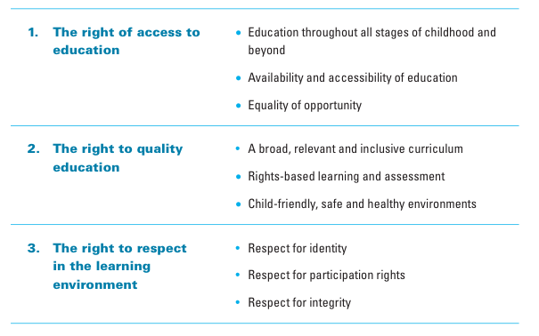

Source: UNESCO and UNICEF, 2007, p. 28
The right of access to education refers to the right of every child to access education without any sort of discrimination and with equal opportunity. This implies that education should be available for, accessible to and inclusive of all children.
The right to quality education refers to the relevance of the curriculum, the role of teachers, and the nature and ethos of the learning environment. Through education a child should be able to fulfil his or her full potential in terms of skills and knowledge as well as realize opportunities for employment. For this reason, education should be child- centred and relevant. This component should be regularly monitored.
The right to respect within the learning environment focuses on the respect of the universal human rights and of individual in the educational system. To achieve this goal education should be violence- free, ensuring equal respect of every child independently of his or her gender, language, culture and religion. Within this context, in order to ensure the realization of girls’ right to education, measures addressing their rights to freedom from discrimination, protection from exploitative labour, physical violence and sexual abuse should be taken into account.
While the RBA framework is useful for evaluating educational programmes delivered to pastoralist communities in Gedaref state, the framework sketched below serves as a reference for scrutiny of gender dynamics.

3.2.4 The micro level: Agency and diversity
Gender inequality and power relations have been the subjects of heated debates since the beginning of the 20th century. Different frameworks, corresponding in great measure to the previously mentioned development trends, have been adopted focusing on women and the development process. Nevertheless, the two initially designed frameworks, namely Women in Development (WID) and Women and Development (WAD) presented many shortcomings due to their omission of other factors such as race, ethnicity, geographical location, ideology and culture (Unterlhalter, 2008 in Farag, 2013).
The concept of the ‘duality of structure’ developed by Giddens (1981- 1984) holds that, social practices constitute both the medium and the outcome of social systems (Giddens, 1981 in Tomei, 2011). This standpoint involves recognition of the life perspective subjectivity stemming from the nature of socio-economical, political, and cultural structures in place. At the same time, it acknowledges that structures are formed by social actors equipped with reflexive competences giving them the power (agency) to frame and to transform the former (ibid.).
For this reason, the most recent approach, named GAD (Gender and Development), appears to be the most adequate framework for the scrutiny of gender and women’s empowerment as it embraces several factors influencing power relations within communities. As nomadic women are often portrayed as deprived of their rights and freedom, this section is going to present several theoretical notions relevant to the issue.
According to Rowland (1997), the roles played by women in a society are internalized through socialization processes. Owing to this dynamic, some women consider themselves as unable to improve their situation and reinforce the established gender roles. The empowerment can only be achieved if a sense of self- confidence and self- esteem is a priori developed. As he claims:
“ Empowerment (…) must also include the processes that lead people to perceive themselves as able and entitled to make decision” (Rowland, 1997, p. 14).
Within this context it is important to stress that that individual autonomy within each community always exists, even if it varies in its degree (Philips, 2007). The perception among many Western feminists of women from developing countries as mere victims of men oppression and domination is due to their lack of insight into the ideological and historical background of these countries (Mohanty, 1991). To avoid such misconceptions, autonomy has to be defined in an unbiased way. Marilyn Friedman maintains that
“Autonomy involves choosing and living according to standards or values that are, in some plausible sense, one's own.” (quoted in Phillips, 2007, p.101).
Shiva (1988), for instance, sees science as a tool of the dominant classes, which leads to depriving peasants of their livelihood, and which is detrimental to nature (in Grawert, 2007).
This is a universal definition of the term, according to which understanding of autonomy varies depending on factors such as geography, history, ideology and culture (Mohanty, 1991). Nevertheless, such a premise cannot be accurate if our conceptualization of culture is faulty.
“People create culture continuously…No set of cultural understanding … provides a perfectly applicable solution to any problem people have to solve in the course of their day, and they therefore must remake those solutions, adapt their understandings to the new situation in the light of what is different about it.” (Becker, 1982, p. 521)

Anne Philips (2007) asserts that culture should not be perceived as something static with well-established demarcation lines; but as something dynamic, transgressive and requiring contextual understanding. According to her, the interests of the elites are the underlying cause of the representation of culture as a rigid construct. As a consequence, dialogue with the leaders of minority groups, in most of the cases constituted by men (Okin, 1999), reinforces paternalistic hierarchy within the community and sustains vulnerability of a priori vulnerable individuals (Philips, 2007).
Laudowicz (1992) points out that in a number of African countries, the patriarchal leaders have adopted Islam as a state religion and used it as a tool for male power holders to justify the suppression of women. (in Grawert, 2007).
The analysis and interpretation of the data collected for this research is based on the theoretical framework set up above. In order to employ this multi-level approach to the issue of nomadic education in Gedaref, the methodology, as well as the research design, were developed in accordance with the macro, meso and micro level structure. In the next chapter, detailed information about the methodology and research design is provided. Firstly, however, the major elements of the aforementioned three theoretical conceptualisations are elaborated upon.
.

3.3 Conceptual framework
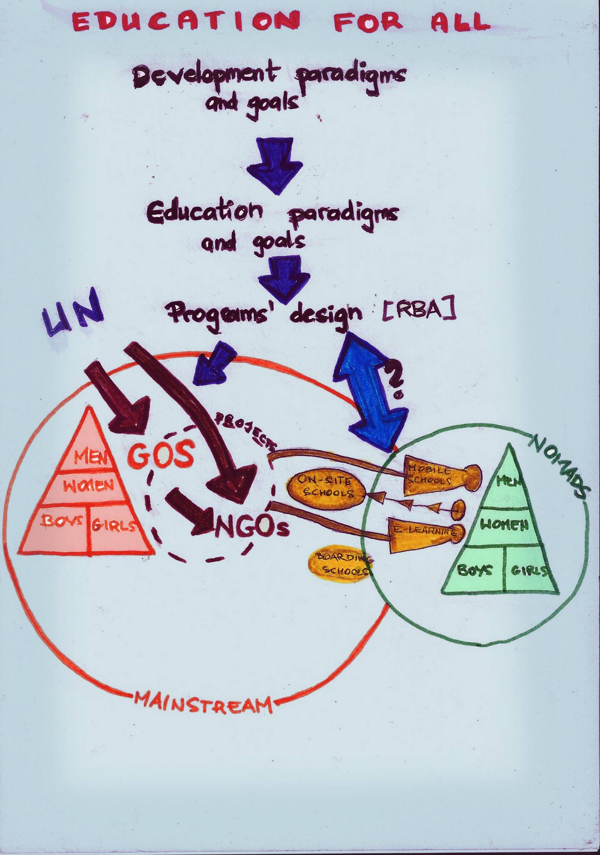

Chapter 4

Research design and Methodology

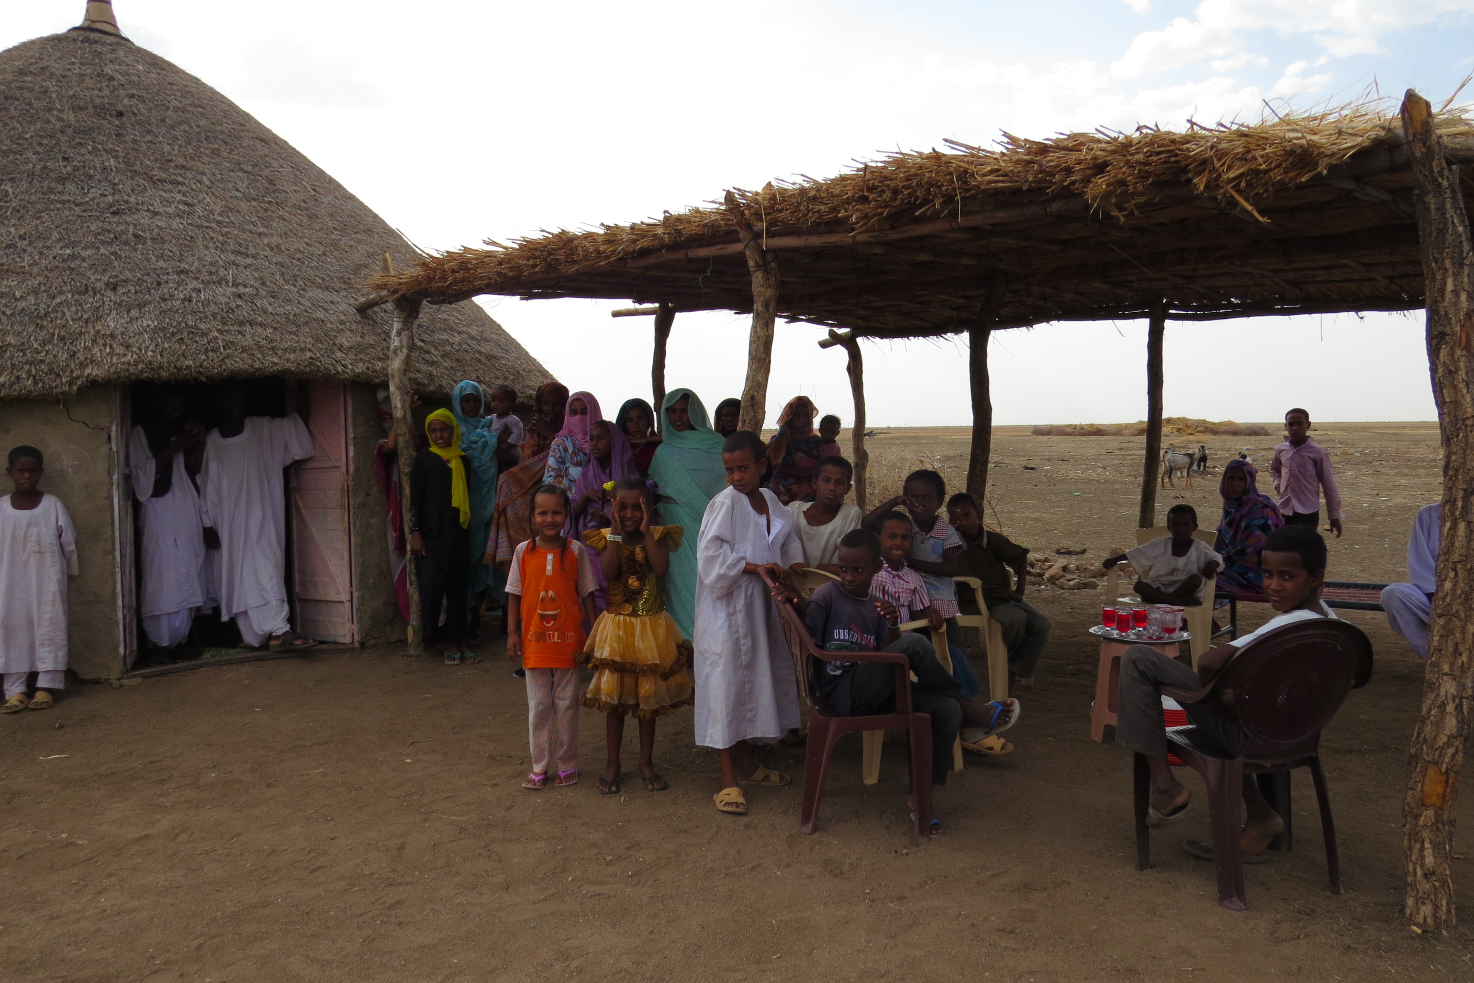

Pic. 5 Wad Nourin community

4. Approaches and Methodology

The social sciences discipline has witnessed the development of different perspectives and approaches to ontological (existence of a real and objective world), epistemological (possibility of knowing this world) and methodological (tools used in order to acquire knowledge) dimensions of research (Corbetta, 2003 in Della Porta and Keating, 2008). This chapter addresses all of these aspects in relation to the research conducted.

4.1 Philosophical Approaches
In the field of social sciences, many discrepancies have arisen in relation to the categorization of various phenomena that we observe as well as the validity of knowledge that is produced. The combination of these two dimensions has led to the emergence of an array of broad approaches, such as for instance positivist, post-positivist, constructionist, interpretivist and humanist approaches (ibid.).
The main objective of this research is to broaden our perspective on problems linked to the education of children belonging to the Lahawin, Shukriyya, and Kenana tribes in the three visited communities (see Chapter 1) of the Gedaref state in Sudan. My endeavour was to find out more about the perspectives on and state of the current provision of education to pastoralist communities and contrast them with the opinions of and strategies used by mainstream society and international stakeholders in relation to the interests of pastoralist children in educational programmes.
Issues linked to the cultural representation of minority groups are of constructionism concern (Bryman, 2012). Therefore, the part of the research concerning the representation of pastoralist needs in educational projects uses the constructionist ontological stance as a paradigm. Constructionism contends that “social phenomena and their meanings are continually being accomplished by social actors.” As such, “it implies that social phenomena and categories are not only produced through social interaction but that they are in constant state of revision.” (Bryman, 2012, p.33). Political agenda also influences interpretation (Della Porta and Keating, 2008).

At the same time, as far as the epistemological position is concerned, the nature of this research is interpretivist, as it aims at examining the views that participants held about the social world; i.e. the mind-set of various individuals concerned with the education of pastoralist children in Gedaref.

Bryman (2012) explains that although each of the broad approaches may entail the use of a particular research method, the links between the approaches and the methodology are not rigid. As many examples have proved, these should be perceived as tendencies rather than ‘definitive connections’.

4.2 The research design
A research design provides a framework for the collection and analysis of data (Bryman, 2012). This research has been conducted in accordance with accessibility to the field and possibility of valid data collection. Cross- sectional design for this study appeared as the most adequate, due to its capacity to embrace various cases, variables and mixed data (both qualitative and quantitative). According to Bryman (2012) cross-sectional design entails the collection of data related to several variables from more than one case study at a single point in time in order to trace patterns of association. This approach allowed me to overcome limitations associated with having a small sample group and little time in the field. It was contingent on the fact that access to the field in Sudan is generally restricted; a matter that became even more difficult in the light of the upcoming presidential elections in April 2015. Under the circumstances, other forms of research design such as experimental, case studies or longitudinal were axiomatically ruled out.
Different members from nomadic communities, teachers and MoE officials in addition to NGO employees constituted subsamples. The diversity of profiles and positions held among participants was deliberate and conducive to gaining multi- perspective.
As data were collected simultaneously the time ordering is absent in the research. Subsequently, the differences between the case studies are crucial for variation measuring and coming up with patterns of association (ibid.) guiding the study implementation.

The documents review and interviews or informal conversation with researchers concerned with the historical background or current situation and projects of the nomadic community go beyond the snapshot.

4.3 Data collection
As mentioned previously, a qualitative data collection method was used when carrying out the study (Burke et al 2007). However, some information was gleaned from a quantitative secondary data set (statistics). The way data are blended and analysed in this research is purely from a qualitative standpoint.
The qualitative component is significantly predominant in the study as it aims at describing the social reality of pastoralist groups. Therefore, the main focus is placed on words and observation. The examinations of perceptions of the participants (interpretivism) combined with the conviction that social phenomena are outcomes of interaction between individuals (constructionism) underpin the research. Qualitative methods carry the great advantage of enabling insights into people’s perspectives and phenomena. The qualitative data included in this dissertation were mostly primary, i.e. gathered for the purpose of this research.
However, the quantitative element was also indispensable for this study and was introduced in order to convey a clearer understanding of the context in which the study is embedded (Bryman, 2012). Statistics and figures, pertaining to social, economic and educational situation of people in Sudan, both in terms of nomadic peoples and more generally, were evaluated and provided information about the scale and magnitude of the problem. Obtaining a full picture reflecting the particularity of the problem linked to pastoralist educational would not be possible without, for instance, contrasting GER among nomadic groups with the rest of the society. Due to practical reasons, such as time, funding limitations and lack of capacity, the quantified part of the research was made up of secondary sources.
The complexity and challenges associated with nomadic education provision means that the matter requires a holistic approach. The adoption of a multi-method qualitative paradigm and data mixing allowed me to create a comprehensive account of the issues linked to the area of my inquiry.
Due to time, financial and access constraints, 3 methods of primary data collection were practiced when carrying out the research in the field, namely, (1) direct observation, also known as participants’ observation; (2) key informants interviews and (3) community group discussions.

The mixing of these three methods was mandatory as some of the issues, especially pertaining to social structure within the community, were too sensitive to be addressed directly. This research relies mostly on the direct observation method. Semi- structured interviews were conducted with key informants that in this research ranged from nomadic children to the Director of the Nomadic Department in the Federal Ministry of Education. Community group discussions turned out to be a very useful tool of data collection from different individuals in a severely limited time span.

4.4 Sample and sampling procedures
One of the main objectives of this research is to gain a holistic vision of different aspects linked to the provision of educational services among pastoralist groups in Sudan. However, the size and dispersion of most of them impedes study of this population in its entirety. Even a study restricted to the nomadic population in one state would be impossible in practical terms for a researcher in my position. In order to overcome this problem, qualitative study is usually carried out on a section of the population that is deemed as corresponding to the characteristics stemming from the research questions. A chosen portion of population that is embraced by a study is called sample (Bryman, 2012).
Sampling is linked with the external validity and plausible generalization of the research findings. The strategy deployed in sampling should allow collection of relevant data and generation of results answering the questions. In general, two sampling methods can be distinguished, namely, probability and non-probability. The former means that the “probability of an element being selected is known in advance” while in case of the latter such likelihood is absent (Grinnell and Urnau, 2013 p. 226) Probability sampling methods are used when the study aims at generalizing the findings and is highly relevant for quantitative research. Qualitative studies usually opt for non-probability (purposive) sampling methods, as they are concerned with in-depth understanding of the issue, nevertheless sometimes seeking generalizability (ibid.) Overall, purposive sampling involves in- depth information collection from a limited number of carefully selected cases, whereas probability sampling implies a larger scope of information from a larger number of units.
Apart from these two methods, a third type of sampling should be differentiated: convenience sampling. This technique involves drawing samples that are easily accessible and willing to participate in a study (Teddlie and Yu, 2007). The combination of two or more methods is referred to as mixed methods sampling.
Multilevel Mixed Methods sampling strategies are often used to research structures in which different units of analysis are intertwined and interlinked with each other (ibid). For instance, sampling of educational settings usually involves sampling at 5 different levels: state school systems, school districts, schools, teachers and classrooms, and students (ibid.) The final overall sampling strategy quite often employs multiple sampling techniques, each one used to address one of more of the research questions. This research was carried out with the help of a Multilevel Mixed Method sampling strategy.

Firstly, when the selection of a particular state in Sudan was carried out, a convenience strategy was utilized. As mentioned previously, travelling out of Khartoum state for foreigners is subject to many regulations and restrictions. Therefore, accessibility and willingness to participate determined my choice of Gedaref state as the eventual study site.
Once in Gedaref, a purposive sampling method, consisting of the deliberate seeking out of participants with particular characteristics according to the needs of the developing analysis and emerging theory, (Bryman, 2012) was utilized at all levels of the study. Specific communities and settings were chosen in line with their potential to provide information about my precise inquiries. The adapted procedure of the purposive sampling in the research was typical case type, aiming at achieving representativeness and comparability at the same time (Teddlie and Yu, 2007). Semi- nomadic and fully pastoralist communities constituted sampling elements at this level of aggregation. At the community level purposive sampling was further employed amongst different units.
Logically, the larger the sample size the more complex and multi-layered the analysis can be. Nevertheless, study of a large group is very time consuming and, therefore, not suitable for small-scale research such as mine. Thus, I aimed at ensuring that the sample would be big enough to address specific purposes related to the research questions and fit into my very limited time frame in the field. A multilevel purposive sampling technique was indispensable for achieving this goal.
The study sample of this research at the community level was de facto defined once I found myself in the field. This state of affairs was a result of many intertwined factors. Firstly, before reaching the field, my knowledge about the communities, their current social situation and historical background was very limited. This sort of information in Sudan is often transmitted orally and its reach is restricted to the surrounding area. In addition, it is almost impossible to know when and which communities are going to be easily accessible beforehand. For instance, in order to visit any of the three communities, MoE officials had to accompany me. Their availability had a significant impact on my sample size. Moreover, the sample of my study was partly dictated by my affiliation to UNICEF and the mission I was carrying out as an employee.
Expert judgment is often utilized within this sampling method for the selection purposes (ibid). The sampling frame of the communities in this study was based on the information provided to me by one MoE official. Without the knowledge and judgment that this person shared with me, I would not have been able to establish the sample properly.
In this research, the stakeholders can be categorized into three clusters: (1) relevant researchers and Education sector officials in Khartoum; (2) ministry of Education officials in Gedaref state; and (3) teachers/ facilitators and members of the three pastoralists communities. Variation in the units’ characteristics was used in order to obtain multiple perspectives on the pastoralist education situation.
The Ministry people were contacted and informed about my arrival and purpose a couple of days before the departure from Khartoum. In total, three communities were visited. Two out of three semi-nomadic communities were participating in the e-learning programme and were thus influenced by the itinerary of my work assignment as a UNICEF employee. The third community was chosen taking into account the mobility pattern of pastoralist groups. Therefore, one fully nomadic community was selected implying visit in one out of two mobile schools in Gedaref state. In addition, the three communities were chosen because they had children that for a very long time did not have access to education.
The study directly involved a sample of 73 people comprising 5 education sector officials and employees in Gedaref state. The study sample in each community was as follows: (1) WadNourin: 18 community members (the community leader, 1 facilitator, 2 men, 13 women, 4 boys and 3 girls); (2) Tayba: 3 facilitators and 15 community members (the community leader, 2 men, 6 women and 5 girls) and (3) WadAlKhasheet: 3 teachers and 32 community members (the community leader, 5 community members (men only), 18 girls and 10 boys)
One community was visited per day. The ministry officials had previously informed the community members and teachers about our arrival. In Tayba and Wad Nourin communities data collection for this research was undertaken simultaneously with the work mission. In all three cases, the visit started with a discussion with the community leader/ representative, teachers (facilitator) and other accompanying community members. Children with whom discussion took place were gathered in the learning spaces others were present in the surroundings.
As far as informal conversations/ interviews with researches working with pastoralists groups are concerned, these were conducted applying a snowball sampling technique consisting in gathering research subjects through the identification of an initial subject who is used to provide the names of other actors/participants (Bryman, 2006).

In general, this research is underpinned by triangulation. This term usually signifies using more than one method or source of data in the study of social phenomenon; however, it has sometimes been employed more broadly. For instance, Dezin (1978) used it when referring to an approach that uses ‘multiple observers, theoretical perspectives, sources of data and methodologies’ (Burke et al. 2007). In this research triangulation is present under multiple forms, namely: data triangulation (use of variety of sources in a study), theory triangulation (use of multiple theories to interpret the results), and within methods triangulation (multi-methods to study research problem).

4.5 Data collection instruments
In this study, semi-structured interviews with education officials and teachers, diverse community members, community focus group discussions, and participant observation were used for the collection of primary data. The choice of these three instruments is in line with the nature and characteristics of the sample. Document analysis was used for secondary data collection.

4.5.1 Design of instruments
The research instruments were designed prior to my visit to the field. However, not all of them were used during my study. Questionnaires initially developed in order to cross- check qualitative and quantitatively obtained data could not be used. In order to compensate, more emphasis was placed on community group discussion and participant observation methods. In addition, many of the interview guides were adjusted once I found myself in the community due to limited timing and the social setting.

4.5.2 Semi structured interviews
This instrument was purposely designed for the nomadic community leaders, parents, children, teachers as well as researchers, NGOs and the ministry officials.
The semi-structured guides for the community members were designed to cover the main themes contained in the research questions, which were: the challenges in accessing education, the perception of the current educational system (structure and curriculum), expectations of education of girls and boys (gender breakdown) and attitude towards formal/ non-formal education.
The semi- structured schedules for teachers/ ALP facilitators were developed in order to gain an insight into their perception of the adequacy of the current curricula, challenges linked to teaching pastoralist children, sufficiency of materials and learning spaces, their qualifications and opinion about the mechanism in place to report on needs, obstacles and desires of pupils in relation to education.

The pastoralist population in the field is rather accustomed to open discussions. Several times it was difficult to interview individuals alone. Other community members would just join in the process, so I had to conduct a group interview or change the method to community group discussion.

All of the community leaders were interviewed though in some cases, the discussion took the form of a monologue. As far as parents are concerned, only two participated in an individual manner. The same results can be noted for children. The number of teachers targeted for the individual/ group interview was 5 but I was only able to interview 4. This significant decrease in sample size was because my time and language communication capacity were very limited in the field.
This technique was preferred for nomadic communities because they are usually illiterate and used to oral communication. Moreover, interaction with community members had the advantage of eliciting complete, complex and deep information that could otherwise be missed with other methods (Cohen et al., 2007). In addition, interviewing allowed me parallel collection of essential non- verbal data by the participant observation method (Robson, 2002).
The semi-structure interviews were carried out with the help of a translator and noted down. Data resulting from the narrative responses were coded and sectioned into areas of interest in line with the research questions and research objectives. Emerging themes were identified and grouped together to compose the final analysis and discussions given in the chapter five.
The interview guides for the researchers, NGOs and ministry people were devised in order to get an overview of approaches, programmes and perspectives of these stakeholders concerning nomadic education.

4.5.3 Community group discussions
Community group discussions are a more general group discussion with persons located at a specific site. A community group has less homogeneity than a Focus group discussion (FDG)(ACAPS, 2012). FGD is a type of group interview where the participants interact, argue and make joint elaboration on the topic of concern (Bryman, 2012). The FGD is based on the basic strategy of involving people who have shared experiences. Focus group discussions can be effective in identifying the cultural norms and understanding the issues of concern within groups in an affected population (ACAPS, 2012).
Characteristics of the social setting coupled with time, money and language limitations made me opt for this method. The CGD emerged spontaneously as a result of my attempt to interview one particular person. In the process, all the discussions were written down and incorporate them into their respective sections in the data.
Four community group discussions (CGD) took place during this study. At least, one group discussion was held in each community. In WadNourin the discussion was with men (exceptional was the presence of the female facilitator), in Tayba with men and women separately, while in WadAlKhaseet with men only. The main advantage of using this method was the possibility of capturing how people respond to each other’s views and building up a view out of the interactions (Bryman, 2012).

4.5.4 Direct Observation and informal conversations

Direct observation
Direct observation, also known as participant observation, is a process of data collection by observation of naturally occurring behaviour within a usual context. This is achieved by focusing on conditions and specific features of a site from a range of viewpoints and locations (ACAPS, 2012). It allows one to contrast and complement the data gathered through interviews, community group discussions or informal conversations.
Throughout my stay in the field, participant observations were made continuously. This proved very helpful in understanding the way of life in the various places and in getting an additional insight into interactions between various actors concerned by the study.
The observation was undertaken at diverse levels and in various settings. It served to find out about: (Ministry and Education Sector) interest in nomadic education issues; the design, implementation and monitoring of programmes; the coordination of activities; (Communities and teachers) interaction between the teacher and the community; male / female power relations; (learning spaces) the physical condition of the learning spaces; teacher-pupil interaction; gender parity index (GPI); learning materials; and school environment: availability of drinking water, toilets, food and practices of punishment.

Informal Conversations
Besides the semi-structured interviews, community group discussions and direct observation, informal talks proved to be clarifying and highly informative. These talks took place in various settings, including professional, over a six-month period equivalent to my stay in Sudan. Clarifications and rectifications, obtained while having discussions, lead me to a greater understanding of the gap between theory and praxis in the field of pastoral education.
Both informal conversation and participant observation were indispensable for the validation of my research findings.

4.5.5 Document Analysis
The last method of data collection I used was literature analysis. The secondary data included project and policy documents, proposals, publications, reports, presentations, short documentaries and brochures addressing the nomadic education in Sudan. These documents, published and unpublished, were obtained from various people willing to support me in my research. Their analysis permitted me a diachronic insight into understandings of pastoralist education/culture by the state apparatus and other stakeholders.
Moreover, statistical data from official sources - mainly the Ministry of General Education & State Ministries of Education and UN agencies - were used.

4.6 Validity of the research instruments
In this research, triangulation was applied throughout the whole study in order to obtain an illustrative and complete picture of the situation. This approach to the study helped strengthen the validity of the research as a whole.
The triangulation was reflected in the multi-level design of the study and the multi-level theoretical framework. In addition, triangulation was used for the sampling purposes, enabling me to obtain a representative sample. The triangulation of diverse research tools helped in strengthening and validating the findings. Robson (2002) argues that triangulation ‘enhances the rigour of the research’. This process enables me to claim that findings of this study are valid and as objective as possible.

4.7 Research ethics
All social research has to consider ethical issues. According to Spencer et al. (2003) ethical concerns determine the quality of qualitative research (Bryman, 2012). In order to be able to conduct my study I had first to get an ethical approval from Ahfad University for Women in Sudan. In the presented proposal, I had to explain how the data would be collected and for what purposes. I was granted a written permit and a letter of introduction addressed to whomever was concerned by the research.
Both UNICEF and SMoE were informed about the double character of my field visit. Similarly, all informants had been familiarized with the nature of my trip. Although I favourably disposed to hand out written consents, none of them was utilized during this research because oral consent seemed to be culturally more suitable. In addition, the majority of people interviewed in the field were illiterate.
In the three study sites, I also took an account of the moral climate within which the community operates. As Robson (2002) defined, ethics signifies respect and sensitivity for the rights of others and their moral standards and codes of conduct; therefore I always took an account of these three elements with which the community operates. For this reason, for instance, I avoided mixing men and women and asked permission to interview women from the community leader.
The anonymity and confidentiality of information given by all participants was maintained and guaranteed as recommended by Cohen et al. (2007) during collection of data. In the process of the research, participants were given the freedom to participate or withdraw.

4.8 Data analysis
Qualitative content analysis is one of numerous research methods used to analyse text data. It is conceived as a method for the subjective interpretation of the content of text data through the systematic classification process of coding and identifying themes or patterns. It can range from impressionistic interpretations to highly systematic analyses of text-based data (Hsieh and Shannon, 2005). Both deductive and inductive approaches to qualitative content analysis were employed in this research. The former was mostly used to identify the overall physical, social, and organizational features of nomadic education by applying existing theory and prior categories. The latter was especially employed to identify needs, preferences, and desires of nomadic communities as well as their views on the e-learning programme. It fitted the exploratory part of the study oriented towards understanding socially constructed reality subject to constant alteration (Bryman, 2012).

When using the deductive approach, I started data analysis with a coding template in mind. This was developed through literature review and reflected in the research objectives and questions. The design on the interview, containing both open and closed questions, was partly predetermined by categories deriving from available documents pertaining to pastoralist education. Though having this previously existing template, the structure of the template into which data were fed has been altered. Alterability was essential as the aim of the study was to test and expand the relevance and validity of existing frameworks (Finfgeld, 2003; Zimmer, 2006 in Hsieh and Shannon, 2005).
Content analysis gave room for in-depth interpretation of nomadic education issues. Moreover, it allowed assessment of the current educational system’s provision of accessible opportunities for nomadic children.

4.9 Fieldwork reflections and study limitations
In Sudan, in order to conduct my research or take part in the field mission, I had to obtain a permit from the Humanitarian Aid Commission. It took me over two months of struggling to eventually reach the field. This high dependence on exogenous factors sparked uncertainty in me regarding the feasibility of my research. I was aware of the fact that the outcome of my research was contingent on this permit.
The communities visited in Gedaref were not initially chosen as research area. Firstly, after familiarizing myself with the conditions and problems linked to education of nomads in different states in Sudan as well as the proportion of nomads in the overall population, my desire was to reach AdDeain (Eastern Darfur) locality. However, the status of ‘conflict area’ of AdDeain locality in the Darfur region (OOSCI, 2014) significantly hampered my chances to access the field.
For this particular reason, I was advised to conduct my study in an area where conflict was neither widespread nor would affect data collection. After discussions with scholars familiar with the Sudanese context, I chose to focus my research on the White Nile area.
The selection of this geographical location was conditioned by the existence of different programmes targeting nomadic children in Sudan. However, gaining the access to the field turned out to be very challenging due to the upcoming Presidential elections in Sudan and security concerns from the government. Joining an organization working in the Education Sector in the country appeared as the only solution for the continuity of my research. Thus, although my will was to perform as an impartial researcher, I re-joined UNICEF Education Section for the period of two months in order to reach pastoralist communities.
As stated previously, While Nile state was my study area of preference. During approximately one month I undertook all necessary actions in order to ensure a smooth research process. After receiving the indispensable letter of invitation from the White Nile State Ministry of Education, following the due procedures, I applied for a travel permit from HAC. Nevertheless, more obstacles appeared and as a consequence my invitation to White Nile state expired. Fortunately, I could gather the necessary data during my field trip to Gedaref in which I participated as a member of UNICEF staff. In this context it is relevant to point out that in all communities, I was perceived as being a UNICEF representative. On the one hand, I highly appreciated this status as it caused the communities to take me seriously. On the other hand, I must acknowledge that their answers might have been conditioned by my status.
I obtain the permit to travel to Gedaref in the last possible instance before the time scheduled for my departure. Although I was remained hopeful until that moment, the late response significantly hindered my preparation for the field trip. It was incumbent on me to ensure the presence of interpreter for my individual inquiry (not linked to the UNICEF visit). The opportunity to find well- qualified interpreter was curtailed, and the belatedly received permit was also accompanied by a need to solve logistical issues at the last moment. Though the change of the study area entailed rearranging logistical and organizational issues, fortunately it did not influence the validity of my research. This is because different nomadic groups across Sudan show similarities in their cultural and nomadic patterns.
Accessing nomadic communities out of the UNICEF activities programme was a highly challenging goal. Fortunately, my affiliation to UNICEF and the good will/cooperation of the Ministry people in Gedaref, made achieving my aim possible.
Unsurprisingly, accessing pastoralist groups required a lot of time. This limited time rendered impossible the use of, for instance, the previously developed questionnaires. In addition, travelling in hot, stifling weather conditions was exhausting. All ordinary on-site schools were closed due to upcoming final exams. Luckily, nomadic children benefitting from the programmes of interest to me, i.e. specially designed for pastoralist people, were ready to meet me. Classes provided through the e-learning programme and in one mobile school were still taking place.
Overall, getting all the necessary information from the community was an arduous process. I found it difficult, for instance, to collect the number of school age children in each farig. The emergence of such obstacles was due to my identity. First of all, my condition as a foreigner was sometimes sparkling lack of trust in my intentions (I was referred to as ‘Khawaga’- meaning foreigner). In addition, both the mainstream as well as nomadic communities are very patriarchal; therefore, as a young woman, I would not always be treated with seriousness and respect.
It was also challenging to conduct interviews with individuals, especially women, due to the fact that they were under men’s surveillance. Nevertheless, women were very eager to talk to me.

CHAPTER 5

Findings and analysis

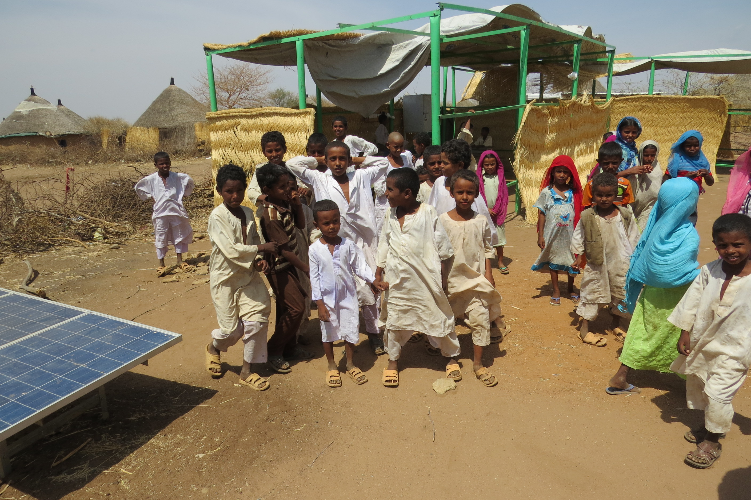
Pic. 6 Learning space in Tayba community

5.1 Introduction
This chapter presents findings and analysis related to the data collected throughout my research. On the basis of the reviewed documents and in accordance with the previously established conceptual framework, the data was clustered into 3 groups corresponding to macro, meso, and micro levels. The chapter ends with a synthesis of the gathered and analysed data.

5.2. Macro level
- The extent to which the UN guides the Ministry of Education
Official documents issued by the Ministry of Education, as well as the dynamic during education sector meetings, reveal the government’s strong dependency on directives set up by UN agencies (UNICEF and UNESCO in particular).
The gestation of the Directorate for Nomadic Education, a special ministry body concerned with education of pastoralist people, is presented as stemming from the government’s commitment to diverse supranational declarations. In the Nomadic Children Education Strategy for the Years 2013-2016, the provision of education to nomadic children is justified as follows:
“Sudan has committed to all international declarations to extend the agenda of providing the basic right of education to all its citizens (…).” (MoE, 2013b, p. 3)
“(…) provision of basic education has been guided by the regional and international instruments, declarations and plans to which Sudan is strongly committed” (ibid, p. 5).
Thus, the Sudanese government’s interest in, and willingness to, extend education services to nomadic communities is presented as being propelled by an exogenous factor. This thus implies that the national drive to ‘educate’ nomads was weak. This understanding is supported by the observation that at both state and federal levels, the Directorate for Nomadic Education falls under the auspices of the Ministry of General Education, and is even physically distanced from the NCLAE running the ALP programme. Logically, both institutions are concerned with pastoralist education since many nomadic individuals benefit from, or are potential beneficiaries of, the ALP. The lack of a coherent logic behind the design of this institution thus suggests that the MoE’s efforts to deliver special educational services to nomads were dictated not by national priorities, but by international stakeholders. Indeed, we observe that the developed framework for action in the sphere of primary education is not merely influenced by the UN Millennium Development Goals, but is an exact copy of it.

- Compulsory ‘western’ education and gender equality
MDG Goals 2& 3
(2) Achieve universal primary education: Ensure that all boys and girls complete a full course of primary school.

(3) Promote gender equality and empower women: Eliminate gender disparity in primary and secondary education by 2015.

MDG 2, above, is underpinned by the assumption that primary schooling is a priority for all children. Girls, as well as boys, are supposed to be included in the education system, and state-provided education is conceptualised as the right and universal way to achieve development. Therefore, Sudan’s general policies regarding nomadic education are based on the understanding that traditional patterns of pastoralist subsistence are not conducive to the achievement of development goals. Instead, institution-based learning is seen as key to development.
As far as MDG 3 is concerned, one may interpret the emphasis on girls’ education as being propelled by Sudan’s willingness to include them in the formal economy. The UNDP’s latest report on development remarked that despite this progress towards achieving the MDG 3, the share of womenin the labour market in 2011 was at 23.1%, and only 8.6% of employers were female (AEO, 2014). There has been an upward trend since that report, but female participation in the labour market is still only 31.2% compared to 76% male participation (UNDP, 2014a). The World Bank has expressed concern about women comprising only 23% of the formal economy, but 70% of the informal economy (WB, 2012 in WFP, 2014). Assessment of the successfulness of programmes aimed at achieving EFA is usually gauged by participation in the formal economic sector.

- Areas of interventions and vulnerability
For more than a decade, Sudan has been affected by a protracted crisis that has hampered provision of basic services by the GOS. The prioritisation of areas in which education programmes are launched is, in general, determined by the UN, which relies heavily on the Humanitarian Needs Overview (HNO). The HNO is built on a set of carefully selected vulnerability- indicators, and is intended to be capable of assessing the humanitarian situation in every locality. The number of nomadic people inhabiting an area also constitutes a variable taken into account for its creation. Although the value of this database is unquestionable in a country that has endured years of protracted, acute conflicts and recurring natural disasters, the final HNO has a serious limitation: it does not reveal in which localities pastoralist people need support, or whether organisations are already active in those areas. And yet, the majority of programmes and activities implemented by the NGOs, MoE and UNICEF are based on the HNO or other UN directives.

- De-centralisation and community participation
Sudan’s Interim National Constitution, amended in 2014, reaffirms the country’s decentralised and democratic model of governance (AEO, 2014). The state delegates functions to localities, which then govern communities through urban and rural administrative units. Importantly, these localities have no direct executive or legislative functions other than coordination of the relevant units. From the statement included in the national strategy targeting nomads, one can deduct that at present, programmes are planned centrally, and that this needs to change:
“Government goal: improving and leadership building of managers – improving information delivery system [sic] and increasing community participation and ownership.” ( MoE, 2013b, p. 18).

Communities do not have enough of a voice or a presence in determining what their particular needs and aspirations are, and the government is aware of this shortcoming. In order to reduce opposition to centrally- planned programmes, the government adopted the participatory approach. However, community participation is often limited to cost- or resource-sharing. Moreover, as the mechanism of communication relies on the centrally administrated structure, community voices are not heard at the federal level: to have an impact on policy and on project implementation nomads must have recourse to the state itself. However, based on my observations during education sector meetings in Khartoum and in the Gedaref state, the flow of information between state and federal level is very weak. For instance, the FMoE could not indicate the exact dates of the enrolment campaigns in each state, as they were not aware when exactly the academic year for nomadic children was finishing in each case. Consequently, having an impact on policy is not really plausible for nomadic people, under the current structure.
As a further matter, as the Director of Nomadic Education Department at the Federal MoE explained:
“Where nomadic tribes remain within one state it is easier to coordinate their education”.
Yet, many tribes cross interstate boundaries while grazing their animals. This statement indicates that the administrative structure is poorly adapted to a pastoralist lifestyle.
In addition, the performance of the MoE at the locality level is very weak. As one of the community members in Wad AlKhaseet explained:
“When we thought about educating our children, we made our request at the state level”.
The localities’ capacity to intervene is extremely limited. As I was informed, the State MoE, due to insufficient funding at the locality level, pays the salaries of the teachers in nomadic schools.
- The role of Non-Governamental Organisations
As already mentioned, the education sector in Sudan is formed by UNICEF, the MoE and national and international NGOs. UNICEF plays the role of sector leader and usually does not operate as a direct implementer of programmes, but instead entrusts this task to ministries or NGOs. During my internship period, I was informed that a preference for collaboration with an NGO over the MoE should be justified by the existence of added value in the form of increased community participation.
However, NGOs are heavily dependent on donors’ preferences. As one of the AlMassar workers explained:
“When planning an intervention, we take into account donors’ preference for the geographical area and type of activities they want to sponsor”.
Moreover, international donors are often afraid to entrust their money to unknown local NGOs (ALNAP, 2009) with limited capacity. Therefore, such NGOs often sign Programme Cooperation Agreements with UN agencies. As a result of this dependency, a strong pattern of intervention in the same, in many cases overlapping, locations can be traced.
The justification for intervention in a specific place is often based on low enrolment rates:
“Guided by the lessons learned (...)this project is targeting low enrolment communities and will rely on community effective participation and local actors capacity building to create ownership and for sustainability. ”(AlMassar)

However, concentrating on one area might entail neglecting other communities in need. As the Director of ALP in Gedaref explains:
“For these reasons we used to call NGOs like PLAN Sudan, Al Massar and ZOA to widen their areas to accept more children out of schools in not only Al Fashaga locality but other localities with fewer intakes of children aged 6-9 and children and youth 10-24age old”.

AlMassar and Plan International Sudan are the two main NGOs working in the field of nomadic education in the state of Gedaref. The projects implemented by the NGOs involve close collaboration with UNICEF, the Ministry of Education and nomadic community leaders. The review of their project proposals unveils that: they show a strong predilection for the mobile school mode of education delivery; they prioritise community participation (for example, via children’s clubs, empowerment of the school PTAs and formation of mothers’ councils); and they place a strong emphasis on teachers’ training and on the provision of educational materials, which include water tanks. In addition, schools are often used as ALP centres.
In general, the project implementation starts with intensive awareness-raising and mobilisation campaigns. As we read in AlMassar’s proposal: “(the project) will rely on community effective participation and local actors capacity building to create ownership and for sustainability [sic].”

In addition, in order to reinforce the sustainability of education services for nomadic children, AlMassar opts for an integrated approach entailing engagement with other sectors. Once the project is finalised, the activities are further transferred to national ministries, which are supposed to ensure their continuation.
- High turn-over and shortages of education sector staff

Based on my observations during the internship period and on conversations with the government, UN and NGOs representatives, I can state that there is a recurrent high short-term staff turnover. At UNICEF alone, I saw 3 staff members leaving and 2 new employees joining the office. In addition, while organising the Education sector meetings, I was repeatedly informed that the NGOs focal point for Education had left the country. In addition, these institutions, especially international ones, have staff shortages, largely because of restrictions on Sudanese work visas and difficulties obtaining travel permits. As a result of such shortages, huge geographical areas and responsibilities fall on the shoulders of one aid agency worker: workloads that are far above the capacity of one human being. UNICEF, for instance, does not have its office in Gedaref state. One officer is responsible for three Eastern states: Kassala, Red Sea and Gedaref.
The high staff turnover in education service delivery is detrimental to project implementation and sustainability. Based on my observations, the lack of exchange of information between previous and the current employees is crippled. Moreover, the mechanism to enable dialogue and collaboration is very weak. I saw staff members seeking out further background information about the projects they were leading and were unfamiliar with. As a consequence, many projects end up in limbo or are neglected for extensive time periods due to the employees’ limited capacity to complete them, or quite simply their lack of familiarity with the projects. . These conditions are highly detrimental to project continuity within the nomadic communities.

- Financial crisis and economic dependency
Sudan is currently experiencing an economic crisis. It remains one of the least-developed, lowest-income countries, having ranked 166thout of 197 countries in the 2014 Human Development Index (AOE, 2014). Its humanitarian and financial situation has substantially worsened since the secession of South Sudan in 2011, which resulted in the loss of 75% of oil revenue. The inflation rate reached its peak at almost 50% in 2013 and early 2014 (see illustration 2). This situation has severely affected the government’s economic capacity.
Illustration 2
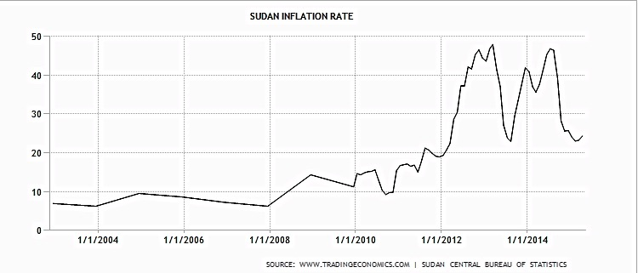

The negative effect of inflation on education was to be offset by international financial support. In order to sustain the educational system in Sudan, international stakeholders have galvanised resources to ensure the realisation of the MDGs. The Ministry of Education is thus financially dependent on donors’ funding. A 4-year Basic Recovery Project was launched in 2013 with the aim of ensuring primary education delivery to children despite the economic situation:
“The Basic Education Recovery Project will be implemented by the Ministry of Education with a total of US$76.5 million Grant financed by the Global Partnership for Education Fund (GPEF), which is a multilateral partnership devoted to supporting countries’ efforts to educate children from early primary school through secondary school.” (WB, 2013).

What is more, previously estimated budgets for schools constructions often turn out to be insufficient. As an AlMassar employee explained:

“The biggest obstacle we currently face is inflation. It is hampering implementation of our planned constructions.”

- Low expenditure

Fiscal retrenchment after the lost of a significant portion of oil revenue considerably reduced public social spending on education. In 2014, public spending on education amounted to 0.42% of GDP and is estimated to drop by a further 0.1% in 2015 (AOE, 2014). This financial situation rules out the possibility of education being free.
9) Development conceptualization
In order to rescue the Sudanese economy, a five-year programme of economic reform (FYPER 2015-19) has been designed, and is expected to enhance macroeconomic stability, raise public investment and strengthen social safety nets in support of sustainable and inclusive growth. It aims at tackling obstacles such as restrained business formalisation or job creation (AOE, 2014). In order to boost the economy, in 2014, the Central Bank of Sudan in 2014 adopted a policy aiming at increasing traditional cash-crop exports. Although the contribution of livestock production to the GDP is mentioned in the strategy, future development is conceptualized exclusively in traditional, macro-agricultural economic terms. While reforming land ownership and administration in the Gezira project (providing about 924 000 hectares of irrigated land) is considered to be a backbone of the revitalisation strategy, the issue of pastoralism is not addressed at all (ibid.).
As far as bio-diversity is concerned, over the last 20 years, the quantity of forested areas has plummeted by 28%. Currently, 40% of the population is living on degraded lands. The employment-to-population-ratio is 55.1 (percentage of those aged 25 and above) (UNDP, 2014b). Further, in 2014, the electrification rate in Sudan amounted to 35. 9% (UNDP, 2014b);
10) Data, Targets & Indicators
Every year, the education sector leader- in Sudan’s case, UNICEF –sets up indicators and targets commensurate with the MDG 2&3, in consultation with other partners. These indicators need to be easily measurable in order to reflect the sector progress towards the achievement of the set- up goals. Nomadic children are targeted, in line with the general UN work plan. The same indicators are used for the mainstream (see below) and nomadic populations. For this reason, GER and the number of OOSC children are used to assess nomadic education participation.

DATA: 2013-2014
 | Number of enrolled students (primary education) |  |  | Number of school aged children (6-13)
Area | Boys | Girls | Total | Boys | Girls | Total
Gedaref | 149130 | 124060 | 273190 | 211758 | 206156 | 417914
Sudan | 2816569 | 2527380 | 5343948 | 3920578 | 3747428 | 7668006

GER 2013-2014
State | Boys | Girls | Total
Gedaref | 70.4 | 60.2 | 65.4
Sudan | 71.8 | 67.4 | 69.7

For instance, in the current strategic plan, participation of pastoral children in the educational system is based on the Gross Enrolment Ratio calculation:
“The data of the Education Statistic book 2009-2010 showed that the annual GER in basic education has increased from 69.9% in 2008 to 73.2% in 2010, while the GER in nomad's children basic education has increased from 23% to 33% during the same period. From this percentage only 38% are girls (State Reports and Workshop for the endorsement of this strategy, June2013).” (MoE, 2013b, p.5)

GER (Gross enrolment ratio) is calculated by taking the number of children enrolled in a particular level and dividing it by the total of the age group population officially corresponding to that level. In the Sudanese context, assessment of progress according to the established indicators appears to be bogus, as there are huge discrepancies between different sets of officially released statistics pertaining to the (total) nomadic population. Similarly, the number of OOSC is not valid as an indicator (see below). Moreover, measuring the successfulness of education programmes amongst pastoralist children using the GER is inaccurate, since not all nomadic children want to access education (see Chapter 2).

Table (a): Distribution of nomadic people by state, MoE 2013b, p. 3
State | Total population 2008 | Nomadic population 2008 | % of nomads from state population
Gedarif | 1,348,378 | 18,257 | 1.4%
Sudan | 30,894,000 | 2,758,588 | 8.9%
Source: Population Census 2008

Table (b): Nomadic education gross enrolment trends 2005 – 2009
State | Estimated school age children | Enrolment in 2004/05 | Enrolment in 2005/06 | Enrolment in 2006 /07 | Enrolment in 2007/08 | Enrolment in 2008/09
Gedarif | 29,135 | 920 | 7,320 | 4,526 | 7,242 | 8,333
Sudan | 520,918 | 79,058 | 131,398 | 142,300 | 171,088 | 165,020
Sources: Federal Nomadic Education Department, 2008

State | No. of children age 6-13 years |  |  | No. of nomadic children enrolled in school |  | No. of nomadic children out of school
 | Boys | Girls | Total | Boys | Girls | Boys | Girls
Gedaref | 18,172 | 17,730 | 35,902 | 5820 | 4705 | 13960 | 11367
Sudan | 331,411 | 270,720 | 616,555 | 106,984 | 68,985 | 276,439 | 246,579
Source: States Reports, 2012

According to table (a) and 2008 data from the national census, 18,257 people (both adults and children) of nomadic background inhabited Gedaref in 2008. However, the table “b” data, which was produced during same time period, places the population of school-aged nomadic children at 29,135. The inaccuracy of at least one data set is certain. Further, a third source of information (table 3) indicates that the number of school-aged children is 35,902. According to this data, then, the number of nomadic children had substantially increased since 2008. This figure is questionable as no assessment was conducted between 2008 and 2012 in order to estimate the number of school-age children. Therefore, this wide discrepancy between different data sets implies two things:
- There is a substantial lack of coordination and information exchange between different government bodies since each source provides different numbers; and
- The gathered data is not credible, and as a consequence, estimations of progress based on the GER are not credible.
According to a data set accessed at the state MoE in Gedaref (Field Trip Data Set), a significant increase in the number of pupils has taken place over the last 15 years. In 2000 there were 5 schools in the state functioning with the support of 5 teachers. At present, 10,575 pastoral childrenare attending school and 480 teachers are employed.
The current number of out-of-school children aged from 6 to14 in the nomadic areas is placed at 25,327 (both boys and girls). In total, this amounts to 35,902 nomadic school-aged children.
Nevertheless, these established indicators fail to reflect through which method of education delivery the nomadic children have been reached. It would be indispensable to compare GER trends with sex disaggregation amongst nomadic children in mobile and on-site schools.
11) Reporting, monitoring and evaluation
Reporting is not a common practice in Sudan. In addition, the FMoE lacks sufficient funding to conduct indispensable surveys. The Director of the Department of the Nomadic Education visits only 5-6 states per year, as more frequent visits are not fiscally viable. Ministry officials on the federal level are often unaware of progress happening in the field.
When asked how many target children benefit from the basic education programme, and how many from the ALP programme, Ministry officials consistently responded that the numbers comply with the Strategic Response Plan. What is more, when asked to share the data on progress made in relation to education sector targets, Ministry officials repeatedly claimed not to dispose of such information.
Furthermore, programmes implemented by national and international NGOs as well as UN agencies are then evaluated by these agencies. Their assessments are developed in accordance with the previously established, easily measurable indicators, and thus are subjective.
- The Ministry’s perceptions of nomads and their education
Where educational provision fails, mainstream society tends to blame the recipients of education. Sudan’s limited success in providing basic education to pastoralist communities is primarily attributed to those groups’ cultural norms. This culture of blame is apparent in the Nomadic Education Strategy 2013-2016:
“ Although nomadic children basic education in Sudan met some success as it increased their economic input and changed old trends, it also faced many barriers due to nomadic population cultural and social believes namely illiteracy and early marriage (girls 10-12; boys 16 years) (…). “(MoE, 2013b, p. 3).

Ministry officials, too, show a strong conviction in the belief that mobility is the main obstacle towards nomads’ successful development. As one respondent expressed:
“A solution to the problem of providing education to nomads would be to create water centres, in order to gather them all in one place. The settlement of nomads would be the best solution.”

In addition, some officials still preserve an antiquated understanding of nomads and their internal cultural dynamics based on a static conceptualisation of culture. When asked about the consequences girls or women might face when opposing a community leader, one MoE staff member answered in a rather stereotypical way:
“Opposing? They don’t even think about it”.

Nevertheless, the majority of education sector employees seem to realise that through awareness-raising campaigns and flexibility, good results can be achieved. The head of Girls’ Education in Gedaref pointed out the following:

“There has been a shift in men’s mentality; they are more pro-girl’s education. “

Changing views about the needs and desires of pastoralist people is difficult, especially in the case of women, since they are underrepresented at the top level. Among all the stakeholders involved in the education cluster, only one organisation, namely AlMassar, is founded and represented by individuals with a nomadic background.
In sum, pastoralists’ invisibility within education policies continues, and a biased image of the nomadic population is still apparent among policy makers.

5.3 MESO level

5.3.1 PROGRAMMES:
In this section, currently- run educational programmes designed to reach nomadic communities are analysed and presented according to the RBA framework. These data were mainly obtained during my field trip. It is first crucial to highlight that according to the information provided by the State MoE, there are 87 primary on-site schools and 2 mobile schools for nomadic children in Gedaref. No boarding schools exist in the state. In general terms, this implies that not much effort has been made in order to target nomadic children via methods of education provision that are adjusted to their needs. The above meso analysis addresses firstly the mobile school (basic education) curriculum and then the e-learning programme (ALP).
  - Mobile School (available)
- The right of access to education
One of the biggest advantages of the mobile school system is the fact that children do not have to leave their habitat in order to access education. As I observed during my field trip, all children– including those with certain disabilities – could attend the classes. Both girls and boys could partake, as the community felt they were safe. Remoteness from the nearest village no longer posed a threat to students’ security. As a head of a PTA explained:
“We want to educate our children, but they are too small to walk long distances to school. Having the school and the teacher here is a really good solution”.
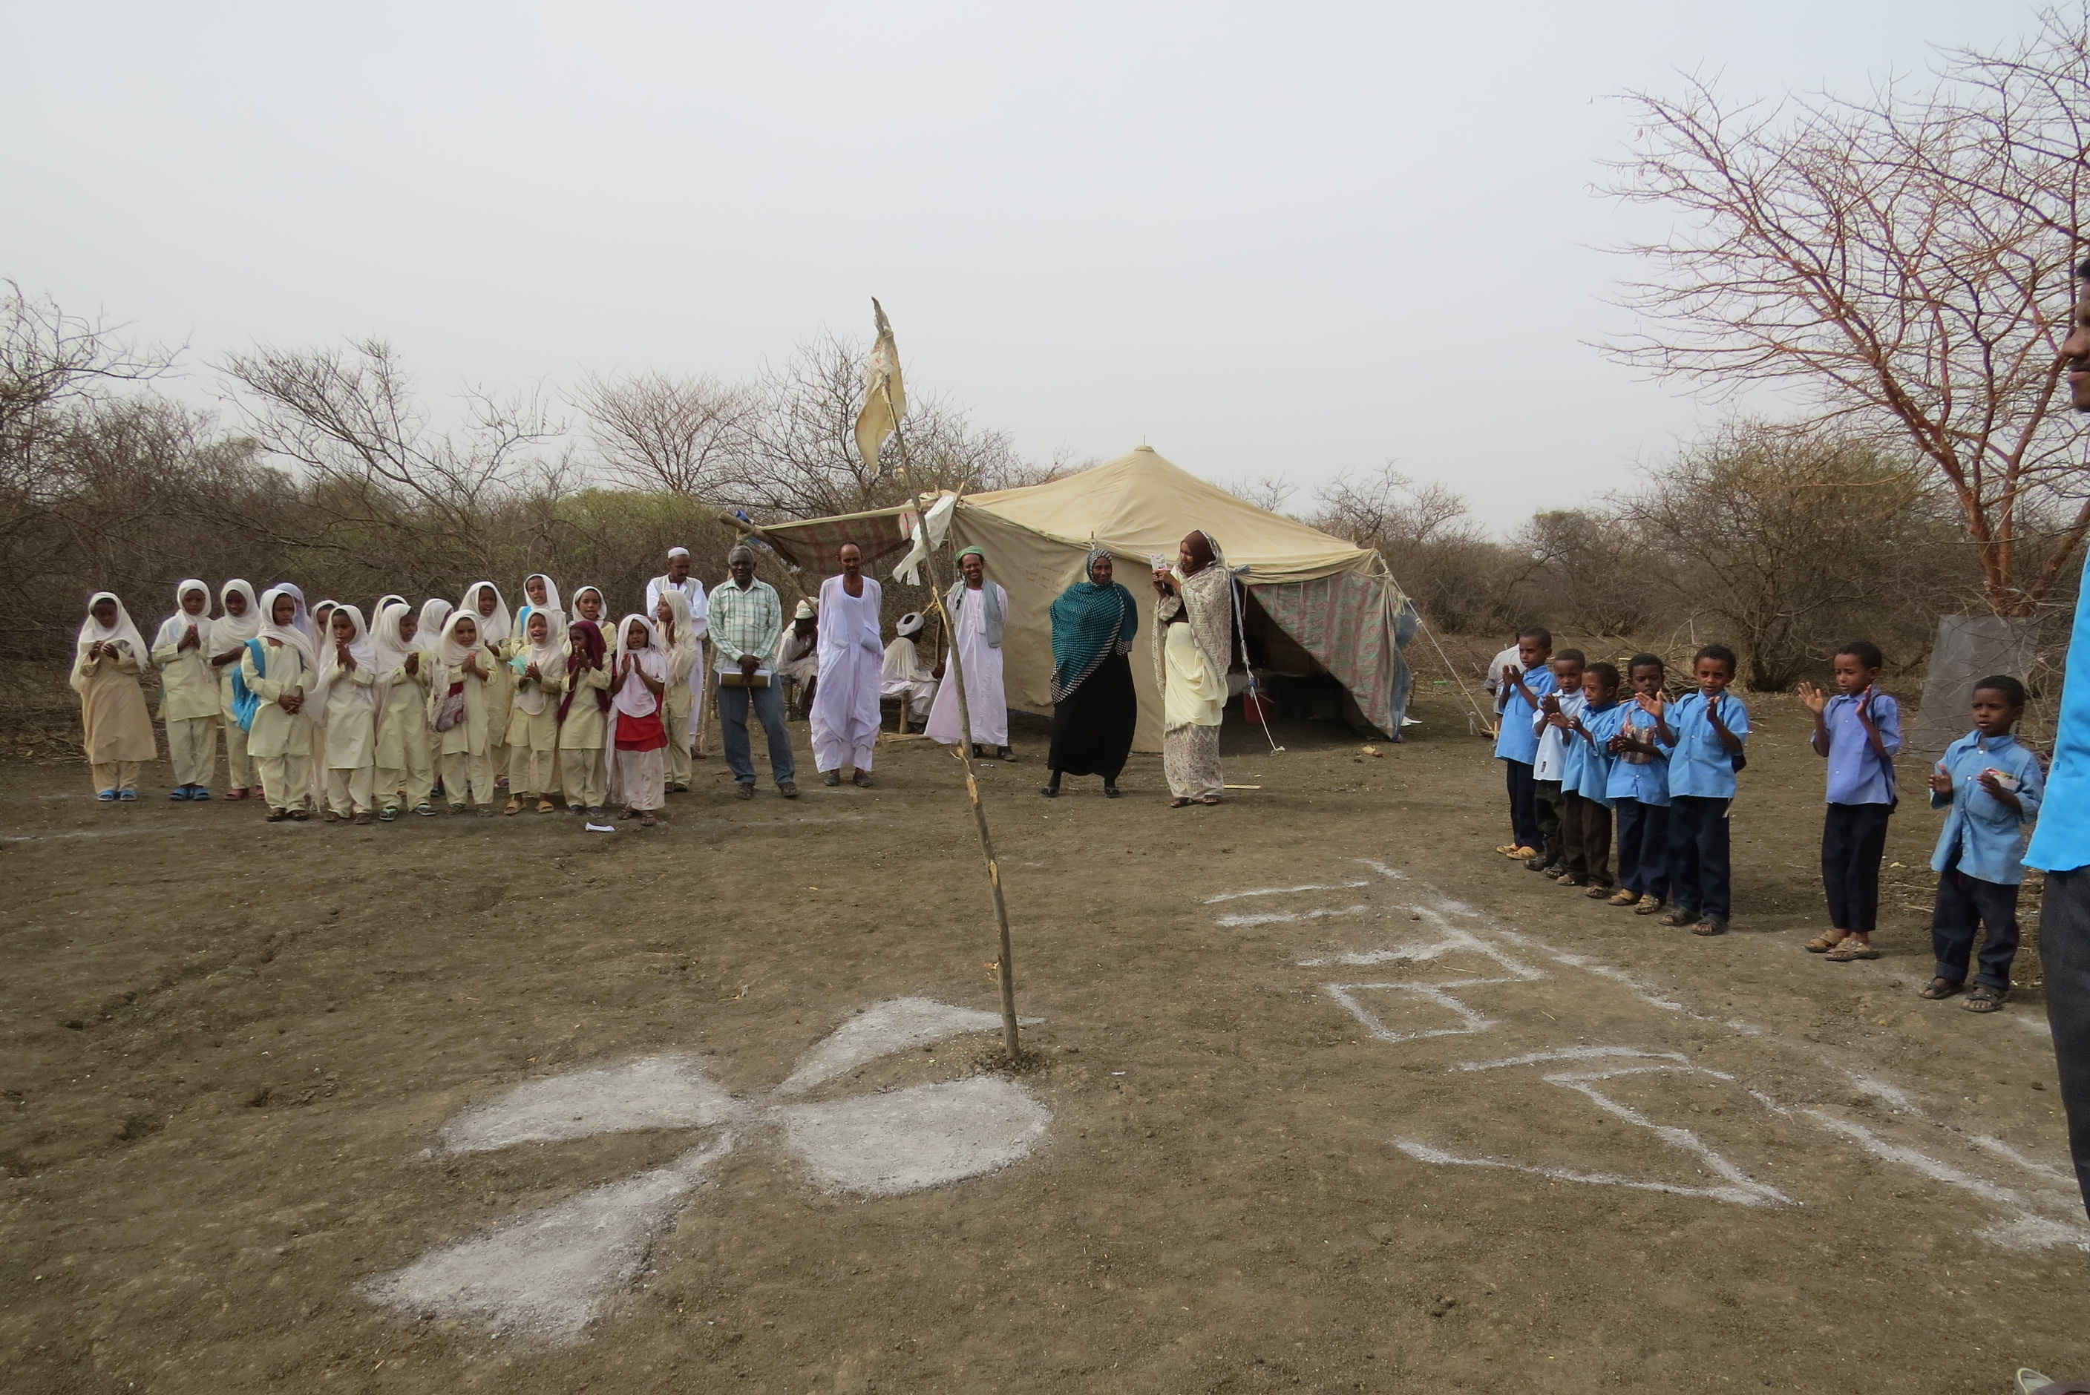
Pic. 7 Mobile School in alHawata surroundings, Wad al Khasheet
“We want to educate our children, but they are too small to walk long distances to school. Having the school and the teacher here is a really good solution”.
The school had been opened recently and thus had only one class. Although the exam period had officially started, school was still in session, due to the school having opened belatedly. The high flexibility of the mobile school system allowed for teaching to continue, despite this not being in accordance with the established plan. As explained by one community member, the school calendar was adjusted to children’s mobility pattern:
“The school opened on the 22nd of January. That’s why we asked for an extension of the teaching period.”
The mobile school system is highly adaptable to children’s needs. However, as already mentioned, it is available only up to the 4th year of primary schooling. Theoretically, after finishing this formal learning period children should continue their education in a remote fixed school. Access to life-long education is not only hampered by this MoE policy concerning formal education. There is a need to ensure an intake of 50 pupils per year in order to keep the mobile school open. One of the ministry officials explains:
“ It is very good that children can have mobile schools, but for how long will it last? […] The requirement of the MoE is to have an intake of 50 children per year. This is often the problem”.
The nomadic school I visited was functioning as a basic education school. However, as explained the NGO programme officer, “sometimes, the same learning spaces is used by AlMassar in order to provide ALP programme”.
b) The right to quality education
The curriculum provided throughout the first years of basic education seems to satisfy children’s needs. According to teachers:
“ Girls and boys are equally interested in education. They enjoy writing and religious classes a lot”.
In addition to the standard curriculum, teachers took the initiative to teach basic hygiene. These additional classes depended on teachers’ will and qualifications.
Based on my observations, the environment in which classes are taking place is friendly. The children had a good rapport with the teachers and they were smiling. But many essential materials are missing, such as sitting mats, solar lamps, water tanks and notebooks. Children are learning in harsh conditions.
One of the parents stresses that:
“ I contributed as much as I could. I gave the school a water tank. The children need water. But we still need things such as solar lamps. Without these, the teaching time is very limited”.
As far as teachers’ qualifications are concerned, three out of four teachers were qualified to teach. Three appointed teachers’ had received training on nomadic education, while the volunteer had not. However, as he points out:
“My father is a teacher. I have finished secondary education and I don’t have any problems during the classes (in terms of knowledge provision).
Schools are mostly built with the use of local materials. The community can feel real ownership over the project and run it with little support from the MoE. At the same time, meagre financial support leaves a huge burden on the community and curtails quality of education.
c) The right to respect in the learning environment
In mobile schools, the child’s integrity is preserved and respected by teachers. They take into account and respect cultural habits, such as child labour. They usually benefit from short-term training on nomadic culture. They tend to do their best in order to assure the equal progress of all children although this might sometimes be disadvantageous to the rest of the class. As two teachers expressed:
“Children’s absenteeism is one of the biggest obstacles. When a child misses class for one day, we have to repeat the whole programme with the class for that one child.”
  - Boarding schools (not available)
Boarding schools are needed. Their establishment seems to be essential for girls’ further education (i.e. the second cycle of primary education). Parents don’t want to send older girls to remote on-site schools, and the mobile school does not continue after grade 4. For this reason, as the Head of Girls Education states:

“One boarding school could help them (girls) complete their education. And it should be gender specific.”

Although the establishment of boarding schools has been part of the nomadic education strategy for the last few years, no boarding school has been created in Gedaref state, mostly due to limited funding. In the words of the Minister:

“Many factors, many. But mostly money.”

- Non-formal education (ALP): E-learning programme
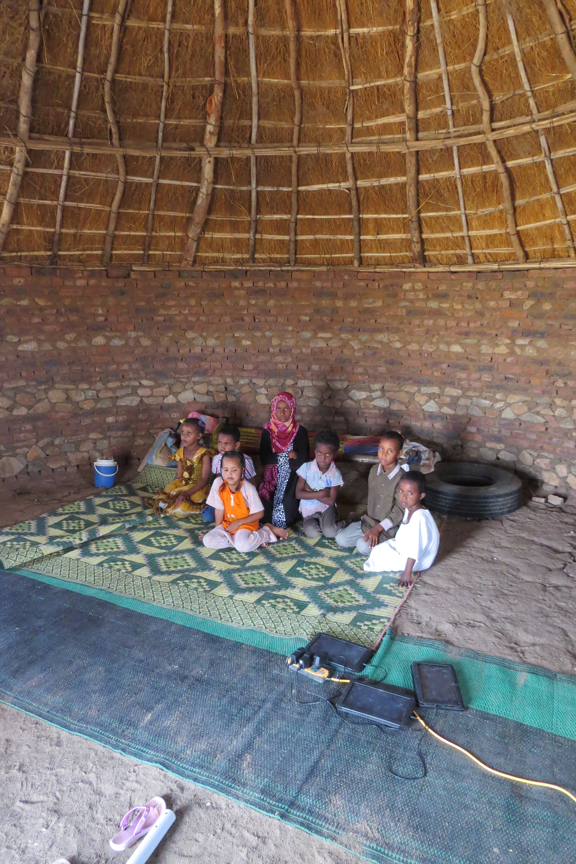
Pic. 8 The e-learning space in WadNourien community

- The right of access to education
The distance learning method is designed to provide access to quality education in remote areas. Indeed, such access is ensured. As community members observed:
“School is too far away for them to walk. Now, they can only be educated within the community.”

Sessions with tablets are adapted to children’s daily rhythm. In addition, the learning pace corresponds to the individual’s rhythm. Those children that have to skip classes in order to comply with their chores can do so without being concerned about having to catch up on lessons. As one of the beneficiaries of the e-learning programme explains:
“ Yes. Sometimes I have to help with the daily duties, like washing the dishes or fetching the water. (…) then I can restart the game where I left off”.
As stated, the programme overcomes the obstacle posed by absenteeism. A need for syllabus repetition disappears; a child can resume a task at the point he/she stopped previously. However, participation in classes is highly dependent on the availability of technical devices. As one of the facilitators explains, if one of the tablets gets broken,

“I call the relevant person. He comes, picks up the tablet and sends it to Khartoum. It’s back after two weeks. (…) The child has to wait for his tablet to arrive back”.

As a consequence, while repairs are happening, the child remains without any means to continue his/ her learning process. Moreover, although currently sponsored by the donor, it is plausible that tablets will in the future be limited only to the wealthier children. The other possibility is that aid agencies’ funding will chiefly determine access to learning. And thus, a continued equality of opportunity to access education is dubious under this project.
Another substantial problem linked to the e-learning project is the fact that it is designed as a non-formal educational path/track. Although it solves the problem of remoteness while preparing pupils to join formal education, it fails to solve the problem of continuity after finishing the course. Axiomatically, in the long-term, the issue of remoteness of schools is only postponed.

- The right to quality education
The quality of education as regards e-learning programmes depends on the software used. One of the facilitators expressed her appreciation of the software by saying:
“The e-learning programme is more user-friendly. Children learn faster. They also learn how to use a tablet. ”
Generally very optimistic about the programme, the same facilitator recognises that:

“They (the children) know how to write, but it would be better to incorporate more writing into the programme.”

Although they are overall content with the programme, the facilitators believed that the curriculum package provided by the e- learning programme is very limited (Maths and Arabic). They insist on the need for additional subjects to be available.

“First aid, hygiene and nutrition should be taught.”

As could be observed and deduced, the provision of additional classes relies completely on the facilitators’ will and qualifications. In other words, motivated and experienced facilitators can broaden the curriculum. As a consequence, they continue to play a crucial role in determining educational quality. In addition, attempting to ensure quality education by using technology at such a basic level seems to be misguided, since local teachers/volunteers are more likely to be able to teach at a basic level, but then to lack adequate skills to deliver the full curriculum at higher levels (OOSCI, 2014).

- The right to respect in the learning environment
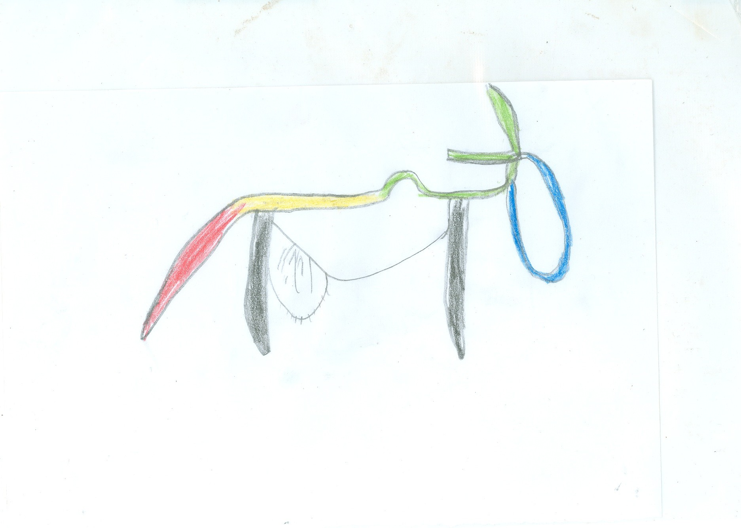
By remaining within the community, children usually feel safe and respected. In order to adjust the project to the nomadic environment, the software design is based on children’s drawings (though disputable: see below)

Source: Alp, powerpoint presentation
However, facilitators providing the e-learning package to communities have received training on the use of tablets,but not on nomadic culture. This is because e-learning is designed to reach the ‘hard-to-reach’, rather than being exclusively for pastoralist children.
Children are generally happy with the new method of acquiring knowledge. Girls participating in the project expressed their joy at learning:
“ We really are enjoying learning. It’s really nice. We are learning a lot”.
Nevertheless, one of the community leaders has expressed his fierce opposition to this innovative teaching method, saying:

“We don’t need technology over here. We need water and blackboards: blackboards to teach children how to write.”

The clash between living conditions and technology is unquestionable. It is hard to expect a sense of ownership of the programme from a community that is reluctant to embrace technology and perceives this mode of education-delivery as antagonistic to their lifestyle. Consequences are visible on this chapter’s front-page picture (see pic. 6). As the head of the NCLEA department explained:
“There were several incidents of purposive damaging of equipment. The electricity was cut off, and the community decided to create the learning space outside of the settlement.”

5.3.2 General observation pertaining to the implementation of educational programmes:

Awareness-raising campaigns
If not preceded by sensitisation campaigns, all of the programmes tend to have bad results or completely fail. AlMassar’s strategy is always to run an awareness-raising campaign before implementing any activity. As one of the staff says:
“Oh yes, we firstly run the campaign. Otherwise the project fails.”
The Director of the Girls Education Department of the MoE in Gedaref state holds similar position:

“Awareness campaigns are essential. We also target men in order to raise their awareness about the importance of nomadic education. ”

Such campaigns in her opinion are needed, since

“Community leaders have an old-fashioned mentality. They oppose girls’ education”.
The awareness-raising campaigns run by the MoE last for 4 weeks. They target all community members. However, the number of such campaigns is limited to only a few per year. In addition, if only one village is targeted it is difficult to introduce any changes.

Schooling fees
Although basic education is theoretically both free and compulsory in Sudan, parents often bear the burden of paying school fees or otherwise contributing financially to its running costs. Primary school fees in on-site schools are around 150 SDG for the first year. After that, pupils are supposed to give ‘donations’, which in practice are obligatory. Where education takes place within the community, parents have to provide food and/or shelter for teachers or facilitators remaining in the fariq.

Teachers/ Facilitators
Teachers from other communities are unwilling to relocate and take up posts in nomadic schools due to the absence of adequate incentives and the general hardships related to nomadic lifestyles. It is preferable that teachers have a nomadic background, but out of the seven teachers I encountered, only one matched the profile – and this person was not qualified to teach. Given the scarcity of pastoralist teachers, the actual teachers face the problem of reaching remote places. Therefore, when desired, teachers should have the opportunity to stay within the community. However, teachers complained about the poor living and food standards among pastoralists. These factors seemed to be deterring them, especially the female teachers, from living with pastoralists. All of the encountered non-pastoralist teachers or facilitators were travelling to teach the children on a daily basis. The problem of transportation to the pastoralist communities remains one of the most discouraging factors for teachers or facilitators. The incentives barely cover transportation expenses, or indeed do not cover them at all. As two teachers described:
“We have to take transportation every day. It is costly. We should be getting incentives for it but we still haven’t received any. And they’re not good enough anyway.”
In WadAlKhasheet community, although the mobile school was just recently opened, the initially appointed teacher had abandoned the school. The reason behind his leaving was not disclosed to me.
On another occasion, facilitators that were not of the nomadic background in Tayba community admitted that they sometimes feel ‘not welcomed’. As one of the minister added:
“7 years before, the attempt to provide education to this community failed. During the project implementation, 2 teachers left. One of the was of nomadic background.”
As the Director of NCLEA department explained:
“There is a scarcity of teachers. Only 50% of the facilitators participating in the e-learning programme are qualified teachers. The rest are volunteers.”
Being a volunteer entails not receiving any salary apart from incentives, and both the salary and the incentives are very low: around 700SDG and 400 SDG respectively. A level of frustration with such remuneration was apparent among all teachers I encountered.

Needs’ assessment in the targeted communities
None of the visited communities has yet been subject to a thorough needs or situation assessment. This was clear, as based on my observations: criteria for project implementation were not being met, the situation of women was not being addressed, and the total number of school-aged children was unknown to anyone. In addition, as I was told, different tribes show different attitudes towards education. As the Director of OOSC department explains:
“Most of the Skukriyya tribe communities are interested in education.”
It was noteworthy that in the Shukriyya community I visited, only a small minority of girls were participating in education (4 out of 18 pupils). In contrast, in the Tayba community belonging to Lahaween – considered by MoE staff as being ‘reluctant about education’- there was equal participation of girls and boys in the e-learning programme.

Distance and materials provision
The only road connecting the capital of AlGedaref state with the AlHawata is a bumpy dirt road. The drive takes about 4 hours. Due to the limited budget and staff shortage at the ministry level, provision of educational materials is done sporadically. In order to reach to nomadic communities, the Directorate of Nomadic Education uses one car donated by UNICEF years ago. The same car, used for relocation is used to deliver learning materials. In order to economise time and expenses, when going on a visit to WadAlKhaseet fariq, director of the MoE for nomadic education decided to provide a blackboard to the newly- established mobile school. However, due to constant shaking it broke before we reached our destination.

Food and water availability
The issue of a lack of food was apparent on numerous occasions during my field visit. Malnutrition among children was easily noticeable. Although the World Food Programme provides meals to schools due to the pour nutritional status of young children across Sudan, (WFP, 2015b), in 2013 and 2014 for instance, due to complexity of the malnutrition problem in the country Gedaref has not been identified as an intervention area.
Moreover, access to water is essential to ensure an education-friendly environment. The scarcity of water in the surroundings is hampering children’s learning cycle.
One of the community leaders was quite sceptical about education in light of the lack of water. He said:
“The closest water point is 6 km away. We have to think about it before we think about anything else”.
One of the parents says:
“I have provided a water tank. But another one is needed. This is a problem for children attending the classes”.
Latrine provision:
It has been recognised that girls are more sensitive to school quality and to how child- friendly an environment is, than boys are (USAID, 2008 in Farag, 2013). However, according to current government and UN policy, latrines are provided only to permanent structures. School structures designed in order to match a semi- or fully-mobile lifestyle, are bereft of sanitary services. This, according to the Federal MoE Nomadic Department Director, is one of the “biggest problems”:
“Children defecate around the school. There are no toilets in either mobile or semi-permanent schools. It definitely affects girls’ education more than boys’ education”.

Nomadic Girls Programme
There is no special programme addressing the needs of nomadic girls. Currently, girls’ clubs are places to enable young women to discuss and take action on rights violations. However, there is no definite policy targeting nomadic girls in particular.

5.4 Micro level
This section presents findings related to nomadic needs, desires and challenges in regards to education, taking into account the dynamic between the community and the individual - both in terms of agency and in terms of structure.
1) Desires

Content/ Curriculum
Overall pastoralist communities are strongly interested to benefit from education. The recognition of advantages arising from learning process is ubiquitous. What varies is how education is conceptualised in terms of what it aims to achieve, and what gains ensue from its provision. Expectations and desires vary from one individual to another. Among Kenana individuals, several parents expressed the desire for school to lead to opportunities in higher education; in the words of one father of 6 children:
“They should be able to reach universities”.
This appreciative perception of education was well-grounded in reality. The father quoted, who actively participated in the establishment of the mobile school, stated further:
“I know education is very useful. My sister-in-law is a University graduate and has got a really good job”.
This statement is but one example of how personal exposure to advantages resulting from education influences individuals’ expectations and understandings of education. This man’s perspective seemed to be prevalent within his community.
The PTA head added:

“ We want to educate children so that they will have a profession in the future”.

Children were also eager to learn as much as they could. They tended to appreciate knowledge gained during the teaching hours, although their expectations stemming from knowledge acquisition at an early age (6-9) are not defined yet. Asked about her perspective on education, and her desires linked to it, the 8- year old girl replied:

“I really enjoy learning. I hope to learn more”.

In general, the expected contents were oriented towards basic practical competences. In all communities, acquiring basic numeracy and literacy skills was perceived as a main objective:

“They should learn how to read and count”
Writing skills appeared to be essential and the most enjoyable for all children. Teachers agreed on the following:
“Children enjoy writing a lot. This is what they like the most”.
Religion was frequently cited as an essential subject, alongside Mathematics and Arabic classes. As one of the teachers explained:
“Children need to learn how to cultivate their faith”.
Another community member, when asked about their vision of a basic curriculum, answered:

“Maths, Arabic and Islamic studies”
On the other hand, the desire to provide life-skills to girls was stressed several times by various community members, especially among Lahaween community members. The most common skills mentioned were: cooking, nutrition, cultivation and sewing.
In one case, a strong discrepancy between female community members and the community leader’s vision of education was apparent. While women and girls were trying to define the life-skills that they wish to acquire in addition to basic literacy skills, the community leader claimed:

“We want cooking and discipline classes for girls”.
In the case of the Wad Nourin community, after observing the children participating in the programme, women expressed their strong desire to be educated as well:
“We are really happy with our children learning. It is great. We also want education”.
According to the Director of SMoE Girls education:

“ Both girls and boys reach secondary education but usually only boys go further. Separation of subjects (i.e. life-skills) occurs only at the secondary level (not at the primary level); life-skills are more attractive to girls”.

The trade- off for investing in education
As far as profit from education is concerned, parents in WadAlKhaseet are ready to invest in their children’s education, even independently of their sex:
“ I would pay for education of boys and girls equally”

On the other hand, fathers in WadNourin community, were less optimistic, and complain about not having immediate compensation for education:

“We pay but there is no money in return. “

Although the community leader maintained that he does not differentiate between investing in girls’ or boys’ education, in this particular case, only boys were going to a conventional school.

Means of delivery
As far the as e-learning education model is concerned, views ranged from very optimistic, to mixed, to negative. A very optimistic perspective was expressed by one of the facilitators:
“The e-learning programme is more-user friendly (than the traditional learning method). Children learn faster and they also learn how to use a tablet.”

Similarly, children participating in the e-learning programme said they enjoyed education with the use of technology.

“ I like the game. And I enjoy learning.”
However, the majority of the facilitators admitted that children would like to write as well. One of them stated:
“ Children say that they would like to write more”.
As far as older community members are concerned, they usually acknowledged that traditional means of delivery seemed more suitable for, and less antagonistic to, their culture:
“Learn with the use of traditional means: writing on the blackboard.”

- Needs

Provision of education from an early age within the community
Lack of geographically proximate schools is causing parents to be reluctant to send their small school-aged children to on-site schools. As the whole community univocally agrees:
“They are too young to walk long distances.”

In addition, as the young individuals grow older – and more vocally resistant to long walks in the heat – the fear for girls augments in parallel:
“We don’t send older girls. It is too dangerous for them”.

Moreover, a general trend of being less interested in education with age predominates. One of the Almassar staff has noticed:

“As children grow older their interest in education rather decreases. It is easier to encourage young people”.
The Director of Girls’ education believes that:

“Nomadic people would be eager to educate their children from an earlier age if this was provided within the community”.

Further, she adds:
“If the school is not co-educational, girls’ retention till the end of the basic education cycle is higher.”
Therefore, lack of schools within community is especially detrimental to girls’ education. Overall, a will and desire to access educational services is widespread among nomads. Although the school year calendar and daily schedules have been adjusted to the pastoralist rhythm of life, the age at which children are targeted seems not to have been. Educational services provided to nomads need to identify the age that will best fit with nomadic culture.

Support: water, electricity and learning materials
Complete ownership of the official educational programme for nomads is not really a viable option. Communities require guidance and support. Accessibility of water is crucial, and provision of learning materials and electricity is in high demand. One parent in the mobile school stated the following:
“We need to be supported by some institutional bodies. Solar lamps and water are necessary in order to secure time for education. Also, the learning space won’t survive heavy rains”.

Other learning materials are also scarce. As teachers observed:
“Books, notebooks and pencils are needed,[…] and sitting mats”.

Lack of basic educational materials was immediately apparent in every community. Overall, while the introduction of the technological component in the form of tablets was deemed superfluous, solar panels seemed to be regarded as very useful.

Gender-orientation
Child labour is indispensable for securing nomadic livelihoods. Harsh life conditions mean every community member must participate in daily chores or help with herding from an early age. Therefore, girls and boys are needed within their communities. Sometimes, children that attend school receive help from their older siblings and can partake in classes. Two girls in Tayba explain:
“ We have some daily duties: fetching the water, bringing the wood in or washing the dishes. But our older siblings support us. They want us to learn.”
However, this situation is different for the boys who roam during the night. As one minister explained,
“Boys from a Lahaween tribe- still in possession of a significant number of livestock- have often skipped classes. They are too tired to go to school after spending the night herding animals”.
In this case, there is thus a need to consider different work timetables for boys and girls.

The right to the land
Not all of the nomadic tribes are in the same situation in regards to land ownership. Kenana tribe members acknowledge the low viability of the pastoralist system, but as one of the schoolchildren’s fathers expressed:
“Even if we would like to settle somewhere, we don’t know where we can”.
One of the PTA members adds:

“ We often have problems with farmers.”
Problems surrounding rights to land vary from one community to the next. The Lahaween community had a permanent settlement; Shukriyya owned farming land; while Kenana didn’t have a permanent base.

Hygiene, health and nutrition
Raising awareness about hygiene and nutritional habits appeared to be imperative. Two teachers from a mobile school agreed that nomadic communities:
“(…) need to learn more about hygiene.”
Apart from the obvious consequences that a lack of hygiene entails for the community and pupils, it also deters teachers. A couple of facilitators expressed their discomfort at the low quality of food and hygiene, and thus their unwillingness to continue their work within the community.

Dialogue
There is a need to establish more comprehensive dialogue between pastoralist and mainstream societies. The dialogue should be established between specific groups and their counterparts. Without such communication, misunderstandings regarding each community members’ actual needs and desires occur. The establishment of a dialogue is essential for overcoming cultural barriers that obstruct girls’ education which stem from an uneven gender hierarchy.

- Challenges

The gender issue
The separation of pupils by gender has not yet been seen as a priority. It is, however, important to highlight that children in this context were aged 6-9. As two girl students asserted:

“ We are studying together with our brothers and it’s not a problem at all”.

Community members also admitted that co-educational learning during the life span (6-9) is not controversial for them. According to one of the ministry representatives:
“The issue of gender separation occurs around the age of 12-13 when girls are perceived as adults.”
Gender separation becomes desired once girls are considered as adults due to the cultural norms predominant within the communities. However, the adulthood is not conceptualized for boys and girls in the same manner. According to the director of the Nomadic Department of MoE in Gedaref
“Adulthood starts at the age 12-13 for girls and 18 for boys”.
This conceptualisation of adulthood is intertwined with the practice of early marriage. Thus, the aforementioned discrepancy between ages when this practice occurs probably indicates that there has been a change to this deeply- rooted cultural habit.
In all communities the subordination of women, and the resultant relegation of women to a lower category of people, was patently obvious. Women were not invited to participate in our meetings. They remained in a separate part of the village. Talking to them required authorisation from men. In addition, although in one of the communities we received permission to talk to women, the community leader interrupted the discussion after 10 minutes, using a whip to ‘impose order’.
On another occasion, while taking pictures of the surroundings, I was dragged into a hut full of women. They started expressing their willingness to be educated. As I left the hut, they followed me and started an argument with the community leader claiming their right to education. He reacted in an offensive way, threatening them with divorce and stressing the fact that their function is to take care of men. The Ministry official witnessing the situation intervened during the quarrel and started reciting verses of Quran in order to convince the community leader that women also have a right to education. He later explained to me that although he had been to this place several time over the last 6 months, he had never seen women before.

Moreover, it was evident that female teachers and facilitators were scared to express their opinion in front of the men. Once in private, they started to address issues that were bothering them.

Corporal punishment

As already mentioned, during one of the discussions with women, the community leader interrupted it and was using a whip in order to impose discipline and authority over the women and children. One woman immediately took her child out of the hut where the meeting was being held. Others became quiet. From the reactions of the gathered people, it was deducible that corporal punishment within the community happens on a daily basis.

Absenteeism

When children are absent, in case of boys, this tends to occur for the entire school day. This is because:
PTA: “The roaming children cannot participate in the classes.”

Girls, in turn may be absent due to the daily chores such as washing the dishes or fetching the water. In many cases frequent absenteeism eventually leads to drop-out. Moreover,
absenteeism among children requires high flexibility and patience form the teachers’ side.as she/he have to repeat the whole programme for one child. What is more, all children are obligated to repeat the same syllabus with that child.

Perceptions of the provider
Pastoral communities seemed to be suspicious of service providers’ intentions. The Shukriyya community tried to hide the fact that they had livestock, although this was easy to see. In the Lahaween community, the community leader didn’t want to disclose the fact that they had previously benefited from MoE support.

One community leader asserted the following:

“ We don’t want programmes that are not for us; that come from international agencies to fill the government’s pockets.”

In several cases, the community was reluctant to indicate the exact number of children as well as the number of school-aged children.

Chapter 6

Discussion, conclusions, and recommendations

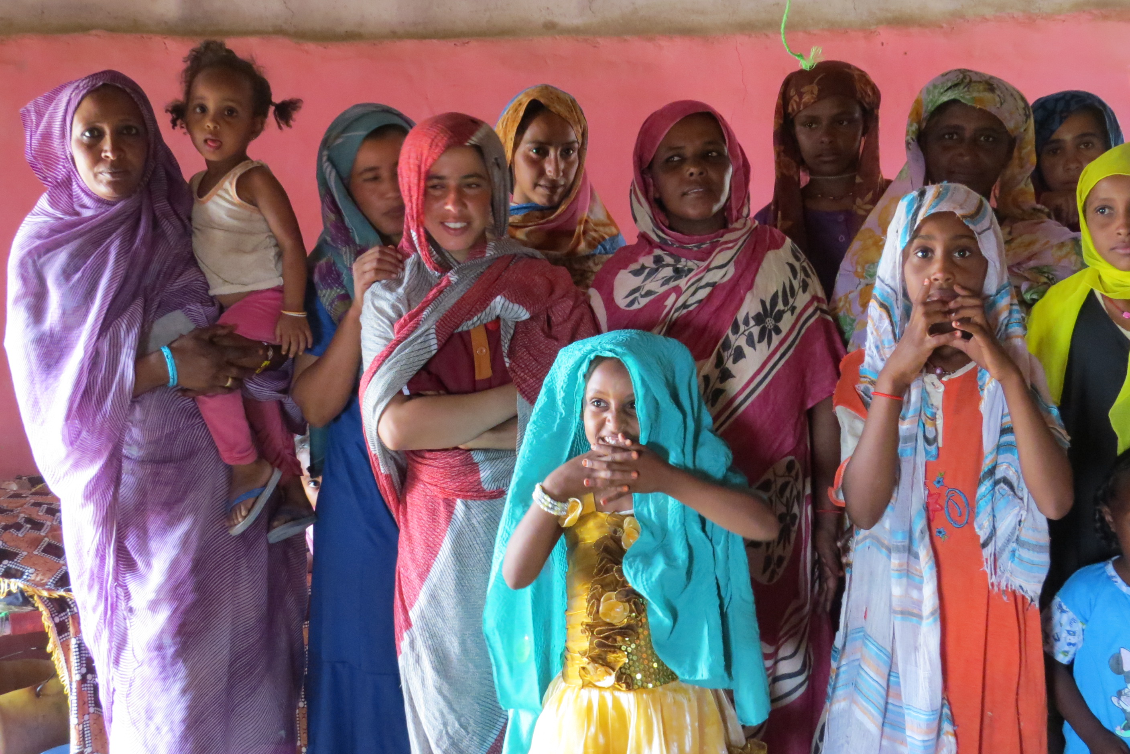
Pic. 10 Women from WadNourein community
“The core issues around sustainability are so serious and strongly affect all of us… from climate change to urbanization to bio-diversity. How successful we are going to be will all depend on our skills as educators.”
(Puntenney, P. in UNESCO, 2007)

6.1 Discussion
To recap, the current emphasis on nomadic education was laid down by international development agencies. Supported by international stakeholders, the government was supposed to develop strategies and mobilize part of the needed resources in order to meet EFA goals by the current year (UNESCO, 2000). Several researchers (Dyer and Krätli 2009, ElDood 2010, Ismail, 2002) have stressed that such a goal was ambitious, and that it posed huge challenges: aside from financial investment it required development of new policies, structures and strategies. Five years ago, such steps had not been taken in a meaningful way by the GOS: expenditure was low and an inefficient, decentralised educational structure crippled service delivery (ElDood, 2010). Some progress was made, but this was mostly due to UNICEF’s and other NGOs’ involvement in the matter. The current economic crisis has led to GOS investment being even more acutely restricted than before, confirming its very weak commitment to the signed declarations. Until now, any adaptations made by the GOS to meet pastoralist communities’ needs are mainly cosmetic.
The EFA declaration stipulates that support shall be provided as long as the government follows the EFA principles for action, which include comprehensiveness, equity, a learner-friendly environment, commitment to EFA goals, and keeping pace with technological advancements (UNESCO, 2000). The government has persistently displayed both very low motivation, and very low capacity for compliance with these principles, and yet international stakeholders continue to galvanise resources to ensure the realisation of the declaration. To the present day, education cannot be considered either free or compulsory in Sudan (ElDood, 2010; Farag, 2013). Moreover, there is little evidence of humanitarian agencies’ financial support on the ground (ALNAP, 2009). These factors for failure are further augmented by the GOS’s current restrictions, which mean humanitarian assistance is limited in terms of staff and access. Under these circumstances, the MoE’s reluctance to disclose data is not altogether surprising. It may, indeed, be dictated by a desire to keep the real situation in the field hidden, so as to facilitate future requests for donor funding.
Furthermore, there is very weak coordination between the various agencies involved, and ministry bodies. This is exacerbated by the fact that following the national structure of educational system entails dividing nomadic programme coordination into ALP and Basic Education categories. This significantly hampers service delivery. Under the current system, coordination of nomadic education is markedly inefficient, or indeed absent; and is considerably more intricate than it could, or should, be.
Little familiarity with, or a negatively biased perception of, the nomadic lifestyle is apparent within the great majority of education section partners. ElDood (2010) remarked that annual plans for nomadic education are developed without pastoralist community consultation; five years on, the statement is still valid. The same observation can be made with regard to the international aid agencies that have designed, for instance, the e-learning programme. Lack of information flow between UN agencies and nomadic communities, as well as abstractly established targets, led to the assumption that e-learning programme could suit nomadic needs. This ALP programme, which aims to provide quality education to disparate communities, might be practical, but only at a higher educational level. The introduction of a technological component in order to provide a limited and simple curriculum is superfluous and at odds with pastoralists’ daily living conditions and preoccupations, such as accessing water. The e-learning programme proved to be at odds with the beneficiaries’ surroundings, and was not welcomed at all by some members of the Lahaween community. It is not hard to understand the community leader’s frustration at basic needs not being met, while education was being provided via tablets.
Therefore, instead of shifting from a ‘disadvantage-based’ to ‘a diversity-oriented’ approach to nomadic development, the e-learning programme rather adapts a ‘post- welfare neo-liberal’ framework of intervention.
This intervention was undertaken despite existence of i.e. mobile schools: schools implemented by MoE, UNICEF and some NGOs (Farag et al. 2008; Browne, 2005) and in line with the EFA stance (especially in terms of access). They had already met some success; however, its effectiveness was circumscribed by existing policies.
Moreover, boarding schools, which appear to be crucial for continuity of education among nomadic children, and especially nomadic girls (Farag, 2008 et al. ElDood, 2010), are still not available in Gedaref. So long as the expenditure of the GOS does not increase substantially, this situation is unlikely to change.
In light of the decreasing viability of pastoralism, the Kenana tribe has shown considerable interest in education, but their access to it has been very restricted. In line with the social transformation paradigm it can be argued that this nomadic community wants access to state-provided education but are not able to achieve it until they are freed from constraints (Mohanty et al., 1991) imposed by the GOS.
Moreover, although educational programmes provided in the visited localities might be perceived as involving non-formal mode of delivery, the structure and content follow a traditional conceptualization of education. The same curriculum that was developed for mainstream society is applied both under the Basic Education programme and the ALP. While mobile facilities respect the pastoralist reality, the curriculum content is not necessarily in line with their needs. As remarked by ElDood (2010) and Farag (2013), the educational sphere remains firmly attached to the belief that a sedentary way of life is superior to the nomadic way of life.
This is especially detrimental to girls’ education. In order to avoid a protectionist backlash, and in order to ensure a positive trade-off for nomadic communities, girls’ curriculum content should be oriented towards practical and life-sustaining skills. The provided education should include a component relating to income generation.
However, as mentioned before, Crossley and Watson (2003) have stressed that there is “a difference between being the agent of one’s own development as defined in one’s own terms and being a mere beneficiary of development as defined by someone else”. Some nomadic tribes are not interested in conventional education. Areas of intervention should not, therefore, be based on the GER, as nomadic population figures are not a suitable indicator to determine their educational needs. As in the Wad Alkhasheet community, high enrolment among nomadic community members suggests an increasing need to secure their livelihoods in non-traditional ways (Krätli, 2001). Low enrolment might suggest that nomadic children cannot attend schools since their work is highly demanded by the community. Implementation of programmes in low-enrolment localities might therefore entail targeting people who are less in need of, and less interested in, an institution-based education.
Not only are education targets established abstractly, with a distinct lack of indicators adapted to the nomadic reality, but there is also a serious paucity of statistical data. This deficiency was inherited from the inadequacy of the census, and only acts to exacerbate the current lack of proper statistical assessments and tools (i.e. EMIS). The absence of reliable data on population on the local level, the state level and the country imply that many existing statistical series pertaining to the Sudanese education sector are of very doubtful reliability.
There are, therefore, a number of fundamental critiques that can be aimed at the approach to development that has been applied under the EFA scheme. However, as Grillo and Stirrat (1997) have observed, “A discourse identifies appropriate and legitimate ways of practicing development as well as speaking and thinking about it”. Given the current reality of educational development in Sudan, this section will now turn to a discussion of whether and to what extent EFA standards can be complied with by the GOS, irrespective of the above-mentioned critiques.
Several changes have to occur in order for the MoE to comply with RBA standards. As noted earlier (Browne, 2005, Oxfam, 2005 Farag et. al, 2008, ElDood, 2013), changes at the policy level should imperatively include an extension of the mobile school system to higher grades, focus on early learning (for girls in particular, taking into account the practice of early marriage), and should include a component related to sanitation (water tanks and semi-permanent toilet structures). The latter element is imperative as scarcity of water is negatively affecting all children’s class participation, while a lack of toilets is especially detrimental to girls’ rates of attendance. Although the mobile school system is a priori girl-friendly, a lack of toilets prevents their participation once they reach puberty. The scarcity of basic learning materials available (ElDood, 2010) is remarkable. Water tanks, notebooks, pencils, and uniforms: all of these items need to be provided in order to achieve EFA goals. Provision of electricity (for instance, the need for solar panels in the e-learning project) is an intervention that requires closer attention.
Low government expenditure results in a lack of incentives for teachers or facilitators to teach in pastoralist areas, as incentives currently barely cover transportation expenses. Given pastoralists’ strong reluctance to educate girls outside of the community, this is especially detrimental for girls. When young, they are too weak to walk long distances, but once they grow older, there are serious risks associated with leaving the community.
Moreover, the current mapping, monitoring and evaluation mechanisms are hardly functioning and are not oriented towards actual community needs. As regards programme implementation, especially by the MoE, it is clear that the community’s internal dynamics often fail to be addressed. Awareness-raising campaigns target all community members, with their focus being placed on girls’ education; but power dynamics remain unaddressed. UNICEF (2015) stresses the critical roles played by ‘power relations’ in obstructing girls’ education. These dynamics are apparent at the family, school, community and national government levels.
Okin (1999) has observed that dialogue with the leaders of minority groups is usually restrained to elite men only, this having been confirmed in the Sudanese context by Grawert in 2007. I also observed this reality while undertaking my research. According to Philips (2007), such an approach to consultation reinforces the paternalistic hierarchy within the community and sustains the vulnerability of a priori disadvantaged individuals. The position of women, as I observed in the WadNourin community, confirms Philips’ hypothesis.
As stated during the Mera Gathering (IFAD, 2012), I observed that, while nomadic communities are often marginalised by national development agendas, female community members tend to be completely neglected. But within these communities are further degrees of marginalisation. Girls and women pastoralists are marginalised within the community. Given the illiteracy of the community members, individuals of all ages should be encouraged to participate in education programmes. The patriarchal values of mainstream Sudanese society, which I was subject to as a researcher, are hindering any attempts to empower women within nomadic communities. Addressing the subordination of nomadic women is essential for nomadic girls’, and indeed nomadic communities’, future development.
Institutions such as the World Bank, and governmental organizations, have started to use the notion of ‘empowerment of women’ implying that the female development deficit could be made up for with the use of formal education (Grawert, 2007). However, the teachers and facilitators I encountered seemed to be afraid of opposing men’s views. In my observation, education did not lead to a change in women’s societal status. In this context, it is pertinent to recall the notion of ‘empowerment’ developed by Rowland (1997) “ Empowerment (…) must also include the processes that lead people to perceive themselves as able and entitled to make decisions” (Rowland, 1997).
Many factors may have contributed to the fact that education has not automatically resulted in empowerment.
One possible explanation is that the autonomy of women is restricted due to that way religion is conceptualized. As Giddens (1981-1984) has noticed social practices constitute both the medium and the outcome of social systems. Islam can be sometimes used as a tool for male power holders to justify the suppression of women (Laudowicz, 1992). Therefore, a deep connection to a patriarchal conceptualization of religion may lead women to accept their subordination. All communities demonstrated a very keen interest in religious education; accordingly, the way in which this subject is taught needs close scrutiny.
Another possible explanation is that, in the frame of the development projects, women mostly neither get legal access to land nor legal control over the resources, nor they are involved in decision-making process (Grawert, 2007).

Waring (1988) points out that the IMF, the World Bank and the UN measure economic growth by putting value on production and on interactions with the labour market. Institutions like the World Bank continue to gauge the development of women in Sudan through their participation in the labour market and formal education. Orientation towards sedentarization through education suggests the validity of Shivas’ (1988) argument that science has become a tool of the dominant classes to deprive peasants of their livelihood and to destroy nature.

Werlhof, Mies and Bennhof-Thomsen (1983) argued that capitalism is allied with patriarchy. They concluded that the self-determination of women is greater in the subsistence sector then in the commoditized sector. Looking at the current education system in Sudan, and taking into account women’s situation on the labour market, I have to agree with Grawert that the developmental-educational projects tend to enhance the superiority of men over women.
The underlying idea that nomads are backwards is still apparent in the approach adopted by the majority of education partners in Sudan but also in the current agenda for the development of the country. The conceptualization of development according to the old, neo-liberal pattern remains visible, for instance, in the new FYPER.
Historically, due to land degradation, pastoralist mobility was first reduced, and then was oriented towards urban agglomeration. Yet, urban agglomerations in Sudan currently have little to offer, particularly for women. On the contrary, the country’s economy is, to a large extent, relying on pastoralist livestock production. Analysing the development process in Sudan holistically, it is clear that for both the Sudanese government and the nomadic people, keeping pastoralism alive is beneficial. This system of subsistence significantly contributed to the national GDP and has proved to be resilient in the face of global market dynamics and environmental adversities. And yet, educational services for nomadic people are not currently oriented towards providing knowledge that would enable revitalisation of their particular livelihoods and lifestyle. It rather aims to prepare them to join the ‘developed’, mainstream world. It is now recognised that pastoralists and agropastoralists are capable of income generation and livelihood creation in conditions where conventional farming fails (IFAD, 2012). Education should include land revitalisation, and should take place within the community. Recognition that abandoning the Gezira scheme was a mistake needs to be accompanied by recognition of the value of pastoralist production.
The EFA’s assertions fit both the neo-liberal deficit framework, and the difference framework. As both approaches call for community participation, they can easily be confused. The real crosscutting factor in this matter lies in the source of agency. Rather than adapting social transformation and/or diversity approaches, the whole educational system is oriented towards integrating nomads into mainstream society. To truly comply with EFA, there is an acute need to adopt the difference approach to pastoralist communities in order to assure the sustainable development of all people in Sudan.
The current educational system, being weakly adapted to nomadic or semi-nomadic lifestyles and needs, is currently inappropriate for those nomadic individuals who wish to benefit from the service, and this is especially true in the case of nomadic girls.

6.2 Conclusions
EFA, as explained previously, is an initiative that aims to provide education to every human being so that they may reach their full potential and secure their livelihood. This premise should not be confused with the integration of all children into schooling. Informal education is also a form of education, which has served nomadic communities for centuries, and which was sufficient and adapted to their understanding of life and vision of society.
Education serves the purposes of development strategies. For instance, the current educational system in the Western world emerged in response to the needs of an increasingly industrialised world. The institution of formal education has enabled individuals’ participation in the labour market. A similar pattern can be observed in the history of development in Sudan. The colonializing power needed to form a cadre of educated individuals who would be capable of managing developmental programmes designed by the coloniser. Development strategies adopted lead to desertification, land degradation and rural exodus. Meanwhile, nomads, pursuing a means of subsistence that has proved highly resistant to and efficient in harsh environmental conditions, remained capable of following their traditional lifestyle.
Recently, this situation has been subject to change in Sudan, and in Gedaref state in particular. Since 1980, severe droughts have led many pastoralist tribes to start engaging in other activities, and concomitantly, to settle. Those who adhered to the programmes carrying a new vision of development reaped benefits in the form of land entitlement. However, dialogue was only established with the male elite. The result, as can be observed in the Shukriyya tribe in Gedaref, has been the marginalization of women within their communities, and the establishment of dependency on men.

Western actors have shaped the current educational system in Sudan, which envisions furnishing individuals with the skills required to sustain their families under new economic circumstances. However, responding effectively to diverse nomadic needs is very challenging, and requires frequent consultation with the community. This is not only because it increases communities’ participation and gives them a sense of project ownership, but above all because the economic situation of semi-nomadic and pastoralist groups varies substantially between different communities.
It may be argued that the viability of economic activity for a particular group, as well as the type of economic activity adopted, will determine that group’s interest or otherwise in education, and will also determine men’s interest in allowing women access to it.
Traditionally, work among nomadic tribes has been gender oriented. However, when agriculture is chosen as a supplementary mode of subsistence, both men and women engage in the same practice. In the agropastorialist mode of subsistence, the herding workload decreases for men, while women’s household-related responsibilities remain the same. Therefore, it can be argued that allowing agropastoralist girls access to education is against men’s interest, since their participation in education reduces their capacity to work on the land and fulfil household related tasks.
Other tribes that are in immediate need of securing their livelihoods by non-traditional means, and who do not possess land, are keen to invest in education once convinced of its benefits. The Kenana tribe is one such example; this tribe is equally interested in investing in girls’ and boys’ education. However, as observed in the Lahaween tribe, the type of education provided should not be at odds with the surroundings, and should respond to the needs of the community.
In sum, although nomadic communities show similar socio-cultural characteristics (even when settled), nomads’ motivation to educate their children is manifold.

Further, while international actors continue to galvanise resources and design projects according to their conception of development, the government remains comparatively passive regarding education. This passivity is reflected in its low expenditure on education.

Moreover, all programmes fail to recognize the value of pastoralism as a mode of subsistence. The education of ‘pastoralist people’ should aim to sustain pastoralism and their vision of the future; the value of informal education and indigenous knowledge shouldn’t be discredited. Although purportedly designed to fit the nomadic lifestyle, the formal educational track is antagonistic to nomadic lifestyles, while the non-formal track intends to bring children into the formal mode of education in the future.
The current intervention framework aiming at bringing all children to schools by 2015 is underpinned by a perception that western education is universal. This approach is bereft of proper contextualisation. Generalization in terms of nomadic communities’ needs, expectations and desires should be avoided, should the assumption that schooling is necessary and automatically leads to empowerment.
According to the premise of the United Nations Declaration on the Rights of Indigenous Peoples adopted by the General Assembly in 2006 an educational system that fails to discern whether the integrity of the community is preserved or not can be interpreted as its violation. As observed, such is the case in the Sudanese context. Revitalisation of pastoralism should constitute the underlying idea of education for nomadic children. Further, educational programmes should be designed in consultation with every community member.

Moreover, the results of the rural exodus in Sudan are clearly negative. Therefore, the government should abandon the strategy of sedentrization through education, given the fact that their spatial organization hasn’t been properly managed and unemployment is very high. The current mobility pattern oriented towards sedentarisation in urban surroundings should be reversed. This can only occur if the policy for action in different sectors is coherent and oriented towards revitalization of the ecosystem.

6.3 Recommendations
This section sets out a case for a comprehensive set of reforms that can provide major benefits to nomadic communities in Sudan:

a) Government:
- Create a separate body for nomadic education at the ministry level that would encompass both the ALP and Basic Education;
- Change regulations pertaining to the mobile school system: consider it as a viable method of education provision but adjust the structure and the intake requirements;
- Create a separate body of teachers who specialise in nomadic education;
- Improve INGO staff access to the field;
- Design, in consultation with the pastoralist community, a syllabus that is highly flexible and gender-sensitive, with separate consultation for men and women; and
- Include nomads – both men and women – in the decision-making process.
b) UN (UNICEF/ UNESCO)
- Map areas of intervention for nomadic people based on previously conducted assessments, and improve understanding of the needs on the ground across Sudan;
- Strengthen Community Based Approach by making sure that both the government and the NGOs address all community members’ needs when implementing projects;
- Develop a dry toilets model for mobile schools, and include them in every mobile school;
- Invest in an independent monitoring and reporting system to ensure the impartiality of the humanitarian response; and
- Conduct research on nomadic community and domestic coping mechanisms, incorporating these findings into teacher training, in order to spread good teaching practices.

c) INGOs and NNGOs:
- Update the beneficiary list through a verification process; and
- Allocate specific financial and human resources to programme coordination and information exchange.

d) Donors:
- Continue to support research to provide a better understanding of, and deeper analysis of, the nomadic education situation;
- Support and give more credit to local NGOs; and
- Sponsor independent monitoring or supervision of aid programmes.
e) Further research
I strongly encourage anyone concerned with the pastoralist issue, and anyone particularly interested in nomadic girls’ education for sustainable development, to further investigate the relationship between different modes of subsistence and men’s attitudes towards girls’ education.

Bibliography
- Abbas et Al. (1992) Camel Pastoralism in the Butana and Northeastern Sudan. In Nomadic Peoples, No. 31, 1992
- ACAPS, (2012) Qualitative and Quantitative Research Techniques for Humanitarian Needs Assessment. An introductory brief [Online] Available from: http://www.acaps.org/img/documents/q-qualitative-and-quantitative-research.pdf [Accessed: 30th March 2015].
- AEO (2014) African Economic Outlook. Sudan [Online] Available from http://www.africaneconomicoutlook.org/fileadmin/uploads/aeo/2015/CN_data/CN_Long_EN/Sudan_GB_2015.pdf [Accessed: 4th April 2015]
- ALNAP (2009) Where to now? Agency expulsions in Sudan. Consequences and next steps. [Online] Available from http://www.odi.org/sites/odi.org.uk/files/odi-assets/publications-opinion-files/4190.pdf [Accessed: 4th April 2015]
- Banks, A. (2004) ‘Multicultural Education: Historical Development, Dimensions and Practice’ in Banks, A and Cherry A. McGee Banks (eds.) Handbook of Research on Multicultural Historical Development, Dimensions and Practice, New York: John Wiley& Sons, pp. 3-29
- Babiker, M. (2011), ‘Mobile Pastoralism and land grabbling in Sudan: Impact and Responses’; In The International Conference on the Future of Pastoralism, Feinstein International Center of Tufts University
- BBC, (2012) Khartoum expels foreign aid agencies from eastern Sudan; 1 June 2012, [Online] Available from http://www.bbc.com/news/world-africa-18296430 [Accessed: 4th April 2015]
- Becker, S. (1982) Arts worlds. University of California Press
- Birch, I et al. (2010) Towards education for Nomads: Community Perspectives in Kenya; International Institute for Environment and Development. London. Available from http://pubs.iied.org/pdfs/10026IIED.pdf
- Browne, S (2005) Mobile Education in Darfur: Conduit to EFA or Optical Illusion? [Online] Available from http://www.tc.columbia.edu/sie/journal/Volume_2/Browne.pdf
- Burke, J et al. (2007) Towards a definition of Mixed-Method Research; in Journal of Mixed Methods Research, Vol. 1 No 2, April, Available from http://mmr.sagepub.com/cgi/content/abstract/1/2/112
- Bryman, A (2006), Integrating quantitative and qualitative research: how is it done? SAGE Publications London
- Bryman, A. (2012) Social Research Methods. 3rd ed. Oxford: Oxford University Press.
- Car Hill, R. & Peart, (2005) The education of nomadic people in East Africa – Review of relevant literature (Djibouti, Eritrea, Ethiopia, Kenya, Uganda, Tanzania. African Development Bank
- CBS (2008) Central Bureau of Statistics, Sudan. 2008 Sudan Population and Housing Census. Available from http://www.cbs.gov.sd/files.php?id=7#&panel1-3 [Accessed: 5th June 2015]
- Cohen et al., (2007) Research methods in Education, Routledge, London
- Darosa and Agab (2008) A field survey of some camel (Camelus dromedarius) production traits and constraints in Butana area, Sudan. [Online] Available from http://sustech.edu/staff_publications/20090614130124844.pdf [Accessed: 4th April 2015]
- Della Porta, D and Keating, M (2008) ‘How many approaches in the social sciences? An epistemological introduction’ in Approaches and Methodologies in the Social Sciences. A pluralist perspective. ed. Della Porta, D and Keating, M Cambridge: Cambridge University Press
- Drylands coordination group (n.d) Changes and threats facing nomads in drylands. Oslo available at http://www.drylands-group.org/Articles/1828.html
- Durkheim, E (n.d.) On education and society; [Online] Available from http://eppl751su2012.wmwikis.net/file/view/Durkheim.ch2.On.Education.and.Society.pdf [Accessed: 4th April 2015]
- Dyer, C. (2006) ‘Introduction: Education for Nomadic Peoples: an urgent challenge.’ in Dyer, C. (ed.) The Education of Nomadic Peoples Current Issues, future prospects. New York and Oxford: Berghahn Books
- Dyer, C. (2013) Does mobility have to mean being hard to reach? Mobile pastoralists and education’s terms of inclusion, Centre for Development Studies, University of Leeds, Leeds, UK.
- El-Arifi, S. (1975) Pastoral Nomadism in the Sudan. In East African Geographical Review No. 13, June 1975; pp. 89-103
- ElDood, A. (2010) Education of Nomadic children in Sudan: Current situation, Economic & Social factors and Future prospective; (PhD thesis, Al-Zaiem Al-Azhari University)
- Farag, A et al. (2008) The Evaluation of Nomadic Education in Selected States of Sudan. Khartoum, UNICEF
- Farag, A (2013) Does education work? Perspectives on Semi-Nomadic Girls’ Education in Some Selected Areas of Sudan. In Reflections on Gender and Education in South Africa and Sudan; pp. 77-98
- FAO (1997) Epidemiological studies on camel diseases in the eastern Sudan. [Online] Available from http://www.fao.org/docrep/x1700t/x1700t06.htm [Accessed: 30th March 2015]
- Grawert, E (2007) Women’s role in securing peasant livelihoods. In Making a Living in Rural Sudan. Food production of Women, Labour migration of men, and Policies for Peasant’s Needs. London/ New York (first ed. 1998) Mac Millan Press
- Grinnell, R and Unrau, Y. (2013) Social Work Research and Evaluation: Foundations of Evidence-Based Practice, 10th ed . Oxford University Press
- Hox, J.J. and Boeije, H.R. (2005). Data collection, primary versus secondary. Pp. 593-599 in K. Kempf-Leonard (ed.). Encyclopedia of Social Measurement. San Diego, CA: Academic Press.
- Hsieh H and Shannon S (2005). Three approaches to qualitative content analysis. In Qualitative Health Research 15(9): 1277–1288.
- IFAD (2012) Livestock thematic papers. Tools for project design. Women and pastoralism; Available from http://www.ifad.org/lrkm/factsheet/women.pdf [Accessed: 24th May 2015]
- JISC (n.d) Introduction to eLearning [Online] Available from http://www.jiscdigitalmedia.ac.uk/guide/introduction-to-elearning [Accessed: 13th April 2015]
- Kradin, N (2002) Nomadism, Evolution and World- Systems: Pastoral Societies in Theories of Historical Development. In Journal of world-systems research, pp. 368–388
- Krätli S, (2001) Education Provision to nomadic pastoralist: A literature review. Institute of Development Studies (IDS) working paper 126 – Study undertaken under World Bank
- Krätli, S., and Dyer, C. (2009). Mobile Pastoralists and Education: Strategic Options. Education for Nomads Working Paper No. 1. London: International Institute for Environment and Development (IIED). http://pubs.iied.org/pdfs/10021iied.pdf.
- Konczacki, Z. (1967) “Nomadism and Economic Development of Somalia: The position of the nomads in the Economy of Somalia” in Canadian Journal of African Studies, Vol. 1, No2, Nov 1967, pp. 163-175
- Larsen and Hassan (2001) Perceptions of Knowledge and Coping Strategies in Nomadic Communities – The case of the Hawawir in Northern Sudan, report 15. Center for international Environment and Development Studies
- Miller, C. (2005). Power, land and Ethnicity in the Kassala-Gedaref States. Le Caire, CEDEJ, pp.3-58, 2005
- MoE (2013a) Ministry of Education General Directorate for Education Planning; Girls Education Sub-Sector Strategic Plan 2014-2016
- MoE (2013b) Ministry of Education General Directorate for Education Planning; Nomads Education Department Nomadic Children Education Strategy for the Years 2013-2016
- Mohamed, A. and Ahmed, M. (1991) ‘Camel Pastoralism as a Food System in Sudan: Limitations and Challenges’ in Nomadic Peoples, No. 29, 1991 [Online] Available from http://nomadicpeoples.info/pdf/NP_journal_back_issues/Camel_Pastoralism_as_a_food_system_in_the_Sudan_T_El_sir_Ahmed_Mohamed_and_AGM_Ahmed.pdf
- Mohanty, et al. (1991). Third World Women and the Politics of Feminism, Indiana University Press
- Okin, S.(1999). Is multiculturalism bad for women? In Is multiculturalism bad for women, Moller Okin S. New York: Princeton University Press pp.9-24
- MONEC (2003) Al Massar Charity Organization for Nomads Development & Environmental Conservation, Pastoralist Baseline Survey, Greater Darfur
- OOSCI (2014), Out-of-School Children Initiative, Sudan Country Report, DRAFT
- Oxfam (2005) Beyond the Mainstream: Education for nomadic and pastoralist girls and boys, Education and Gender Equality Series, Oxfam: Great Britain
- Panos (2007) The case of communication in sustainable development, Promoting dialogue, debate and change. London. [Online] Available from http://panos.org.uk/wp-content/files/2007/09/The-Case-for-Communication-in-Sustainable-Development.pdf [Accessed: 4th May 2015]
- Pennells, J and Ezeomah, C. (2000) ‘Basic education for refugees and nomads’. In: Yates C. and Bradley J. (eds), Basic education at a distance, world review of distance education and open learning volume 2. London and New York: The commonwealth of learning
- Perraton, H. (2007) Open and Distance Learning in the Developing World. (Second Ed.) Hilary Perraton. (2007). Routledge, London;
- Phillips, A. (2007) Multiculturalism without Culture. Princeton, NJ: Princeton University Press
- Reinert, E. (2006) How rich countries got rich, and why poor countries stay poor, London: Constable & Robinson.
- Reliefweb (2015) Maps and inforgraphics. [Online]. Available from: http://reliefweb.int/maps [Accessed: 5th May 2015]
- Robson, C. (2002). Real World Research. A Resource for Social Scientists and Practitioner Researches, 2nd edition. Blackwell: Oxford
- Rogers, A (2004) Non formal education. Flexible Schooling or Participatory Education? , Comparative Education Research Centre
- Rowland, J (1997) Questioning Empowerment- Working with Women in Honduras. Oxford: Oxfam
- Saha, L (2008) Sociology of Education. In 21st Century Education: Reference Book 2008; Sage Publications, 19 March 2011
- Sen, A (1999) Development as freedom. First anchor books edition, NewYork
- Tahir, G. and Muhammad, N. (1998) Readings on Distance Education for the Pastoral Nomads in Nigeria, Zaria: Ahmadu Bello Univeristy Press
- Tahir, G, Muhammad, N, Mohammed, A (2005) Improving the quality of nomadic education in Nigeria: Going Beyond Access and Equity, ADEA, France
- Teddlie, C and Yu, F (2007) Mixed Methods Sampling: A typology with examples. In Journal of Mixed Methods Research 1/ 77
- Tomei, G (2011) Cultural and Symbolic Dimensions of the Migration- Development Nexus. The Salience of Community. International Migration Institute (IMI), Oxford
- UNDP (2006a) Nomads’ Settlement in Sudan: Experiences, Lessons and Future action (Study 1); ed. Angela Stephen. UNDP: Khartoum
- UNDP (2006b) Share the land of Part the Nation: The Pastoral Land Tenure System in Sudan. (Study 3) ed. Angela Stephen. UNDP: Khartoum
- UN (2008) United Nations Declaration on the Rights of Indigenous people; [Online] Available from http://www.un.org/esa/socdev/unpfii/documents/DRIPS_en.pdf [Accessed: 24th May 2015]
- UNDP, (2009) Human Development Report 2009, Overcoming the barriers: Human mobility and development, 1st ed. Palgrave, New York
- UNDP (2014a) Sustaining Human Progress: reducing vulnerabilities and building resilience. UNDP: Khartoum Sudan; [Online] Available from http://hdr.undp.org/sites/all/themes/hdr_theme/country-notes/SDN.pdf [Accessed: 26th May 2015]
- UNDP (2014b), Human developments reports. Data 2014. [Online] Available from http://hdr.undp.org/en/data [Accessed: 5th June 2015]
- UNEP (2013) Standing Wealth, Pastoralist livestock production and local livelihoods in Sudan, United Nations Environment Programme
- UNESCO, (1990), Jomtein Declaration of Education for all; Thailand: UNESCO
- UNESCO, (1993) Emile Durkheim Prospects in The quarterly review of comparative education vol. 23, no.1/2, 1993, p. 303–320. Paris: UNESCO
- UNESCO (2000) Education for all: Meeting our collective commitments, The Dakar Framework for Action. Paris: UNESCO.
- UNESCO, (2007) Education for sustainable development; [Online]. Available from: http://www.unesco.org/archives/multimedia/index.php?s=flvplayer&pg=33&vl=Eng&vo=2&id=432 [Accessed: 24th May 2015]
- UNESCO & UNICEF (2007) A human rights- based approach to Education for All, A framework for the realization of children’s right to education and rights within education, UNICEF: New York
- UNESCO (2012) World data on Education. Sudan; Revised Edition; [Online]. Available from: http://www.ibe.unesco.org/) [Accessed: 14th June 2015]
- UNESCO (2015) UNESCO’s Contribution to Post-2015 [Online]. Available from: http://en.unesco.org/post2015/ [Accessed: 24th June 2015]
- UNHCR (2015) 2015 UNHCR country operations profile – Sudan. [Online]. Available from: http://www.unhcr.org/pages/49e483b76.html [Accessed: 27th May 2015]
- UNICEF (n.d.) Definitions of the indicators; [Online]. Available from: http://www.unicef.org/infobycountry/stats_popup5.html [Accessed: 24th April 2015]
- UNICEF (2015) Girls’ Education and Gender Equality [Online]. Available from: http://www.unicef.org/education/bege_70640.html [Accessed: 3rd May 2015]
- Young, H., et al. (2009) Livelihoods, Power and Choice: The Vulnerability of the Northern Rizaygat, Darfur. Medford, MA: Feinstein International Center, Tufts University.
- Young, H et Al. (2012) Pastoralism and Pastoralists in Sudan: A Stakeholder Mapping and Survey; Tufts university; Available from http://fic.tufts.edu/assets/Pastoralism-and-Pastoralists-in-Sudan-LB3-HY21.pdf
- War Child (n.d) Improving the Lives of Sudanese Families. [Online]. Available from http://www.warchild.ca/whatwedo/dafur_sudan
- WFP (2015a) School meals. [Online]. Available from http://www.wfp.org/school-meals [Accessed: 24th May 2015]
- WFP (2015b) Sudan. Overview. [Online]. Available from: https://www.wfp.org/countries/sudan/overview [Accessed: 24th May 2015]
- World Bank (2011) Global Partnership for Education Fund (GPEF). [Online]. Available from: http://fiftrustee.worldbank.org/index.php?type=fund&ft=gpef [Accessed: 24th May 2015]
- World Bank (2013) Supporting Education Progress in Sudan; [Online] Available from http://www.worldbank.org/en/news/press-release/2013/04/11/Supporting-Education-Progress-in-Sudan [Accessed: 5th May 2015]
- Zaki, C (1988) Formal, non-formal and informal education: concepts/applicability. In Cooperative Networks in Physics Education - Conference Proceedings 173”, American Institute of Physics, New York, 1988, pgs. 300-315.
- Proposals: The proposals of the projects presented by WFP (2014), Plan International (2013/2014) and AlMassar (2014/2015) have been reviewed.

ANNEXES:

Annex 1: Tables

Table (1): Nomadic children 6-13 years old who are not enrolled in Basic School
State | No. of children age 6-13 years |  |  | No. of nomadic children enrolled in school |  | No. of nomadic children out of school
 | Boys | Girls | Total | Boys | Girls | Boys | Girls
Northern | 6,982 | 6,982 | 13,964 | 5,408 | 4,634 | 1,964 | 1,958
River Nile | 8012 | 5228 | 13,240 | 5912 | 3987 | 2,100 | 1241
Blue Nile | 13215 | 12,402 | 25,617 | 3147 | 2260 | 10,086 | 10,086
Sinner | 10,000 | 7,000 | 17,000 | 5260 | 2880 | 4,540 | 4120
White Nile | 17,708 | 15,615 | 33,323 | 5402 | 4927 | 4,927 | 9,854
Northern Kordofan | 7,201 | 4115 | 11,316 | 7979 | 3462 | 42,115 | 4120
Southern Kordufan | 27,288 | 29,561 | 56,849 | 5618 | 3602 | 21,670 | 25959
Northern Darfur | 47,790 | 31,860 | 79,650 | 15,307 | 10,665 | 32,497 | 21665
South Darfour | 103,311 | 83,743 | 187,054 | 20240 | 11277 | 83,071 | 72,466
West Darfour | 47,790 | 31,860 | 79,650 | 15307 | 10,18 | 32,497 | 21665
Red Sea | 94,000 | 5060 | 14,460 | 4429 | 2624 | 4,971 | 4436
Kassala | 21,524 | 26.546 | 28,707 | 6055 | 2881 | 14.569 | 23662
Gadaref | 18,172 | 17,730 | 35,902 | 5820 | 4705 | 13960 | 11367
Total | 331,411 | 270,720 | 616,555 | 106,984 | 68,985 | 276,439 | 246,579
Source: States Reports, 2012 in MoE 2013b

Table (2) Basic education statistics for year 2012-2013; Sudan
State | No of children enrolled in school |  |  | No of children aged 6-13 |  |  | GER%
 | Boys | Girls | Total | Boys | Girls | Total | Boys | Girls | Total
Sudan | 2796264 | 2464364 | 5260628 | 3816170 | 3622093 | 7438263 | 73.3% | 68.0% | 70.7%
Northern | 58524 | 56085 | 114609 | 73752 | 69502 | 143254 | 79.4% | 80.7% | 80.0%
River Nile | 102138 | 92365 | 194503 | 125861 | 118446 | 244307 | 81.2% | 78.0% | 79.6%
Khartoum | 459621 | 468151 | 927772 | 631380 | 572999 | 1204379 | 72.8% | 81.7% | 77.0%
Gezira | 381792 | 356408 | 738200 | 420223 | 430076 | 850299 | 90.9% | 82.9% | 86.8%
Blue Nile | 63752 | 52668 | 116420 | 107202 | 106243 | 213445 | 59.5% | 49.6% | 54.5%
Sennar | 123570 | 109950 | 233520 | 161013 | 166097 | 327110 | 76.7% | 66.2% | 71.4%
White Nile | 194569 | 171298 | 365867 | 213597 | 215783 | 429380 | 91.1% | 79.4% | 85.2%
North Kordofan | 287816 | 240622 | 528438 | 334112 | 342307 | 676419 | 86.1% | 70.3% | 78.1%
South Kordofan | 141261 | 117494 | 258755 | 203147 | 203518 | 406665 | 69.5% | 57.7% | 63.6%
North Darfur | 219716 | 199656 | 419372 | 251477 | 235762 | 487239 | 87.4% | 84.7% | 86.1%
South Darfur | 195782 | 156935 | 352717 | 383781 | 349703 | 733484 | 51.0% | 44.9% | 48.1%
East Darfur | 78498 | 62028 | 140526 | 166302 | 143911 | 310213 | 47.2% | 43.1% | 45.3%
West Darfur | 79710 | 49147 | 128857 | 96284 | 100412 | 196696 | 82.8% | 48.9% | 65.5%
Central Darfur | 74936 | 52292 | 127228 | 73760 | 70502 | 144262 | 101.6% | 74.2% | 88.2%
Red Sea | 70493 | 58614 | 129107 | 145810 | 112640 | 258450 | 48.3% | 52.0% | 50.0%
Kassala | 120194 | 93593 | 213787 | 227042 | 188032 | 415074 | 52.9% | 49.8% | 51.5%
Gedaref | 143892 | 127058 | 270950 | 201427 | 196160 | 397587 | 71.4% | 64.8% | 68.1%

Source: MoE 2014

Table (3) Strategy Nomadic Education 2013-2016
Trend | General Goal for Directorate of Nomads Education as per education strategic plan 2012 – 2016 | Strategies
Reaching | - Increase Admission rate to 85%  - Increase enrolment rate from 33% -70%.  - Increase numbers of nomadic teacher by adding 3452 new and train 6166 teachers.  - Increase the number of first year classes (1726) and opening of 1726 new schools. | * Establishment of mobile completed, boarding schools and alternative learning centres.  * Generalize the policy of food for education.  * Implement free education policy.  * Recruitments of teachers and workers  * Avail teaching and learning opportunity for children with disabilities.
Quality | -Decrease teacher's migration out of nomadic schools to zero%.  – Increase/upgrade the rate of keeping in basic schools from 88% to 96% at the end of year 2016.  - Increase the number of trained teachers from 40% to 75% by the end of the year 2016.  - improve school environment by the end of the 2016. | * Availing lodging for school teachers  * Use of motivation policies for nomads teachers who work in difficult areas.  * Prioritize recruitment of education faculty graduate teachers.  * Making school environment attractive and fencing coeducation schools as well as provide sanitation facilities.  * Provision of good food and health services.  * Provision of budget for pre services teacher's training.  * Training of school administrators;  *Establishment of libraries and provide it with scientific, cultural and technical books;  * Establishment of theaters and play grounds at basic school to make the best place for student.
Governate | - Upgrade the administrative efficiency for higher degrees;  - Increase community participation in education;  - Efficient flow of information by 100% by the end of the year 2016. | * Upgrade efficiency of administration  * Training of locality administrators and education statisticians on how to use electronics;  * Families and community empowerment.

Source: (MoE 2013b): Nomadic Children Education Strategy for the Years 2013-2016

Table (4): Strengthen and weakness of existing nomadic education institutions
Institution | Definition | Strengthens | Weaknesses
Khalwas | School organized mainly in order to teach children to read and interpret the Koran. | - Khalwa is well respected in pastoral society.  - Most pastorals children attend Khalwa at some stage  - Khalwa education time is compatible with pastoral life because lessons normally take in the evening when children have finished their daily chores.  - Khalwa is funded by the local community, although Zakat chamber offer support.  - Some Khalwa offer lessons to young married women who have missed the opportunity to attend.  - Khalwa student completes education after 3 years.  - Khalwa education is usually free. | - Most nomadic Khalwa are established on an informal basis.  - Teachers are volunteers  - Teachers are untrained  - Quality of education varies.  - Nomadic Khalwa are usually poorly integrated with institutions offering further opportunities for studies. e.g. Islamic colleges.
Mobile school | It is a one teacher mobile school under tree or built with permanent materials in the places where nomads settle for longer periods. | - Mobile schools are often is the only way for nomadic children to enjoy basic education.  - Children can study without leaving their homes or communities.  - Education is more structured than in the Khalwa system.  - On completion of studies in mobile school, the pupils have the ability to enter higher grade in basic schools.  - Mobile schools receive some assistants from UNICEF & NGOs.  - Mobile schools have special representation in the locality, State & Federal (Nomadic Education Department) | - Mobile school offer limited education (up to grade 4).  - The turnover of teachers is usually high because of tough living conditions.  - Fees are normally charged to attend mobile schools.  - The intensive and structured nature of study means that children who are absent for long periods, a common occurrence in nomadic life, often fall behind or drop out.
Boarding school | School provide free or subsidized education to all using boarding system | - Children from distance nomadic settlements can enjoy stable education.  - Many boarding schools offer the opportunity to continue education after grade 4.  - Female boarding houses allow girls to attend school; boys on the other hand can usually stay with a relative or in a common boarding house.  - Boarding houses promote social contact and interaction between sedentary population and pastoralist. | - Boarding schools are expensive.  - Children must leave their communities and homes to study.  - Few boarding schools are currently functioning with community efforts.  - Poor environment (child safety).
Source: Pastoralists baseline survey in Darfur- MONEC, 2003

Table (5): Distribution of nomadic people by state
State | Total population 2008 | Nomadic population 2008 | % of nomads from state population
South Darfur | 4,093,594 | 979,427 | 23.9%
North Darfur | 2,113,626 | 396,285 | 18.7%
West Darfur | 1,308,225 | 234,311 | 17.9%
South Kordofan | 1,406,404 | 165,829 | 11.8%
North Kordofan | 2,920,992 | 376,835 | 12.9%
Kassala | 1,789,806 | 194,896 | 10.9%
Red Sea | 1,396,110 | 251,640 | 18.0%
Gedarif | 1,348,378 | 18,257 | 1.4%
White Nile | 1,730,588 | 38,626 | 2.2%
Blue Nile | 832,112 | 31,901 | 3.8%
Sennar | 1,285,058 | 27,398 | 2.1%
River Nile | 1,120,441 | 28,322 | 2.5%
Northern State | 699,065 | 13,964 | 2.0%
Gezira | 3,575,280 | 897 | -
Khartoum | 5,274,321 | - | -
All | 30,894,000 | 2,758,588 | 8.9%
Sources: Sudan CBS, 2008

Table (6): Nomadic education gross enrolment trends 2005 – 2009
State | Estimated school age children | Enrolment in 2004/05 | Enrolment in 2005/06 | Enrolment in 2006 /07 | Enrolment in 2007/08 | Enrolment in 2008/09
Kassala | 65,877 | 1751 | 5,680 | 13,123 | 23,361 | 31,229
Red Sea | 40,000 | 7,780 | 21,089 | 21,281 | 17,624 | 20,542
Gedarif | 29,135 | 920 | 7,320 | 4,526 | 7,242 | 8,333
North Darfur | 42,000 | 6,512 | 11,603 | 15,501 | 25,090 | 16,815
South Darfur | 86,166 | 10,045 | 24,462 | 39,139 | 36,045 | 21,955
West Darfur | 49,782 | 16,380 | 10,859 | 10,908 | 20,961 | 21,412
North  Kordofan | 82,903 | 18,296 | 21,709 | 7,563 | 7,418 | 8,647
South Kordofan | 40,000 | 4,295 | 5,111 | 5,638 | 6,429 | 5,764
Blue Nile | 12,000 | 2,407 | 3,614 | 3,633 | 5,498 | 6,883
Sennar | 22,924 | 2,020 | 5,254 | 5,284 | 5,074 | 5,250
While Nile | 32,323 | 1,993 | 4,114 | 4,973 | 4,823 | 6,550
River Nile | 12,000 | 3,809 | 7,280 | 7,144 | 8,015 | 7,792
N. State | 5,808 | 2,850 | 3,303 | 3,407 | 3,508 | 3,848
Total | 520,918 | 79,058 | 131,398 | 142,300 | 171,088 | 165,020
Sources: Federal Nomadic Education Department, 2008

Universal Declaration of Human Rights (UDHR); available at http://www.ohchr.org/EN/UDHR/Pages/Introduction.aspx
In this dissertation ‘Sudan’ refers to the Republic of Sudan
The proportion of OOSC is the highest among 5- year old group (pre-primary education). Almost 50 per cent of this age group children, boys and girls equally are not benefiting from the officially provided education (OOSCI, 2014)
OOSCI initiated by UNICEF and the UNESCO Institute for Statistics (UIS) in 2010 is a call to bring all out-of-school children to school by 2015
‘general’ meaning encompassing children form all backgrounds : urban, rural, and nomadic
The 2012 statistics are going to be used as a reference in this research in order to be able to contrast them with the latest set of statistics showing enrolment trends among nomadic children
According to Rogers the use of this term ‘has become increasingly unfocused’; Application of the concept differs substantially from one agency to another, both in theory and practice (Rogers, 2004).
Meaning ‘family camp’
Map of Sudan is included in the ANNEX. See map 7
In the Ancient literature Butana was referred to as ‘Merowe Island’, see « From Sudan Folk Culture, DrMagid Abdeen, 1972 (Abbas et. Al, 1992)
The map was developed in 1975, thus Sudan refers to the old territory of the Sudanese state before cessation to South Sudan in 2011
The map was extracted from the following website: http://www.fao.org/docrep/x1700t/x1700t06.htm
Not mentioned in the original text, however, present on the map used by the author (see map 3)
For more information see http://www.drylands-group.org/Articles/1828.html
A study in Gedaref State reported that grazing lands reduced from 78.5 per cent (28,250 km2) of the state’s total area in 1941 to 18.6 per cent (6,700 km2) in 2002 (Babikir 2011 in UNEP 2013).
The problem with indication of the exact number of children was encountered in every visited community
For instance, Holland (1996) about Masai in Kenya (Krätli, 2001, p. 35)
Article 7 of The Dakar framework for Action
See Regional Frameworks for Action: The Arab States
http://www.unicef.org/education/bege_70640.html
Children’s involvement in the household division of labour is negatively referred to as ‘child labour’ and represented as situations that deprive children of their fundamental right to education
Conflicts over the land encroachment by camel, livestock animals and herders with farmers have been increasing due to drought and land degradation (UNDP, 2006b)
Therefore, these methods do not embrace « Khalwas system: in Islamic regions, remote areas usually enjoy a system of Quranic schools. Teaching and learning materials are often reduced to a copy of the Quran and locally made basic writing equipment. Lessons, in the early morning and evening, are centred on the reading, recitation and memorization of the Quran. There is no formal examination or qualification (…) there is no concept of failure” (Adaw 1986 in Krätli, 2001, p.32).
The idea is that these constructions can be dismantled, carried on and reassembled in new locations as the nomads migrate seasonally
Perraton indicates two studies which display such conclusions: Tahir and Muhammad, 1998 and Pennells and Ezeomah, 2000
For the per-state distribution see Annex 1, table 5
For the purpose of undertaking the Fifth Population Survey in Sudan, a short-form questionnaire with 10 questions covering basic demographic characteristics was administered to the entire population. Taking into account illiteracy numbers amongst pastoralists, the adequacy of figures is highly questionable (UN, 2006 Census in Sudan in OOSC, p. 28)
Original expression
Urbanisation in Sudan has not been properly managed and has been accompanied by a high core-periphery polarisation. The rural exodus has led to the development of slums and camps for the internally displaced, housing shortages in many cities and the proliferation of informality. This went hand-in-hand with the failure of successive governments to provide basic infrastructure and to consolidate land entitlements (AEO, 2014).
The signature of the Comprehensive Peace Agreement (CPA) was supposed to bring an end to the 21-year conflict between the Sudanese government and the Sudan People’s Liberation Movement/Army (SPLM/A). As a consequence of the conflict, more than two million people were killed by famine, fighting and disease, 600,000 fled to neighbouring countries and an estimated four million were displaced within Sudan (ALNAP)
The General Education Planning and Organization Act of 2001 abrogating the Education Act of 1992 stipulates the right to education for all children of eligible school age without any discrimination. Article 44 of the Interim National Constitution stipulates that the State shall provide access to education without discrimination on the basis of religion, race, ethnicity, gender or disability. Consequently, Sudan embraces a non- discriminatory approach to education (UNESCO, 2012).
On the policy level, the Child Act (2004) as well as Articles 27, 13 & 44 of the Interim National Constitution of 2005 guarantee free basic education (education at the primary level and illiteracy eradication programmes) all over Sudan. It is stated that education is a right for every citizen and that the State shall promote education at all levels all over Sudan. The introduction of compulsory education at the basic stage was effective in 1998 (MoE, 1999 in UNESCO, 2012)
According to the terminology established (see pic.) by the Ministry of Education, the term ‘basic education’ can be employed when making reference to Pre-school and Primary education (Nizam assasi), or when describing only the latter (Marhala Assasiyya).
Khalwas accept children of all ages
The introduction of compulsory education at the basic stage, initially planned for 1995, was effective in 1998. (MOGE, 1999) in (UNESCO, 2012)
The Sudan House Hold Survey
Government Institutions covered government departments and national media; International Actors included international NGOs, UN agencies and donors; while Non- Estate Actors National NGOs, Tribal Leadership, Political Representatives, Association/Unions and Private Companies.
Adopted in 1994
Oxfam is no longer implementing this project
For more information http://www.bbc.com/news/world-africa-18296430
Based on the information included in the assessment conducted by the UN and HAC in 2009, the UN agencies were estimated only to be able to cover 20– 30% of the shortfall caused by the expulsion
The ALNAP study (2009) indicated that hitherto, humanitarian access in Sudan is extremely restricted, particularly for international staff. This is primarily as a result of general insecurity, targeted violence against aid workers and bureaucratic impediments, such as difficulties in getting travel permits (ALNAP). The latest UNHCR’s ‘country overview’ (2015) reiterates this statement and stresses that, as a consequence, the organisation’s ability to fulfil its mission is significantly hampered.
Overall, food security, natural resource management, conflict resolution, and livelihoods constituted main areas of focus (Young et. Al, 2012, p. 6)
The sources of information on which Plan Sudan based its statement is not indicated in the proposal
With the assistance of UNICEF, a comprehensive life skills curriculum was introduced in 2008 and is being implemented in ALP centres across Sudan (WDE). The life skills curriculum includes developing self-confidence and dealing with conflict, HIV/AIDS, and gender issues.
In the Sudanese context, Khalwas can be perceived as the first systematic form of formal education as literacy and numerical skills were also provided as a basic instruction. (ElDood, 2010) However, as this education is not provided by any of the Sudan education sector partner, is linked to religion, and therefore falls out of the snapshot.
According to the Ministry of General Education, out of 521,000 estimated school age nomadic children there were 165,000 children enrolled in basic education in 13 states in North Sudan in 2008; which means that large numbers of nomadic children remained out of school (ElDood, 2010 p. 3)
http://www.jiscdigitalmedia.ac.uk/guide/introduction-to-elearning
The existing Alternative Learning Programme is self-directed learning software made available via tablets. So far, the Mathematics curriculum for Unit 1 of the ALP has been adapted to the software, and tested for functionality and quality. The project is currently in its pilot phase and has been implemented in Gedaref, White Nile and North Kordofan states.
Percentage of the respondents indicating such reason
Multiculturalism is a broad term that is commonly employed in two ways: descriptive and normative. The former simply denotes cultural diversity; the latter refers to ideologies and policies that advocate pluralism and its institutionalization.
For more information about different levels of aggregation visit http://www.appliedsoc.org/society/
There is an existing fallacy about this position; many believe that this approach maintains that the physical world itself is a product of the imagination of the social scientist (Della Porta and Keating, 2008)
Purely qualitative approach is used in the examination of the research questions. However, quantitative secondary data i.e. official statistics were also analysed in the study.
While primary data are collected for a specific research goal, secondary data are originally collected earlier and reused for other purpose of another research question (Hox and Boeije, 2005)
Multi-method is used in contrast with ‘mixed-method’ definition that denotes within- research-paradigm mixing (Johnson et al. 2007)
see ‘Study side description’ Chapter 1
This number is an estimation rather than the actual number, due to the fact that I could not assess how many individuals participated in the community group discussion and/ or were the subject of participants’ observation.
For the interview guides see Annex 3
Therefore following the interview guides
15 years and older
Child clubs are expected to facilitate school-based activities of children’s (debates, drama, music contests on gender and other related issues affecting girls’ education)
“The Global Partnership for Education Fund (GPEF) was established as a Financial Intermediary Fund in 2011 as part of the rebranding process of the Education for All Fast Track Initiative (EFA FTI), which started in 2002 “ (WB, 2011)
“Policy makers must nonetheless face challenges stemming from the structural weaknesses of the economy and limited market penetration”. (AOE, 2014)
measures the proportion of the country's working-age population that is employed; for more information see: https://en.wikipedia.org/wiki/Employment-to-population_ratio
Based on UNICEF and UNESCO definition, the concept of out-of-school children implies that there is a group of children that should be in school but are not. This group is recognised both nationally and internationally as primary school-age children (OOSCI, 2014, p. 21)
http://www.unicef.org/infobycountry/stats_popup5.html
sex disaggregation not available
For the overview of the intervention areas see map 8
The facilitator is from a nomadic background
All of the visited communities previously didn’t have electricity. The ones included in the e-learning programme gained access to it thanks to the solar panels.
See http://www.omick.net/composting_toilets/bucket_barrel_toilet.htm or http://www.motherearthnews.com/homesteading-and-livestock/self-reliance/dry-toilet-ze0z1303zwar.aspx for instructions in English or http://toulouse-metropole.familles-a-energie-positive.fr/public/upload/toulouse-metropole/ADEAS10_Toilettes_seches-1.pdf for the explanation in French

